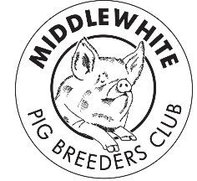
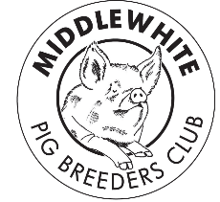
Middle White Pig
Breeders’ Club

Summer 2017

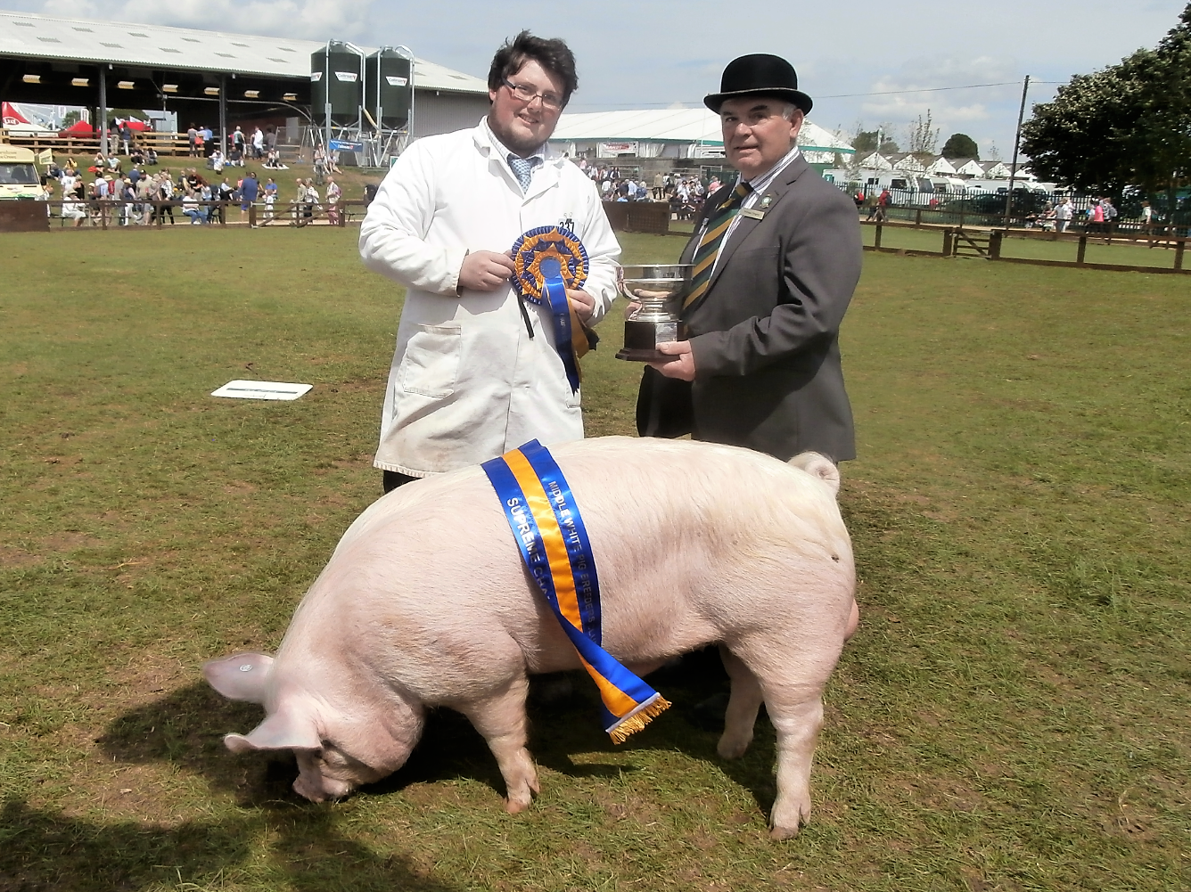

Congratulations to Oliver Giles who wins this year’s ‘Middle White Champion of Champions’ at The Great Yorkshire Show with his boar Tedfold Captain 87, kindly judged this year by William Gregory.

(More photos from the C of C later in the newsletter, photos courtesy of the roving photographer Ann King).

Chairman’s Report

Hi all

It was a sad loss to the Middle White Pig Breeders’ Club that John Herbert passed away earlier this the year, he had been a long-time supporter of the breed, showman and previous Chairman of the club. Our thoughts go to his family.

On a brighter note, it was very encouraging to see one of our younger members, Oliver Giles taking time out of his vet studies to attend the A.G.M. which was held at Tatton Park in Cheshire this year but it would be great to see a few more members, it’s your club come along next year you will be made very welcome. Congratulations also go to Oliver for winning the Champion of Champions held at the Great Yorkshire Show, judged this year by William Gregory.

If anyone has any ideas they would like to put forward or if you would like to put pen to paper, maybe how you started keeping Middles just let one of the committee know and we can put it to print.

Brian

From your Secretary

Congratulations to Oliver Giles on winning the Middle White Champion of Champions at the Great Yorkshire Show and looking forward to seeing more Middle Whites next year out showing.

Sarah

Recipe - We plan to run a pork recipe each newsletter, the following was taken from The Rare Breeds Survival Trust’s ‘Great Meat Recipes’ but if you have a favourite you would like to share send it to us, contact details later in the newsletter -

Roast Middle White Pork Chinese Style

1 ½ lb belly pork  Marinade:  2 tbls light soy sauce  1 tbls soft brown sugar  1 tbls soya bean paste  2tbls fruit sauce  2 tbls red wine  1 tbls oil  1 tsp sesame paste  1 shallot  1 clove garlic finely chopped  To finish:  1 tsp sesame oil  1 tbls honey | Remove the rind from the pork and cut into 3” strips. Mix all the marinade ingredients and leave the pork in this for at least an hour.  Heat the grill on high for 5 mins and then reduce the heat, place the pork on a rack and grill for 25 mins, turning from time to time.  Mix the sesame oil and honey together and brush the pork. Grill for a further 10 minutes.  Slice the pork thickly, place on a hot dish and garnish with fresh pineapple. Serve with fried rice with prawns and a selection of fresh vegetables.  Frances Kennedy  Shenstone
Looking Back to Move Forward –
Why do we keep Middles?

I’m sure there are many reasons but personally I keep them to preserve something beautiful from our past, they are not the sleek racehorses of the pig world, if you need that for your meat production try another breed or a cross bred but please don’t then register them as a Middle White! I know they originated from the small and large white but the large white today is a very different animal to those when the Middle White came into being and the small white has gone altogether, let’s not let the same happen to our Middles.

This is a personal view but if you look at some of the Middles today they have more in common with the modern large whites and other modern breeds, their only likeness to Middles being a shorter nose. I know some of you will tell me that we should ‘modernise’ but look what’s happened in America, their pigs all have the same body shape just having different colours to show they are a different breed – is this where we are going with the Middle White and our other traditional breeds?

The meat of the Middle White tastes great albeit on the fatty side but with a carefully controlled diet this can be minimised – look how top chefs are seeking out traditional pork they know it tastes great – so we must be careful not to lose it.

In the next few issues I want to look back at some of the pictures from old herd books to remind ourselves what the Middle White looked like. As with dog breeding just going off the written word, the breed standard in our case, can lead to extremes so let’s look back starting with the 1920’s –

–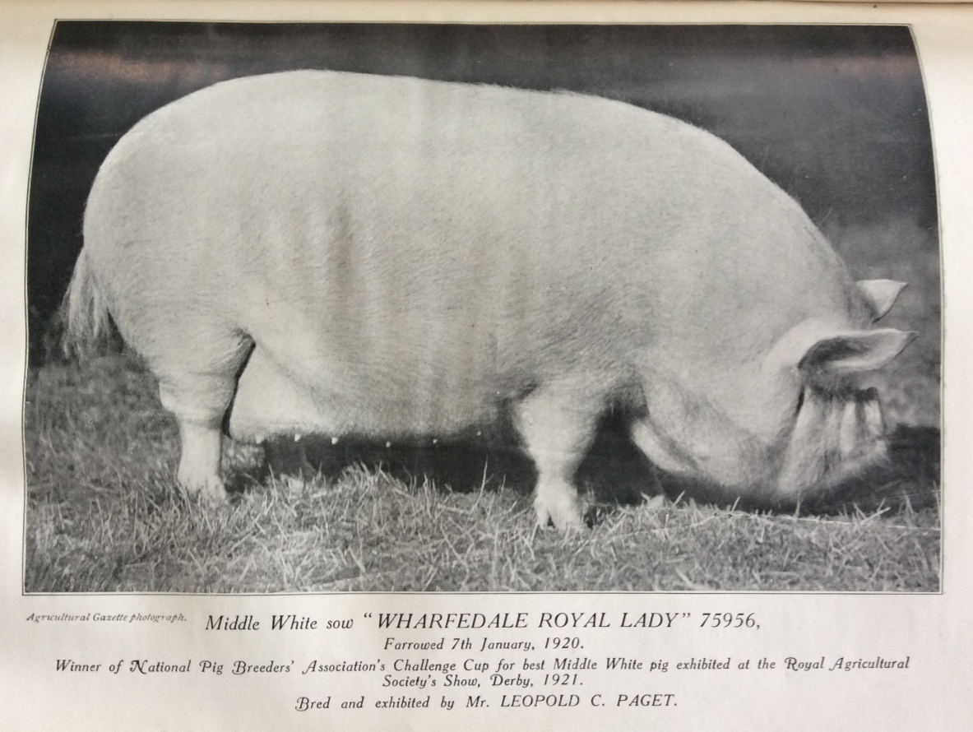

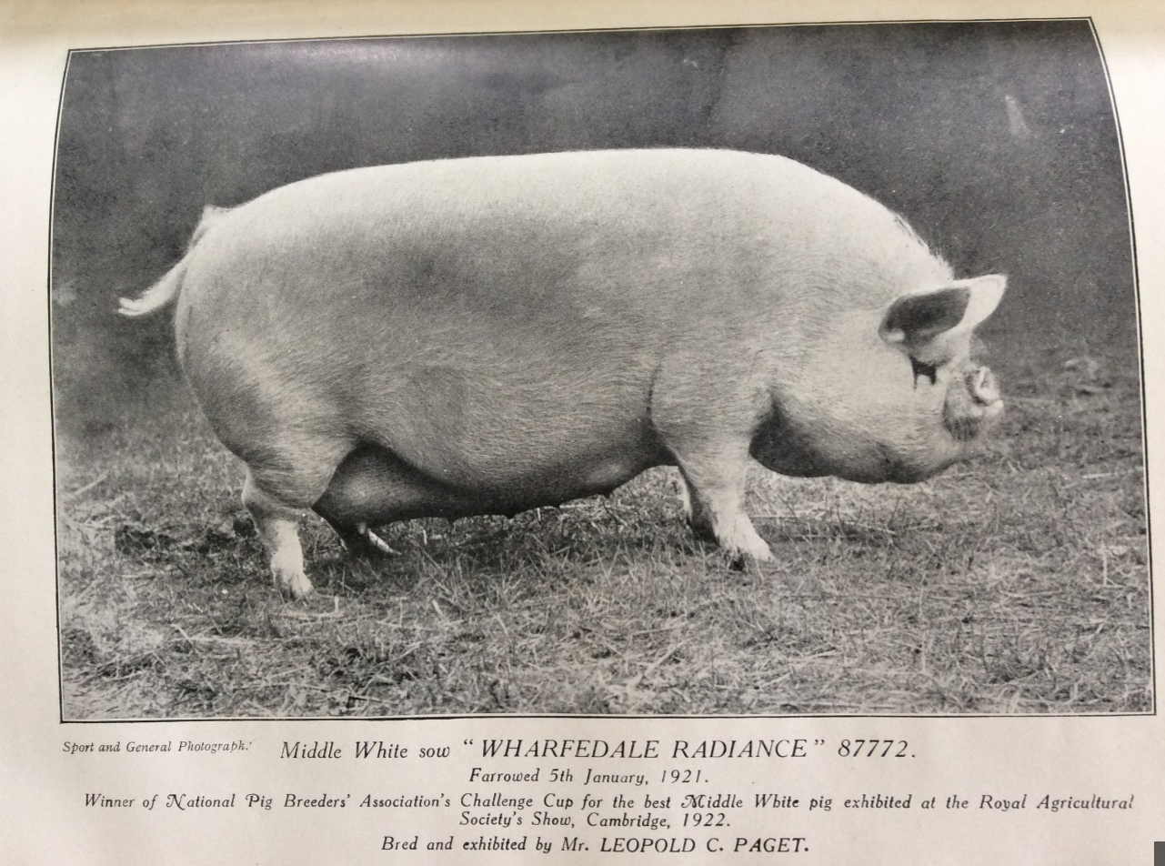

In the next issue, we can look to the 1930’s along with the breed standards of the day against our current standards.

Ann
Contact Us –
Sarah Marsden
The Barn
Eaves Lane
Cheadle
Stoke-on-Trent
ST10 1TL

Tel. 01538 750029
middlewhiteclub@hotmail.com

Ann King
Pinehurst
Station Road
Delamere
Northwich
Cheshire
CW8 2HZ

Tel. 01606 882201

ann_king0@talk21.com

Show Results – so far

Newark & Notts
Boar born after 1st July 2016
1st Berkshire
2nd Tamworth
3rd Gracebank Rajah 15 - Grace Bretherton
Sow
1st Large Black
2nd Eaves Fair Lady 7 - Mick Paddock and Sarah Marsden
3rd Tamworth
Gilt born between 1st July 2016 and the 31st August 2016
1st Lewin Dorothy 28 - Emily Paddock
2nd Tamworth
Gilt born between 1st September 2016 and the 31st September 2016
No Middle Whites entered
Gilt born after 1st January 2017
1st Bolingbroke Carnation – Cynthia Timbury
2nd Saddleback
3rd Saddleback
Champion Female
Lewin Dorothy 28 - Emily Paddock
Reserve Gloucestershire Old Spot
Middle White Champion Lewin Dorothy 28 - Emily Paddock
Reserve Middle White Champion Bolingbroke Carnation – Cynthia Timbury

Devon
Boar Born in 2017
1st Nancenoy Captain 11-Caroline Dunstan
2nd KuneKune
Sow or Gilt Boar before 1st July 2016
1st KuneKune
2nd Fair Lady 19 - Caroline Dunstan
3rd KuneKune
Gilt Born on or between 1st July 2016 and 31 August 2016
1st Nancenoy Fair Lady 22-Caroline Dunstan
2nd KuneKune
Gilt Boar in 2017
1st Nancenoy Fair Lady 24-Caroline Dunstan
2nd Nancenoy Fair Lady 23-Caroline Dunstan
3rd KuneKune
Champion Male
Nancenoy Captain 11-Caroline Dunstan
Reserve Champion Male
Nancenoy Captain 10-Caroline Dunstan
Champion Female
KuneKune
Reserve Female
1st Nancenoy Fair Lady 24-Caroline Dunstan
Champion Middle White
Nancenoy Fair Lady 23-Caroline Dunstan
Reserve Champion Middle White
Nancenoy Captain 11-Caroline Dunstan

Please send in your results so they can be added in the next issue and online, with photos if possible please…

Heathfield Show - 27th May
After heavy rain early in the morning, the weather
changed in time for judging. The judge was Mrs Sarah
Ashcroft from Lincolnshire, who eventually chose a
Berkshire Sow as her Supreme Champion and an OSB
October gilt as her Reserve Champion. The Middle
White results are as follows:
Interbreed Classes
July Boar
1st Tedfold Captain 87 - Oliver Giles
January Boar
3rd Isemonger Captain - Stefanie Georgetti
January Gilt
2nd Isemonger Yootha - Stefanie Georgetti
MW Breed Champion
Isemonger Yootha - Stefanie Georgetti

Surrey County Show - 29th May
Judge: Bill Howes
The Supreme Champion was a Welsh Gilt and Reserve
was an OSB January Boar.
MW Results as follows:
July Gilt Unplaced - Vanilla Woodlands Lady 3 - A Westron
January Gilt 2nd Tedfold Fair Lady 95 - Oliver Giles
Unplaced - Tedfold Fair Lady 101 - Oliver Giles
Breed Champion Tedfold Fair Lady 95 - Oliver Giles

Stafford
Middle White Classes
Boar born before 1st January 2017
1st Eaves Captain 5- Mick Paddock and Sarah Marsden
2nd Gracebank Rajah 15- Tracey Bretherton
Sow Born before 1st July 2016
1st Eaves Fair Lady 7 -Mick Paddock and Sarah Marsden
Gilt Born on or after 1st July 2016
1st Lewin Dorothy 28-Emily Paddock
2nd Gracebank Yootha 28- Tracey Bretherton
3rd Eaves Yootha 18-Mick Paddock and Sarah Marsden
Boar or gilt born after the 1st January 2017
1st Lewin Dorothy 29-Emily Paddock
2nd Eaves Yootha 19- Mick Paddock and Sarah Marsden
3rd Eaves Revival- Mick Paddock and Sarah Marsden
Champion Eaves Captain 5- Mick Paddock and Sarah Marsden
Reserve Champion Eaves Fair Lady 7 -Mick Paddock and Sarah Marsden
Interbreed Pairs
3rd Eaves Captain 5- Mick Paddock and Sarah Marsden
Eaves Fair Lady 7 -Mick Paddock and Sarah Marsden
Reserve Pig of the Year Eaves Revival- Mick Paddock and Sarah Marsden

Bath and West
Boar born before 31st December 2016
1st Pinehurst Revival 5 – Brian Merry
2nd Berkshire
3rd Pinehurst Mischief 4 – Brian Merry
Sow or Gilt born before the 1st July 2016
1st Pinehurst Alma Rose 3 – Brian Merry
Gilt Born after 1st July 2016
1st Pinehurst Fair Lady 23 – Brian Merry
2nd Berkshire
3rd Pinehurst Alma Rose 12 – Brian Merry
No January’s forward
Champion Male
Pinehurst Revival 5 - Brian Merry
Champion Female
Pinehurst Fair Lady 23 - Brian Merry
Champion Middle White
Pinehurst Revival 5 - Brian Merry
Reserve Champion Middle White
Pinehurst Fair Lady 23 - Brian Merry
Group of Three
1st Berkshire
2nd Pinehurst Mischief 4
Pinehurst Alma Rose 12
Pinehurst Fair Lady 23
Pair of Breeding pigs any age of opposite sex section C
1st Tamworth’s
2nd Pinehurst Alma Rose 3
Pinehurst Revival 5
Pair of breeding pigs of any age same sex
4th Pinehurst Alma Rose 12
Pinehurst Fair Lady 23
Flack Trophy
1st Tamworth
2nd Pinehurst Alma Rose 3
Reserve Pig of the Year Traditional Male
Pinehurst Mischief 4 - Brian Merry

SOUTH OF ENGLAND SHOW
Judge: Brian Mulkeen ably assisted by Apprentice Judge Emily Paddock.
MW Results + 1 Tamworth
July Boar
1st Tedfold Captain 87 - Oliver Giles
2nd Vanilla Revival - S Westron
January Boar
1st Isemonger Captain - Stephanie Georgetti
Sow
1st Alsa Fair Lady 1531 - Oliver Giles
July Gilt
1st Vanilla Woodlands Lady 3 - Suzi Westron
2nd Tamworth
January Gilt
1st Isemonger Yootha - Stefanie Georgetti
2nd Tedfold Fair Lady 95 - Oliver Giles
Male Champion Tedfold Captain 87 – Oliver Giles
Reserve Isemonger Captain – Stefanie Georgetti
Female Champion Alsa Fair Lady 1531 – Oliver Giles
Reserve Isemonger Yootha – Stefanie Georgetti
Breed Champion Tedfold Captain 87 – Oliver Giles
Reserve Alsa Fair Lady 1631 – Oliver Giles
POY
Reserve Qualifier Traditional Female Isemonger Yootha – Stefani Georgetti
Reserve Qualifier Traditional Male Tedfold Captain 87 – Oliver Giles

Cornwall Show
Boar Born in 2016
1st Watchingwell Revival 20 – Sharon Groves
2nd Nancenoy Captain 10 – Caroline Dunstan
3rd Nancenoy Sovereign 3 – Caroline Williams
Boar Born in 2017
1st Shaftesbury Revival – Jean Booth
2nd Nancenoy Captain 11 – Caroline Dunstan
Sow or Gilt Born before 1st July 2016
1st Nancenoy Fair Lady 22 – Caroline Dunstan
Gilt Born in 2017
1st Shafesbury Woodland Lady 4 – Jean Booth
2nd Nancenoy Fair Lady 24 – Caroline Dunstan
3rd Nancenoy Fair Lady 23 – Caroline Dunstan
Champion Male Watchingwell Revival 20 – Sharon Groves
Reserve Male Shaftesbury Revival – Jean Booth
Champion female Nancenoy Fair lady 19 - Caroline Dunstan
Reserve champion female Shaftesbury Woodland Lady 4 - Jean Booth
CHAMPION Nancenoy Fair lady 19 - Caroline Dunstan
RESERVE CHAMPION Watchingwell Revival 20 - Sharon Groves
Pig of the year qualifier Watchingwell Revival 20 - Sharon Groves

Royal Three Counties Show
MW Results
Judge: Mr C Bull
Boar born before 2017
1st Eaves Captain 5 - Mick Paddock and Sarah Marsden
2nd Tedfold Captain 87 - Oliver Giles
3rd Watchingwell Revival 20 - Sharon Groves
4th Tedfold Captain 55 - Oliver Giles
Boar born in 2017
1st Eaves Revival - Mick Paddock and Sarah Marsden
Sow
1st Alsa Fair Lady 1531 - Oliver Giles
2nd Eaves Fair Lady 7 - Mick Paddock and Sarah Marsden
3rd Eaves Yootha 16 - Mick Paddock and Sarah Marsden
4th Eaves Yootha 14 - N Groom
Gilt born in 2017
1st Tedfold Fair Lady 95 - Oliver Giles
2nd Lewin Dorothy 29 - Emily Paddock
3rd Eaves Yootha 19 - Mick Paddock and Sarah Marsden
Male Champion: Eaves Captain 5 - Mick Paddock and Sarah Marsden
Res Champion: Eaves Revival - Mick Paddock and Sarah Marsden
Female Champion: Tedfold Fair Lady 95 - Oliver Giles
Res Champion: Alsa Fair Lady 1531 - Oliver Giles
Breed Champion: Eaves Captain 5 - Mick Paddock and Sarah Marsden
Res Champion: Tedfold Fair Lady 95 – Oliver Giles
Pig of the Year
Reserve Traditional Male Qualifier: Tedfold Captain 87 – Oliver Giles
MW Pairs:
1st Mick Paddock and Sarah Marsden
2nd Oliver Giles

National Rare and Minority Breeds Show
(held at Three Counties show ground)
MW Results
Judge S Ashcroft
Boar born before 2017
1st Eaves Captain 5 – Mick Paddock and Sarah Marsden
2nd Tedfold Captain 55 – Oliver Giles
3rd Watchingwell Revival 20 – Sharon Groves
Boar born in 2017
1st Eaves Revival – Mick Paddock and Sarah Marsden
Sow
1st Eaves Fair Lady 7 – Mick Paddock and Sarah Marsden
2nd Alsa Fair Lady 1531 – Oliver Giles
3rd Eaves Yootha 16 – Mick Paddock and Sarah Marsden
Gilt born in 2017
1st Tedfold Fair Lady 95 – Oliver Giles
2nd Lewin Dorothy 29 – Emily Paddock
3rd Eaves Yootha 19 – Mick Paddock and Sarah Marsden
Breed Champion Eaves Captain 5 – Mick Paddock and Sarah Marsden
Reserve Champion Tedfold Fair Lady 95 – Oliver Giles

Cheshire Show
Boar born before 2017
1st Eaves Captain 5 - Mick Paddock and Sarah Marsden
2nd Gracebank Rajah 15 - Tracey Bretherton
Boar Born in 2017
1st Eaves Revival - Mick Paddock and Sarah Marsden
2nd Shaftesbury Revival - Jean Booth
Sow
1st Eaves Fair Lady 7 - Mick Paddock and Sarah Marsden
2nd Eaves Yootha 16 - Mick Paddock and Sarah Marsden
July Gilt
1st Gracebank Yootha 28 - Tracey Bretherton
2nd Lewin Dorothy 28 - Emily Paddock
Gilt born in 2017
1st Lewin Dorothy 29 – Emily Paddock
2nd Eaves Yootha 19 – Mick Paddock and Sarah Marsden
3rd Shaftesbury Woodland Lady 4 – Jean Booth
Champion Middle White - Eaves Captain 5 – Mick Paddock and Sarah Marsden
Reserve Champion - Eaves Fair Lady 7 – Mick Paddock and Sarah Marsden
POY qualifier - Gracebank Yootha 28 – Tracey Bretherton
POY reserve - Gracebank Rajah 15 – Tracey Bretherton

Lincolnshire Show
Any Traditional Breed of Pig
Boar born on or before 31st August –
1st Pinehurst Revival 5th – Brian Merry
2nd Pinehurst Mischief 4th – Brian Merry
Sow born before 30th Jun 2016
1st Berkshire
2nd Pinehurst Alma Rose 3rd – Brian Merry
Gilt born after 1st Sep 2016
1st Saddleback
2nd Pinehurst Fair Lady 23rd – Brian Merry
3rd Pinehurst Alma Rose 12th – Brian Merry
Male Champion - Pinehurst Revival 5th – Brian Merry
Male Reserve - Pinehurst Mischief 4th – Brian Merry
Female Champion – Berkshire
Female Reserve – Pinehurst alma rose 3rd – Brian Merry
Supreme Traditional Champion – Pinehurst Revival 5th – Brian Merry
Group of 3 Pigs
1st Pinehurst Mischief 4th, Pinehurst Alma Rose 12th, Pinehurst Fair Lady 23rd – Brian Merry
POY Qualifier – Best Traditional male Pinehurst Mischief 4th – Brian Merry

Norfolk Show
July Boar
1st Tedfold Captain 87 - Oliver Giles
2nd Pinehurst Mischief 4 - Brian Merry
January Boar
1st Eaves Revival - Mick Paddock & Sarah Marsden
Sow
1st Pinehurst Alma Rose 3 - Brian Merry
2nd Alsa Fair Lady 1531 - Oliver Giles
July Gilt
1st Pinehurst Alma Rose 12 - Brian Merry
2nd Pinehurst Fair Lady 23 - Brian Merry
January Gilt
1st Lewin Dorothy 29 - Emily Paddock
2nd Eaves Yootha 19 - Mick Paddock & Sarah Marsden
3rd Tedfold Fair Lady 101 - Oliver Giles
Male Champion – Eaves Revival – Mick Paddock & Sarah Marsden
Reserve – Tedfold Captain 87 – Oliver Giles
Female Champion – Lewin Dorothy 29 – Emily Paddock
Female Reserve – Pinehurst Alma Rose 12 – Brian Merry
Breed Champion – Lewin Dorothy 29 – Emily Paddock
Reserve Champion – Eaves Revival – Mick Paddock & Sarah Marsden
Reserve Traditional Champion – Lewin Dorothy 29 – Emily Paddock
POY Qualifier – Pinehurst Fair Lady 23 – Brian Merry
Reserve Young POY qualifier – Eaves Revival – Mick Paddock & Sarah Marsden
Interbreed Champion Pair – Brian Merry

Great Yorkshire Show
Judge Bryan Card
Boar born in 2016 between 1 July and 31 December
1st Watchingwell Revival 20 – Sharon Groves
2nd Nancenoy Captain 10 – Caroline Dunstan
3rd Pinehurst Mischief 4 – Brian Merry
4th Gracebank Rajah 15 – Tracey Bretherton
5th Tedfold Captain – Oliver Giles
Boar born in 2017
1st Eaves Revival – Mick Paddock and Sarah Marsden
2nd Acaster Mischief – Trish Horsley
3rd Nancenoy Captain 11 – Caroline Dunstan
Sow born on or before 30 June 2016
1st Nancenoy Fair Lady 19 – Caroline Dunstan
2nd Pinehurst Fair Lady 19 – Brian Merry
3rd Pinehurst Alma Rose 3 – Brian Merry
4th Also Fair Lady – Oliver Giles
Gilt born in 2016 on or after 1 July and 31 December
1st Pinehurst Fair Lady 23 – Brian Merry
2nd Gracebank Yootha 28 – Tracey Bretherton
3rd Pinehurst Alma Rose 12 – Brian Merry
4th Lewin Dorothy 28 – Emily Paddock
5th Templeson Silk – Trish Horsley
Gilt born in 2017
1st Lewin Dorothy 29 – Emily Paddock
2nd Nancenoy Fair Lady – Caroline Dunstan
3rd Tedfold Fair Lady 101 – Oliver Giles
4th Tedfold Fair Lady 95 – Oliver Giles
5th Eaves Yootha 19 – Mick Paddock and Sarah Marsden
Group of 3 pigs
1st Caroline Dunstan
2nd Brian Merry
Champion Male – Eaves Revival – Mick Paddock & Sarah Marsden
Reserve Male – Acaster Mischief – Trish Horsley
Champion Female – Pinehurst Fair Lady 23 – Brian Merry
Reserve Female – Lewin Dorothy 29 – Emily Paddock
Champion Middle White – Pinehurst Fair Lady 23 – Brian Merry
Reserve Middle White – Lewin Dorothy 29 – Emily Paddock

Champion of Champions 2017

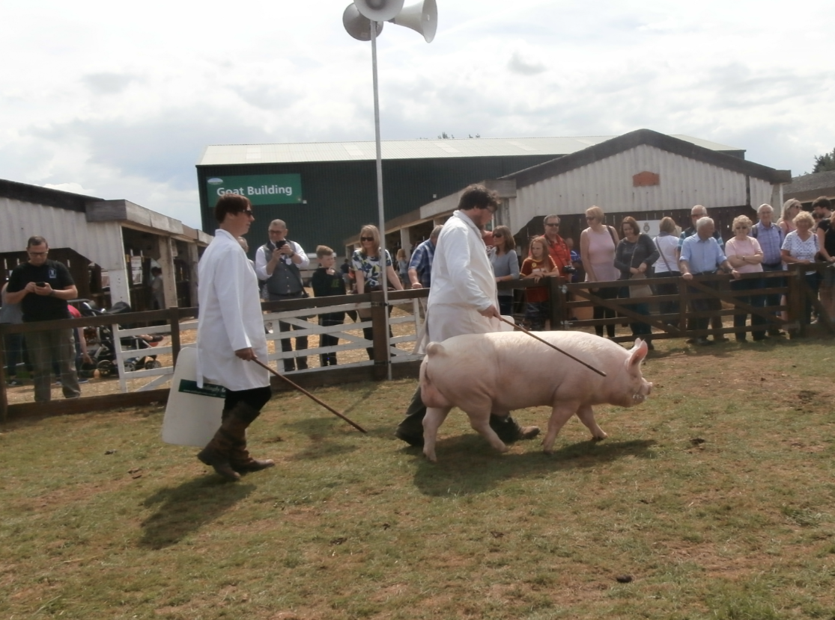
Champion Tedfold Captain 87

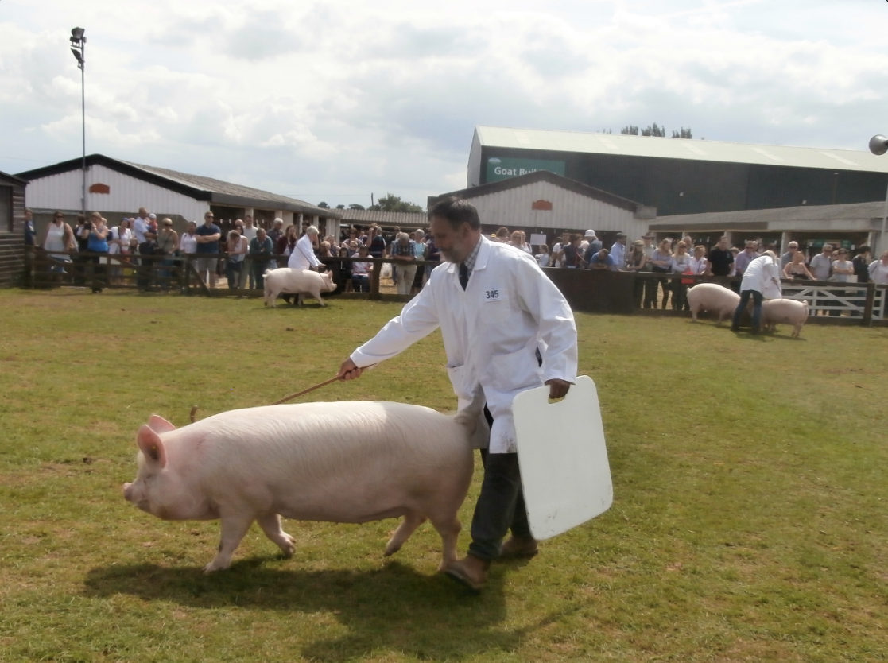

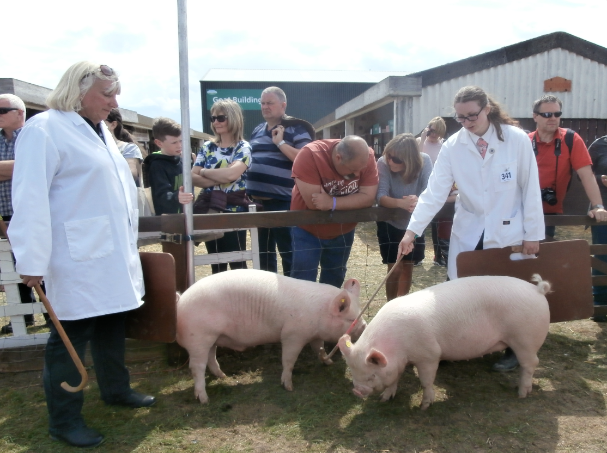

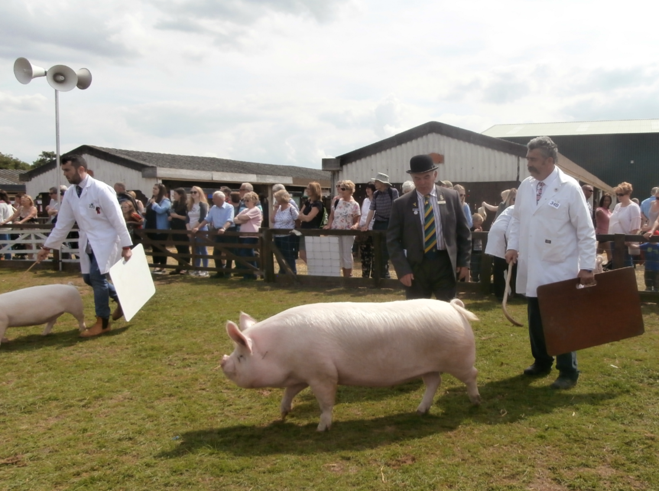

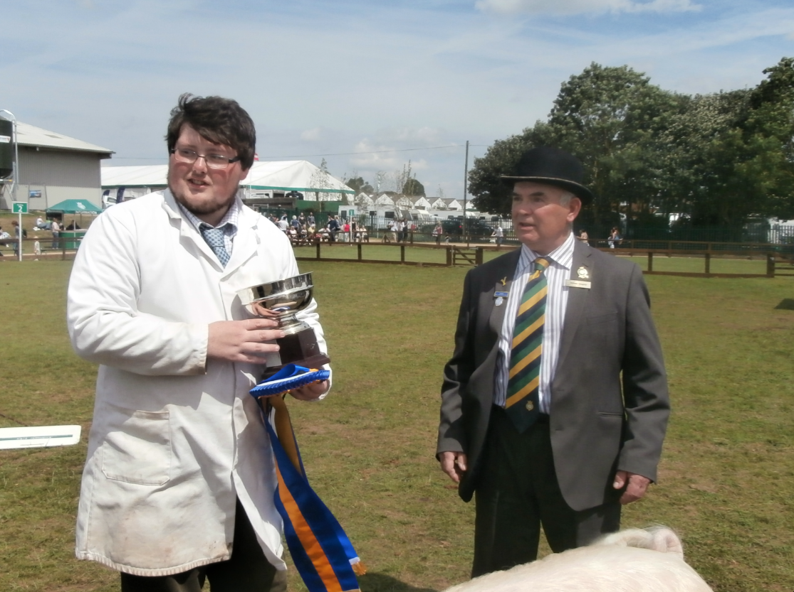
Oliver Giles with judge William Gregory

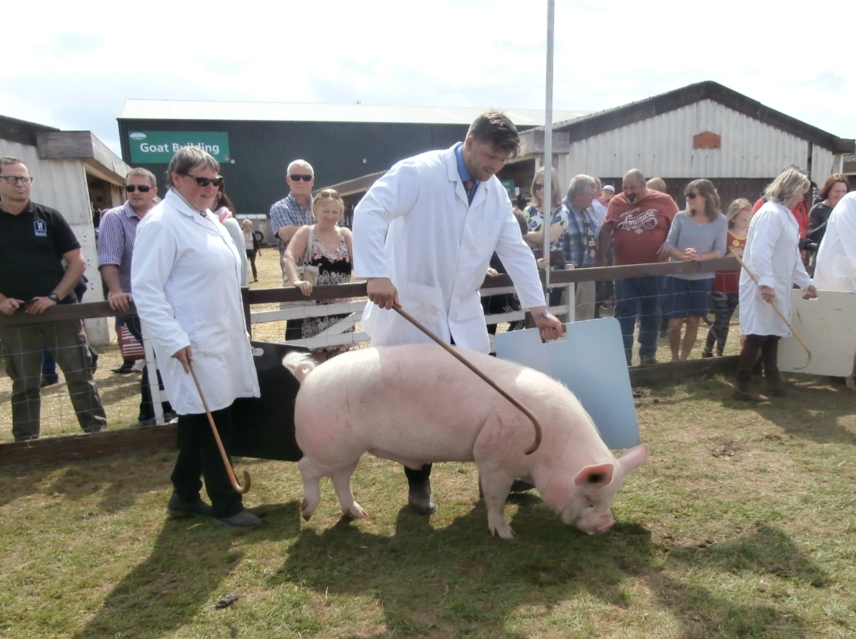

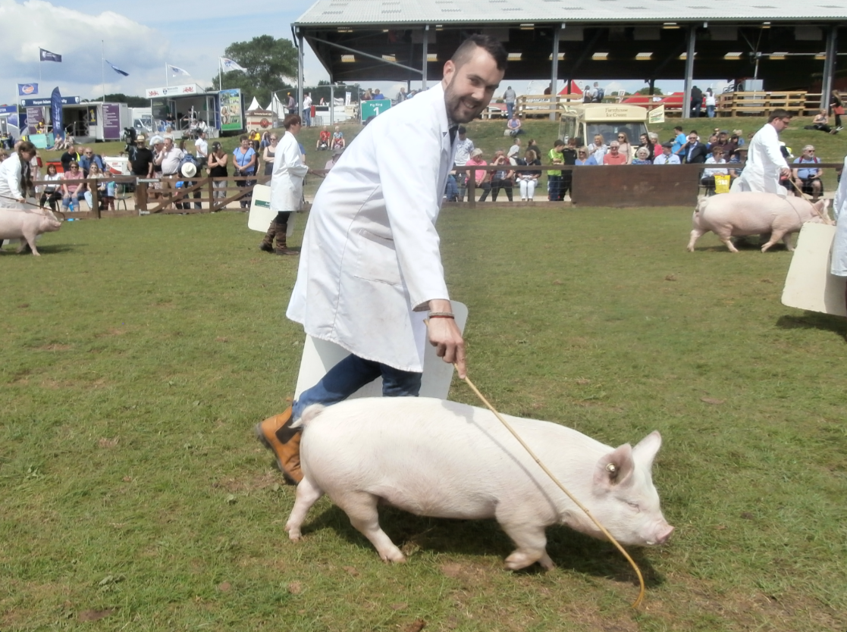

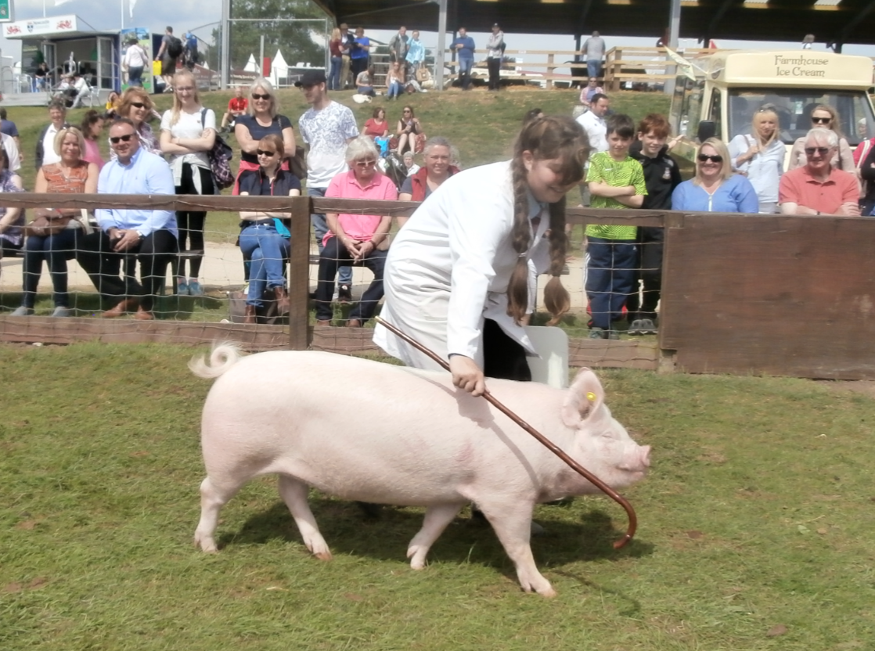
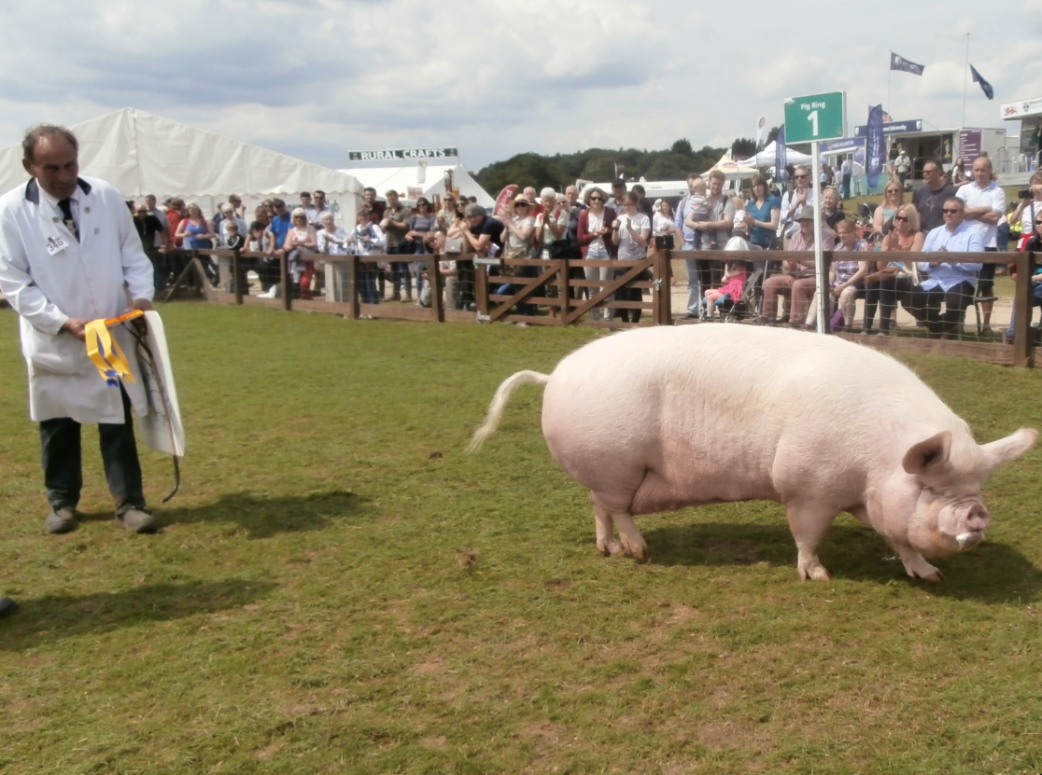
Reserve Pinehurst Alma Rose 3 – Brian Merry

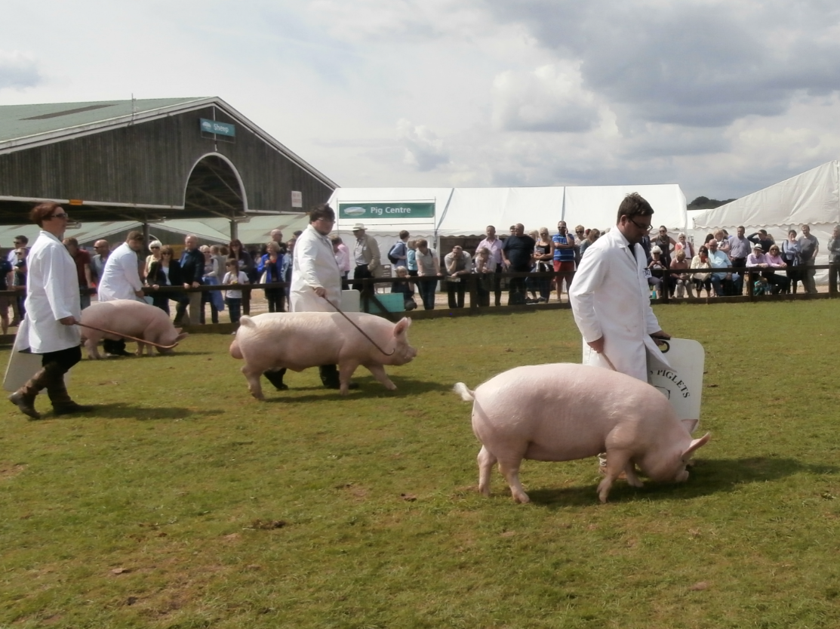

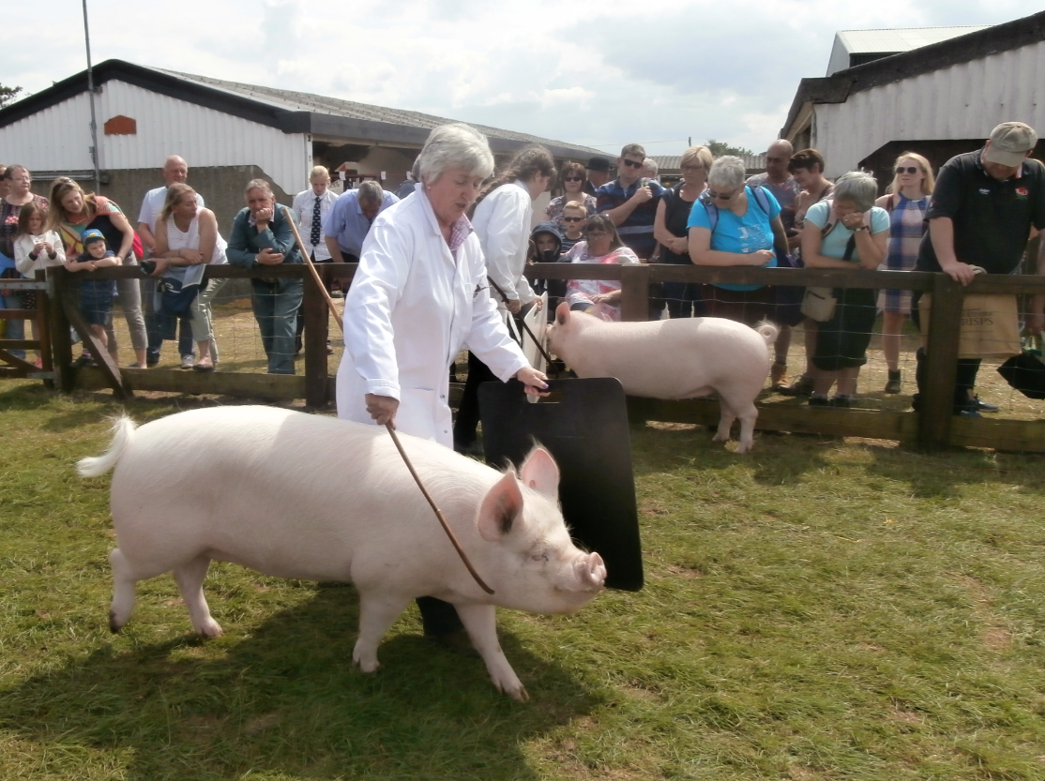

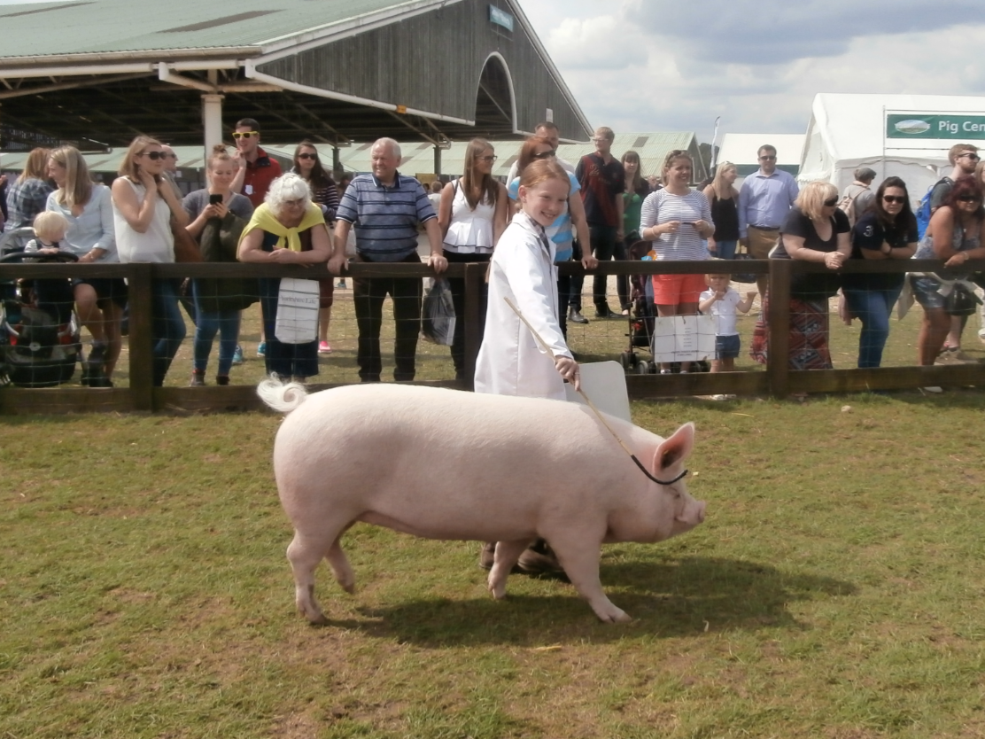
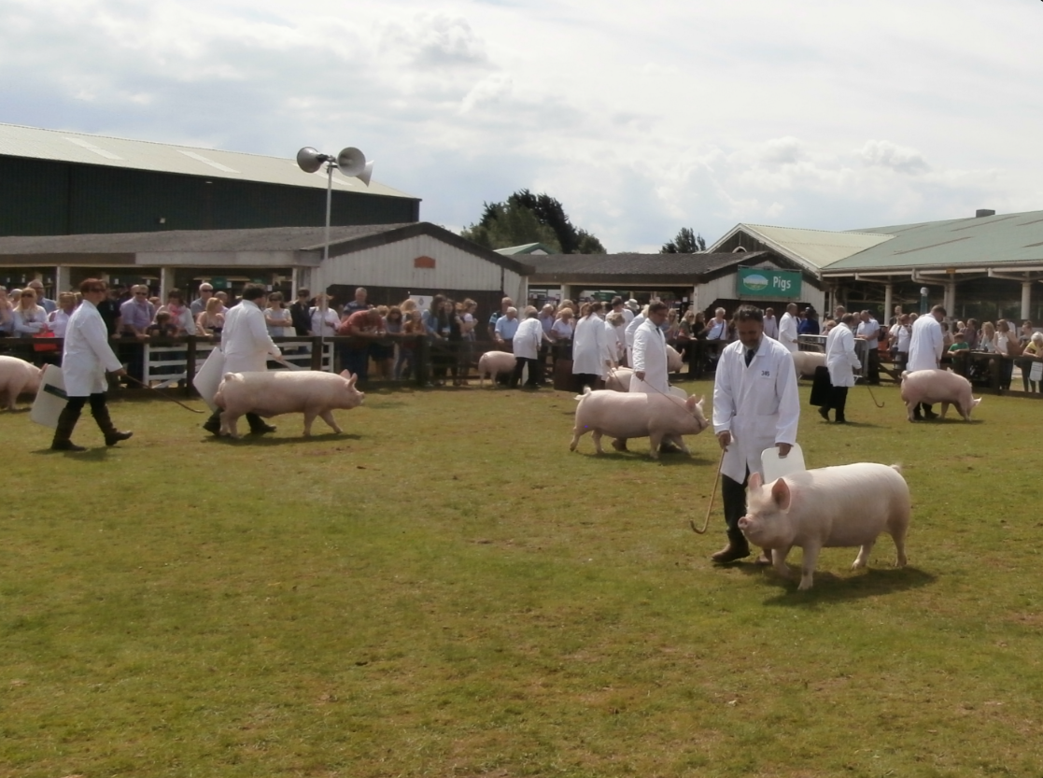

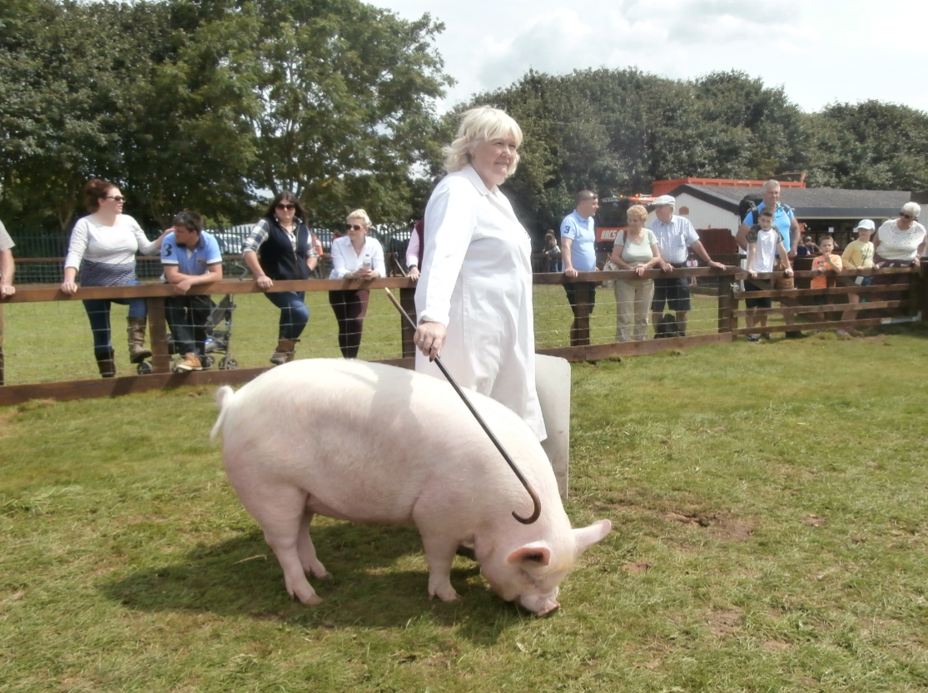

More photos of the Champion of Champions to be found on-line …

(Photos courtesy of Ann King)

