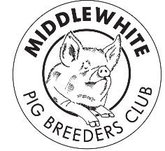
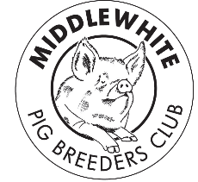
Middle White Pig
Breeders’ Club

Autumn 2017

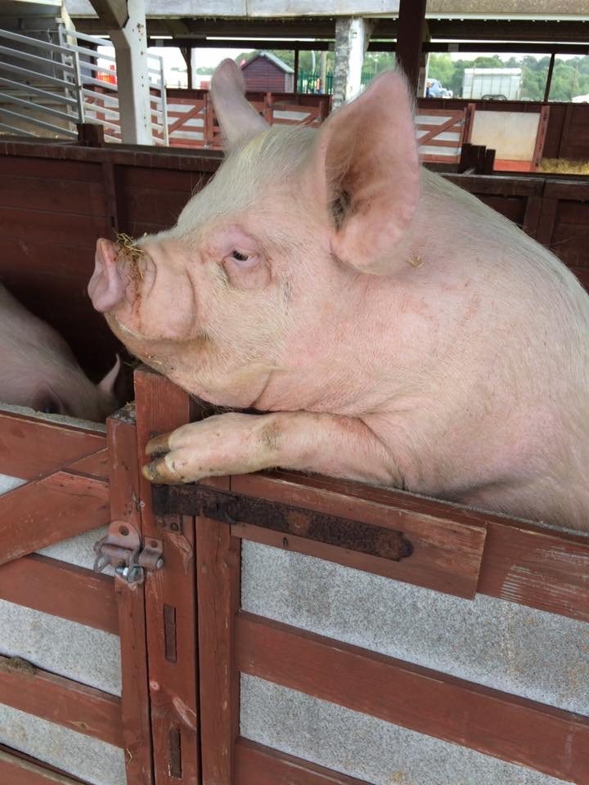
Show’s Over!!

Photo courtesy of Acaster Pedigree Pigs, posted on the Middle White Facebook page.

from your Chairman

Hi all

It is that time again to put pen to paper, most of the shows have ended for the year except for the winter fairs which hopefully will have some Middles on show, good luck to all involved.
We will once again be moving the AGM to a different venue, next year it will be back down country – details to follow in the next issue. Hopefully more members will be able to join us – it’s your club so please come and have your say on its future, it’ not just for the showing members.
I hope you’ve all had a successful year and on with your breeding plans for next year.

Brian Merry

from your Secretary

It has come to the club’s attention that the breed standard for the Middle White was been changed in Autumn 2013 at the BPA. To ensure everyone is conforming to it we have printed the present breed standard on the next page –

We have also updated the Middle White web site with the present breed standard.

Sarah Marsden

Miranda’s Legacy -

I’m sure you all fondly remember our previous secretary and treasurer Miranda Squire whom we sadly lost a couple of years ago. Miranda left a legacy with the RBST for her precious Middle Whites conservation and Sarah recently had a reply from the RBST letting us know what they have done with it so far –

‘….. we used some of the legacy to fund a collection from the Middle White boar Ballybollen Captain 222, born on January 3, 2016, who won first place at Gosford Park last year.
We plan to use the remainder of the legacy on a second Middle White collection….’

Sarah Marsden
We are always looking for new items for the newsletter so if you have any stories you would like to share, photos, pig sales etc. or if there is something you would like us to cover please let us know.
Ann King - Editor

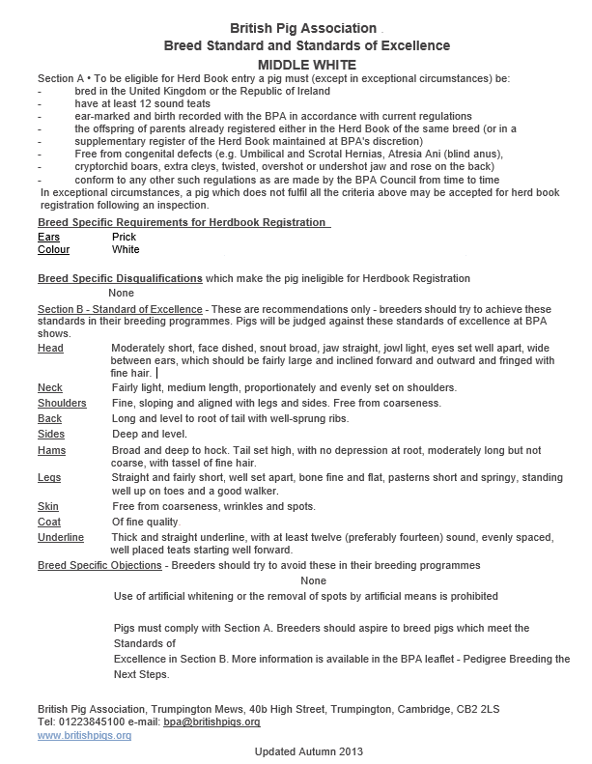
Recipe -

Interested in a basic sausage recipe below is such a recipe taken from Paul Peacock’s book ‘Get Stuck In’.

Basic Breakfast Sausage

This basic sausage can be adapted to various recipes. It has a high meat to fat and curing salt ratio and you can alter these according to your requirements. You can freely vary the cut of pork or even go half pork and half of any other meat.

Ingredients | Method
Basic Filling  - 1kg Middle White pork shoulder  - 200g Middle White pork fat  - 100g breadcrumbs or rusk  - 200ml ice cold water  Seasoning  - 17g curing salt  - 3g black pepper  Casings  - 2 metres of sheep casing, soaked for at least an hour in several changes of water and washed inside and out. | Cube the meat into about 1.5cm pieces and chill with the fat in the freezer for 30 minutes.  Mince the port and fat together using the coarse plate in the grinder and put in the fridge for 30 minutes to chill.  Thoroughly mix the dry ingredients so that the curing salt and pepper are completely incorporated.  Finely mince the meat and fat and mix with the dry ingredients and the water.  Stuff into casing and link as required.  Leave for 24 hours to mature.

The key is keeping things as cold as possible, chill the meat, use ice cold water and grind twice, once with the coarse plate and once with the fine.
You don’t have to use sheep skins you can use hog skins or collagen ones (don’t make the mistake of soaking collagen skins!!)

Tip: Try with 50g finely chopped sage or half a bunch of very finely chopped spring onions or five chopped garlic cloves.
If you have a favourite recipe you would like to share please send it to us, contact details below -
Looking Back to Move Forward –

Editor:
Ann King
Pinehurst
Station Road
Delamere
Northwich
Cheshire CW8 2HZ

Tel. 01606 882201

ann_king0@talk21.com

Contact Us –
Breed Secretary:
Sarah Marsden
The Barn
Eaves Lane
Cheadle
Stoke-on-Trent ST10 1TL

Tel. 01538 750029
middlewhiteclub@hotmail.com

As promised here are a couple of photos from the 1930’s herd books as in the 1920’s we still have the characteristic short turned up nose, ears forward, strong legs and deep body. This time one example is of a boar and as with the sow he still has a good depth to the body.
It is a shame the modern herd books only show ‘July’ examples of the breeds because it gives a much better feel for the breed with the finished animal, as was nearly always the case in the old herd books. I think it was also good to see the shows they had won giving future generations fine examples of the breed at that time in history – perhaps we could get this re-instated!

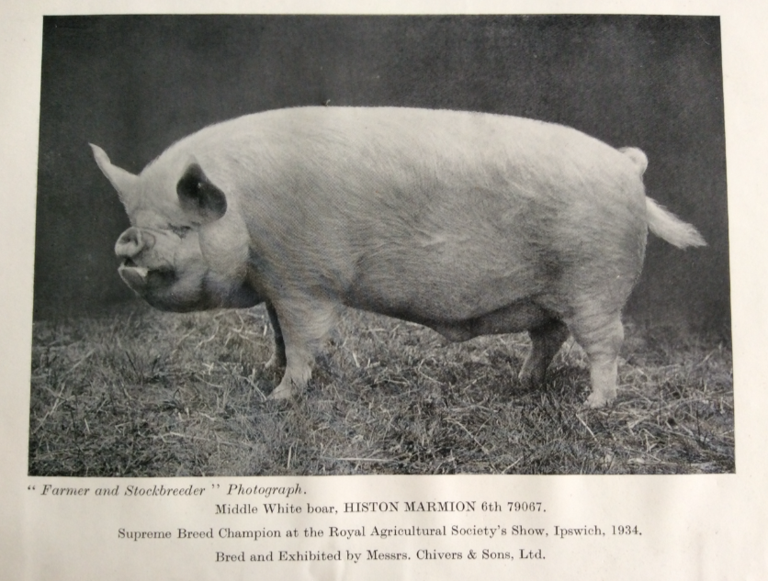

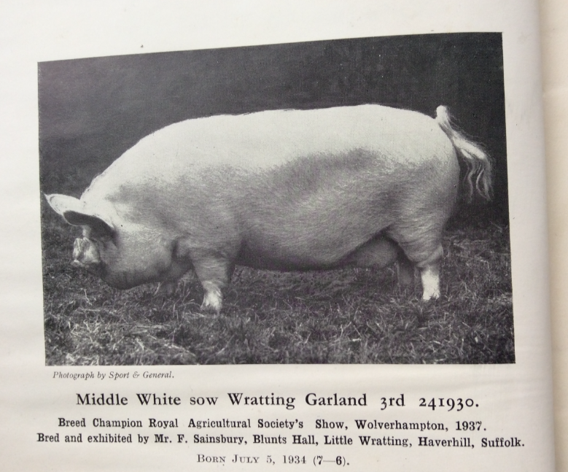

We will look to the 1940’s in the spring issue.
If you have any old photos or snippets of history regarding our breed from yourselves or older breeders who are perhaps no longer with us, please send them to the editor (details on the previous page) so we can share them with the membership in future editions.

Ann King - Editor
New Show Rules for 2018

As your breed representative at the B.P.A. who also sits on the Show and Sale Committee I would like to draw your attention to a rule change. The new rule has been published in Practical Pigs and B.P.A members have received a letter. The new rule reads ‘Female pigs born on or after 1st January and before 1st July in the year before the show, must farrow and rear to four weeks, a live litter within 18 months of their date of birth’.

The old rule used up to the 2017 show season was different for most breeds, with some having two different rules depending on just when the pig was born. The change is to help both shows and exhibitors by simplifying the rule and making it the same for all breeds. Please remember this means your pig must farrow by 17 months of age e.g. a gilt born on the 1st January must farrow by 2nd June and raise a litter to four weeks of age before she is 18 months old on the 30th June. The B.P.A. office staff will be checking birth notes to make sure all pigs comply with the new rule. I hope this change will encourage more members to come out showing not just with young sows but pigs of all ages.

If you have any questions regarding either breeding or showing your pigs remember both I and Tracey Bretherton, your B.P.A. breed reps are here to help.

Mick Paddock – Breed Representative

Late News:
‘South of England’ will be having Middle White classes next year – so get your entries in folks.

Show Results – after the Yorkshire Show 2017 -

Newbury Show Results 2017
Middle White
Judge: Debby Beeby
Sow
1st Alsa Fair Lady 1531 - O Giles
July Gilt
1st Vanilla Woodlands Lady - S Westron
January Gilt and Boar
1st Eaves Revival - M Paddock & S Marsden
2nd Lewin Dorothy 29 - E Paddock
3rd Tedfold Fair Lady 101 - O Giles
4th Eaves Yootha 19 - M Paddock & S Marsden
Breed Champion: Eaves Revival - M Paddock & S Marsden
Reserve Champion: Vanilla Woodlands Lady - S Westron

Judge: Jeremy Barber
Interbreed Senior Boar
1st Eaves Captain 5 - M Paddock & S Marsden
4th Tedfold Captain 55 - O Giles
Interbreed Junior Boar
1st Eaves Revival - M Paddock & S Marsden
Overall Interbreed Boar
1st Eaves Revival - M Paddock & S Marsden
2nd Eaves Captain 5 - M Paddock & S Marsden
Judge: John Millard
Veteran Pig
2nd Alsa Fair Lady 1531 - O Giles

Westmorland County Show
Judge Trish Horsley
Mixed Classes
Boar born before 1 July 2016
1st Pinehurst Mischief 4 - Brian Merry
Sow of any age
1st Pinehurst Alma Rose 11-Brian Merry
2nd GOS
3rd Pinehurst Alma Rose 3-Brian Merry
Gilt Born after the 1st July 2016
1st GOS
2nd GOS
3rd Lewin Dorothy 28-Emily Paddock
Gilt born after the 1st September 2016
No Middle Whites entered
January Gilt born after the 1st January 2017
1st GOS
2nd Tamworth
3rd Lewin Dorothy 29-Emily Paddock
January Boar born after the 1st January 2017
1st Tamworth
2nd Eaves Revival- Michael Paddock and Sarah Marsden
Interbreed Champion
Pinehurst Alma Rose 11-Brian Merry
Middle White Champion
Pinehurst Alma Rose 11-Brian Merry

Dorset
Any other traditional breed boar, born after 1st Jan 2017
No Middle Whites
Any other traditional breed sow, must have produced and reared a litter within 6 months prior to the date of the Show
1st Vanilla Woodlands Lady 2- Chris Sully
Any other traditional breed gilt, born after 1st July 2016
1st Vanilla Woodlands Lady 3- Mr and Mrs Westron
Any other traditional breed gilt, born after 1st Jan 2017
No Middle Whites

Edenbridge and Oxted Show Results 2017
Judge: Alice Newth
Mixed Classes
July Boar
1st Vanilla Revival - S Westron
Sow
1st Alsa Fair Lady 1531 - O Giles
July Gilt
4th Vanilla Woodlands Lady 3 - S Westron
January Gilt
2nd Tedfold Fair Lady 101 - O Giles
3rd Tedfold Fair Lady 95 - O Giles
Breed Champion
Alsa Fair Lady 1531 - O Giles

Egham Royal Show Results 2017
Judge: Andrew Brown
Sow
1st Alsa Fair Lady 1531 - O Giles
January Gilt
3rd Tedfold Fair Lady 101 - O Giles
Breed Champion
Alsa Fair Lady 1531 - O Giles
Reserve Supreme Champion
Alsa Fair Lady 1531 - O Giles

Anglesey
Judge Andrew Robinson
Boar born before 1ST January 2017
1st Eaves Captain 5 - Mick Paddock and Sarah Marsden
2nd Pinehurst Mischief 4 - Brian Merry
Sow born before 1st July 2016
1st Pinehurst Alma Rose 11-Brian Merry
Gilt born on or after 1st July 2015
1st Pinehurst Alma Rose 12-Brian Merry
2nd Pinehurst Fair lady 23-Brian Merry
Boar or Gilt born on or after 1st July 2017
1st Lewin Dorothy 29- Emily Paddock
2nd Eaves Revival-Mick Paddock and Sarah Marsden
Champion Middle White
Pinehurst Alma Rose 11-Brian Merry
Reserve Middle White Champion
Lewin Dorothy 29- Emily Paddock
Champion Pairs
Brian Merry- Pinehurst Mischief 4
Pinehurst Alma Rose 12
Champion group of 3
Brian Merry- Pinehurst Mischief 4
Pinehurst Alma Rose 12
Pinehurst Fair lady 23

Chertsey Show 2017
Judge: Emily Brown
MW Results
January Gilt
2nd Tedfold Fair Lady 101 - O Giles
MW Breed Champion
Tedfold Fair Lady 101 - O Giles

Apologies if we have missed any results but if you would like them adding in the next issue please send to Sarah or myself so we can get them added.

Photo Gallery – thanks to those who have posted on the Middle White Facebook page, keep adding them and we may see you here in the next issue!

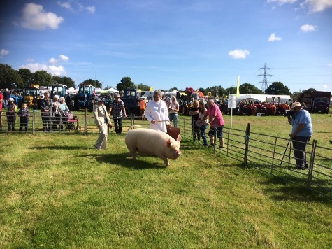
Posted by Emily Paddock – Huffles at Fillongley Show

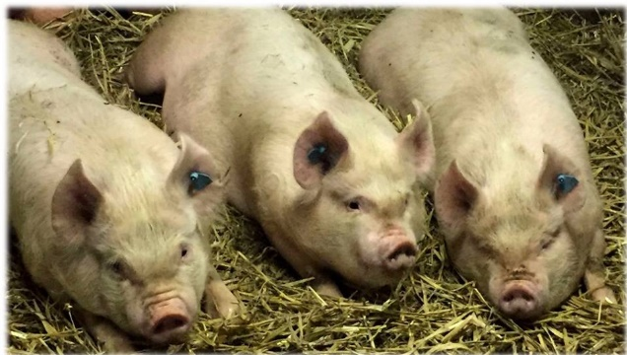
Posted by Acaster Pedigree Pigs – Three little pigs

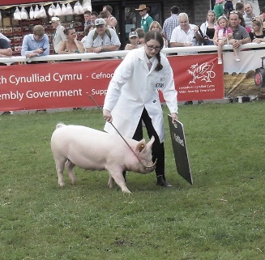
Posted by Sarah Marsden – Royal Welsh Show, Emily Paddock

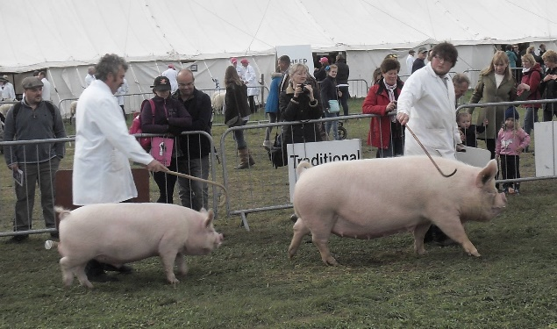
Posted by Sarah Marsden – Newbury Show, Mick Paddock, Oliver Giles

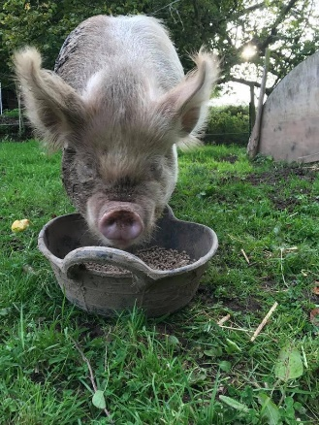
Posted by new member Cathy Baker – 1st venture into Middle Whites!

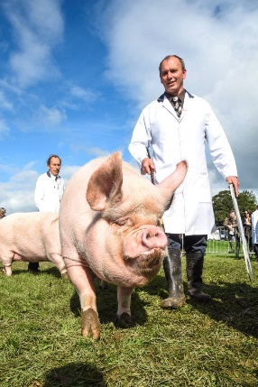
Posted on Westmorland website – Jeff Lloyd & Brian Merry

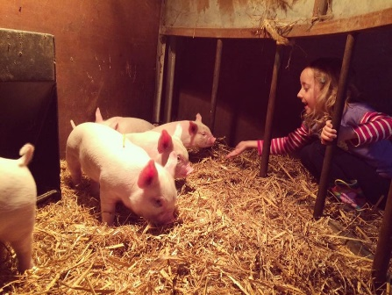
Posted by Stefanie Georgetti – youngsters!

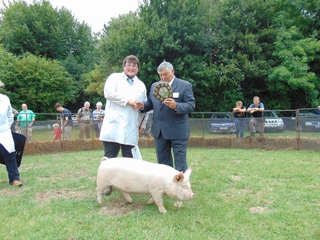
Posted by Tedfold – Oliver Giles and judge Bryan Card at Singleton Rare Breeds Show

