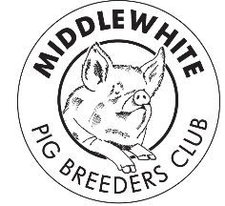
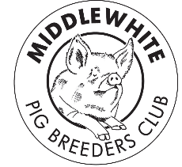
Middle White Pig
Breeders’ Club

Spring 2018

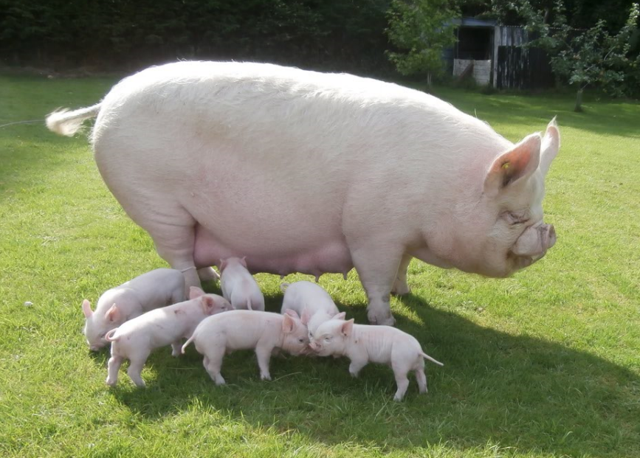

The start of another year!

Photo curtesy of Brian Merry

From your Chairman

Hi all

I hope you have all had a good Christmas (seems such a long time ago now) and New Year with some good January litters ready for the new showing season.

The AGM will be held this year at the Pointer Herd (more details below) they will show us around their farm in the morning which should be very interesting. Although the membership of the club stays fairly similar over time, with some leaving while new members join, we still get very few who will have a say in how the club is going so please come along to the AGM and have your say, if you don’t tell us we can’t change anything.

For those of you that show the schedules are coming through now so even if you only attend your local show get those Middles out there so everyone can see how wonderful they are, that’s our shop window! Rachael Wyllie is doing us the honour of judging the Champion of Champions at the Great Yorkshire Show this year so get qualifying.

I look forward to meeting you at the AGM in April.

Brian Merry

From your Secretary

This year’s AGM will be on the 29th April 2018 at 10:30am.

We will start at Lower Pointer Farm, Wootton Underwood, Aylesbury HP18 0RX where they will show us around their pigs and other livestock. Then we will head for ‘The Pointer’ at 27 Church St., Brill, Bucks, HP18 9RT, tables booked for 1pm. On a Sunday there is a choice of Longhorn beef £24 or Middle White pork £22 for a main course. I’m sure they can sort out a veg option if necessary.

The AGM will be after the meal with a start between 2pm and 2:30 pm. They have sorted a place for the AGM in the garden under a canopy or if it’s bad weather they will sort a substitute for us.

We have booked 15 spaces at ‘The Pointer’ we need to give them a precise number before April.

If you are interested in having the meal, please let me know as soon as possible. If you only want to attend the AGM, please also let me know so we can arrange seating.

Sarah Marsden

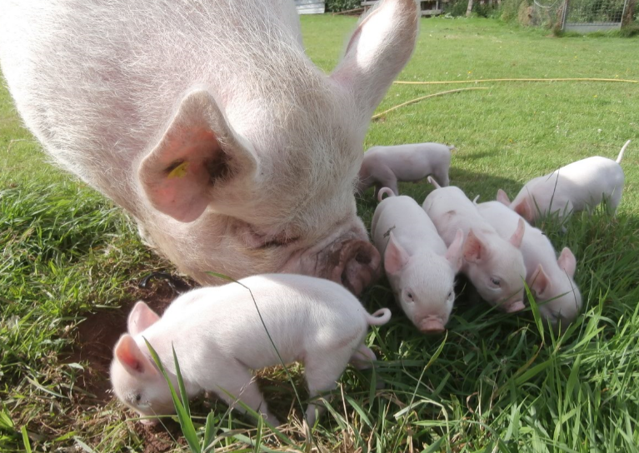
Recipe -

Taken from ‘Great Meat Recipes using traditional British Rare Breeds’ published in association with The Rare Breeds Survival Trust.

Middle White Pigs Liver in Spicy Cream Sauce

(Sorry it’s in imperial measurements)

Ingredients | Method
- 1lb pig’s liver, very thinly sliced  - 2 small onions, chopped  - 1 oz peeled and grated ginger  - 6 cloves garlic, crushed  - 2 fresh chillies, seeded and chopped  - ½ tsp chilli powder  - 1 tsp cumin seeds  - 1 tsp garam masala  - ¼ pt tomato juice  - ¼ pt single cream  - 4 tbls melted butter  - 2 tbls fresh coriander, chopped | Heat the butter in a heavy pan and fry the onions until soft and dark brown.  Add the garlic and ginger and cook for a further two minutes.  Add the chillies, chilli powder, cumin seeds and garam masala and cook for a few seconds before adding the liver.  Cook the liver for no more than 2 minutes.  Add the cream and stir well.  Adjust the seasoning and serve sprinkled with fresh, chopped coriander  This is a very rich dish so needs only a plain rice or bread to accompany. It is also a dish which many liver haters eat and enjoy.  Frances Kennedy  Shenstone
tsp – teaspoon pt - pint tbls - tablespoon

* If you have a favourite recipe you would like to share please send it to Sarah or Ann, contact details below-
Looking Back to Move Forward –

Editor:
Ann King
Pinehurst
Station Road
Delamere
Northwich
Cheshire CW8 2HZ

Tel. 01606 882201

ann_king0@talk21.com

Contact Us –
Breed Secretary:
Sarah Marsden
The Barn
Eaves Lane
Cheadle
Stoke-on-Trent ST10 1TL

Tel. 01538 750029
middlewhiteclub@hotmail.com

Now moving into the 1940’s with Bounty Polzeath 10th who was exhibited by the Grandfather of one of our current breeders Trisha Horsley, followed a year later by a one he had also bred, Fulford Joyful 8th. Trisha tells me the herd name changed to Acaster the following year, 1949.

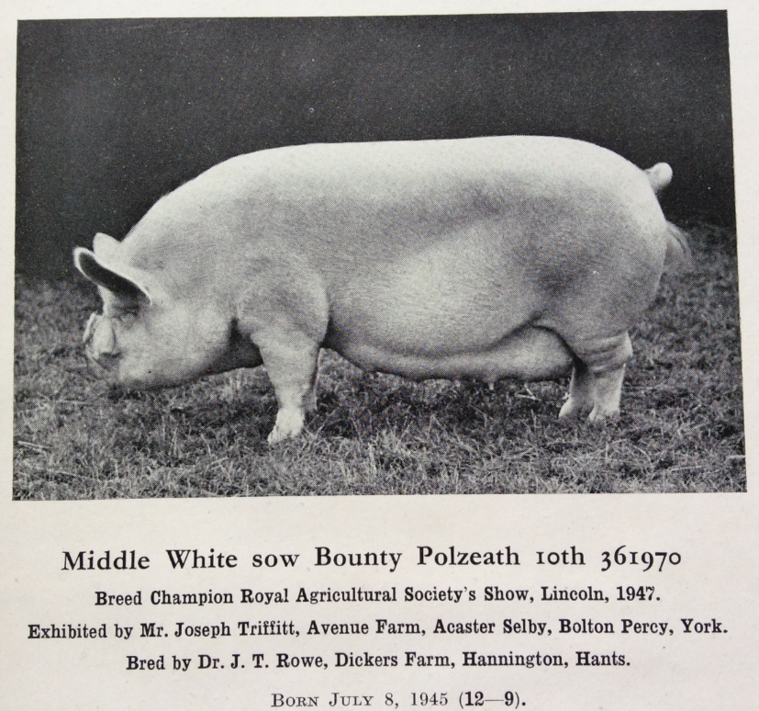

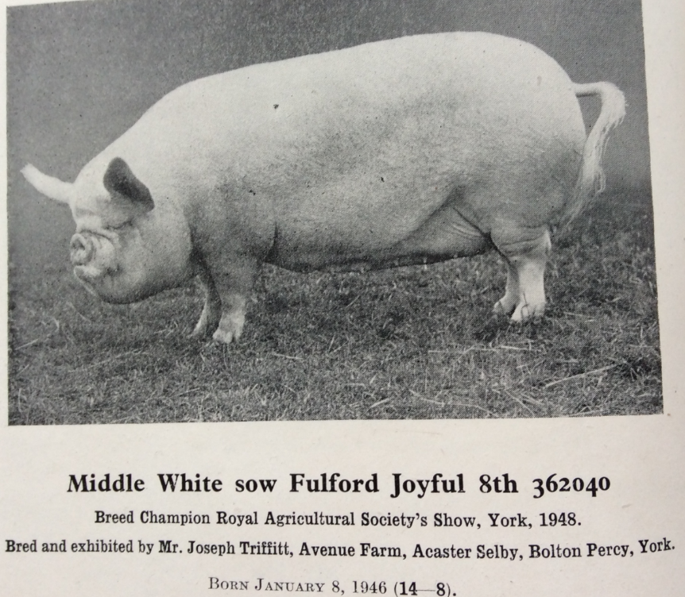

We will look to the 1950’s in the next issue.

If you have any old photos or snippets of history regarding our breed from either yourself or older breeders who are perhaps no longer with us, please send them to the editor (details on the previous page) so we can share them with the membership in future editions. It would be great to hear from you!

Ann King - Editor
The BPA Bloodline Survey for 2017

Members keeping this line |  | Line Name | Registered Sows with BN progeny |  | Registered Sows without BN progeny |  | Total Sows
2017 | 2016 |  | 2017 | 2016 | 2017 | 2016 | 2017 | 2016
16 | 18 | Alma Rose | 17 | 18 | 23 | 29 | 40 | 47
8 | 4 | Carnation | 8 | 5 | 19 | 19 | 27 | 24
10 | 9 | Dorothy | 8 | 4 | 14 | 19 | 22 | 23
33 | 31 | Fair Lady | 40 | 36 | 39 | 38 | 79 | 74
4 | 3 | Ladys Maid | 4 | 4 | 11 | 10 | 15 | 14
8 | 9 | Modiste | 6 | 8 | 18 | 21 | 24 | 29
5 | 3 | Purity | 4 | 1 | 18 | 15 | 22 | 16
9 | 13 | Silk | 5 | 10 | 21 | 23 | 26 | 33
22 | 22 | Woodlands Lady | 19 | 18 | 33 | 24 | 52 | 42
20 | 23 | Yootha | 22 | 19 | 32 | 27 | 54 | 46
 |  |  | 133 | 123 | 228 | 225 | 361 | 348
Members keeping this line |  | Line Name | Registered Boars
2017 | 2016 |  | 2017 | 2016
13 | 15 | Captain | 20 | 19
7 | 6 | Mischief | 11 | 8
10 | 12 | Rajah | 12 | 16
13 | 11 | Revival | 16 | 13
11 | 12 | Sovereign | 13 | 13
 |  |  | 72 | 69
Members with registered Middle White pigs |  |  | 77 | 83

This year’s survey has shown that the total number of sows has increased by 13 and the total
number of boars has increased by 3. Once again there are still more sows without BN progeny
than that of those with and I think we should keep an eye on this.
The three female lines that have had a drop this year are the Dorothy, Silk and Modiste the
others have had a slight increase with the Purity going up 6 and two new keepers with more
planned to be moved around later in the year which goes to show how important the survey is.
The Mischief boar line is vulnerable although we have seen a slight increase.
The number of breeders keeping Middle Whites has increased slightly but we still need to try
and encourage new breeders. We also need to be aware that as before a third of the total
number of sows are in one herd which could be a risk if we have a health scare in that area. It is
important that we carry on updating the survey whenever possible and work together for the sake
of our breed.
It is still vital that we carry on trying to spread the bloodlines around the country and this is going
well working together with other breeders.
Tracey Bretherton
A Little Reminder -

I have been asked to remind our showing members about etiquette in the showring, it’s not just the pigs that need to be clean – i.e.
- Clean white coats
- Clean boots or shoes, not wellingtons unless the stewards have given permission due to weather conditions
- Trousers not jeans
- Preferably shirt and tie

It has also been brought to our attention that some newer members may not be aware of some major faults which we should not be breeding from, for example –
- Extra dew claws
- Rose – along the spine or can be in a round shape above the tail, the hairs grow outward and it resembles a bald batch
- Crooked jaw, could lead to problems feeding
- Black spots, you wouldn’t expect black spots on a white pig any more than white spots on a black pig
Below: extra dew claw Below: an example of a rose, running along the spine.
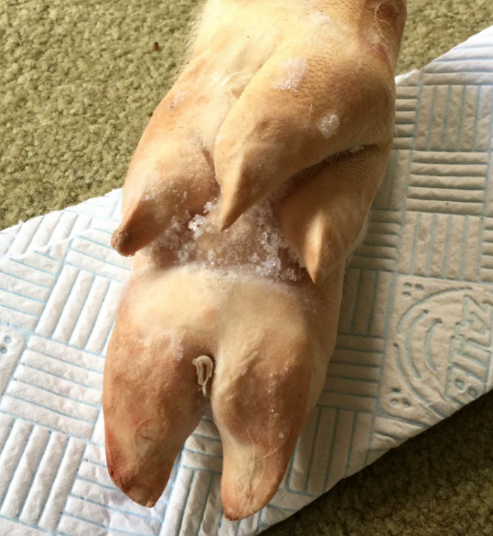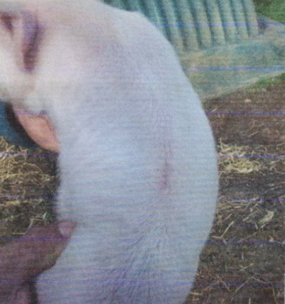
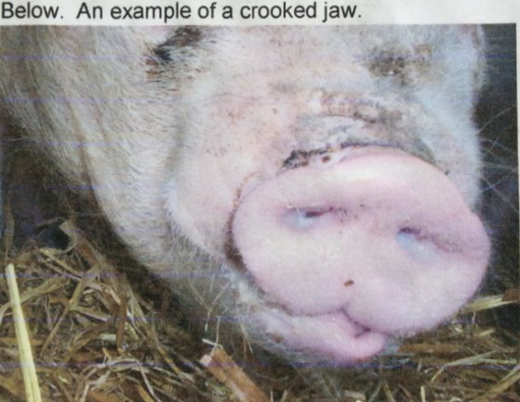

Middle White Pig Breeders’ Club A.G.M
---------------------------------------------------------------------------------------------------------------------------------------------------
Held at Home Farm Tatton Park Cheshire on 2nd April 2017
Meeting commenced at 14.10.
Members present;
B. Merry, A. King, S. Marsden, M. Paddock, E. Paddock, J. Lloyd, C. Pedley, O. Giles, B. Card, N. Pedley
Apologies for absence; R. Wylie, T. Bretherton, A. Westron, V. Mills, S. Groves
Minutes of the A.G.M held on the 24th April 2016
The minutes had been distributed in the newsletter. It was agreed these were accurate and were signed by B. Merry. There were no matters arising from the minutes.
Chairman’s report
B. Merry thanked all the members for the efforts put into the 25 years celebrations last year and reported that the buffet at the Great Yorkshire Show was a huge success with all the pig people present. M. Paddock interjected that this year there would be no BPA catering tent at the Great Yorkshire Show. The pig of the year lunch will now become a barbeque in the evening.
Secretary report.
Sarah Marsden also thanked people for last year’s effort but also asked for more ideas to get more Club members active in both showing and promoting Middle Whites.
Treasurers report
A. King presented the accounts which had been circulated at the start of the meeting. A loss of £213 for the year was explained as money spent on the 25 year celebrations. This was less than the £500 agreed by the committee had agree could be lost. These were passed.
Election of officers and committee
President.
C. Pedley was asked if he was willing to continue, he replied he was, so was elected unopposed.
Chairman. B. Card proposed by B. Merry, seconded by J. Lloyd agreed unanimously.
Vice chairman. B. Merry proposed by B. Card seconded J. Lloyd agreed unanimously.
Secretary. A. King proposed by S. Marsden seconded by J. Lloyd agreed unanimously.
Treasurer. B. Card proposed by A. King seconded M. Paddock agreed unanimously.
Committee.
R. Wylie resigned, O. Giles was asked to be a replacement but declined due to student studies. E. Paddock, M. Paddock and J. Lloyd to continue.
Presentation of trophies
All but one of the trophies were available for presentation.
The Joan Staig Memorial Trophy (Middle White Champion) B. Merry with Pinehurst Alma Rose 11
Marshlands Cup (Opposite sex to the champion) M. Paddock and S. Marsden with Eaves Captain 5.
The Rose Bowl (January boar) O. Giles with Tedfold captain 72 and Caroline Dunstan with Nancenoy Sovereign 3.
The W. H. Hill Plate (January gilt) O. Giles with Tedfold Fair Lady 75.
The July Trophy (July gilt) B. Merry with Pinehurst Alma Rose 11
The Gillhouse Novice Cup (Club member who has never won any of the above Middle White trophies) Steffanie Georgetti
The Miranda Squire Plate (non-BPA shows) Brian Merry
Club website
E. Paddock asked for photographs to add to the ones already received. The site has cost more this year despite the removal of the calendar which is now an extra cost. The domain names have been secured for now. J. Lloyd asked if pigs for sale would be removed after a time as some seem to be on forever. It was suggested a date will be put on so people will know how long the adverts have been up.
Any other business
W. Gregory has been asked to Judge the Champion of Champions at the Great Yorkshire Show this year and has accepted. The meeting agreed to repeat the wildcard system. Spoons to be given to qualifying pigs that attend only.
New leaflets have been ordered and will be distributed when available.
M. Bates of the BPA had asked to talk to the AGM about conservation planning but it was thought that the Great Yorkshire Show was a better venue as more breeders attend this event.
The Clubs constitution to have a update to more modern language and a tightening of receives and residual money on the Club closure.
The Spring Welsh Show has asked if the Club would like a stand at the show. This was considered to be worth repeating from last year. B. Merry and A. King will be showing at the show and will man the stand. M. Paddock and S. Marsden offered to help also.
S. Marsden reported that the Miranda Squire Plate was not working under the current system as there were only 4 entries this year. She suggested using the plate for the July boar. O. Giles suggested a herdsman competition similar to the one run by the BPA for the British Saddlebacks. It was decided to us the Plate for the July boar this year and to monitor how popular this was.
S. Marsden asked if anyone was willing to take over the writing of the newsletter from her. B. card and B. Merry agreed to do this. S. Marsden agreed to continue to print and distribute the newsletter.
The Champion of Champions to be held at G. Y. S in 2017 but the members were asked to put forward a venue for 2018 preferably in the south of the country. The Champion of Champions to be held at the Great Yorkshire Show in 2018 but other venues to be considered in future.
T. Bretherton asked if the club would sponsor a team at this year’s Show Stars. The meeting decided that as the club has no young people eligible to take part it was not a good use of £100.
T. Bretherton also asked if it was feasible to start a separate fund solely for conservation purposes. The meeting decided this was not necessary at present at the club has good financial reserves.
The current pop ups are with O. Giles, A. King and S. Marsden. T. Bretherton asked for a pop up for the smaller shows expressing the rarity of the Middle White pigs and encouraging donations and joining of the club. This was agreed.
No new T-shirts to be produced this year as 7 left form last year, 5 large, 1 medium and 1 small. As we will have a stand at Spring Welsh to try to sell them there.
S. Marsden asked about a return to presenting glasses to show winners. It was agreed to get a price first.
J. Lloyd asked about a club tie. B. Merry to find a price.
Next year’s A.G.M. provisionally set for the 15th April at Pointer Farm Buckinghamshire.
B. Merry thanked everyone for attending and the meeting closed at 15.20.

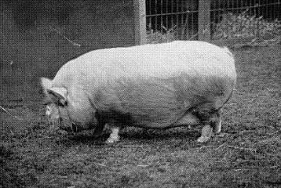
Sorry I don’t have any background information for this photo but thought it might be of interest, look how deep in the body she is!!

