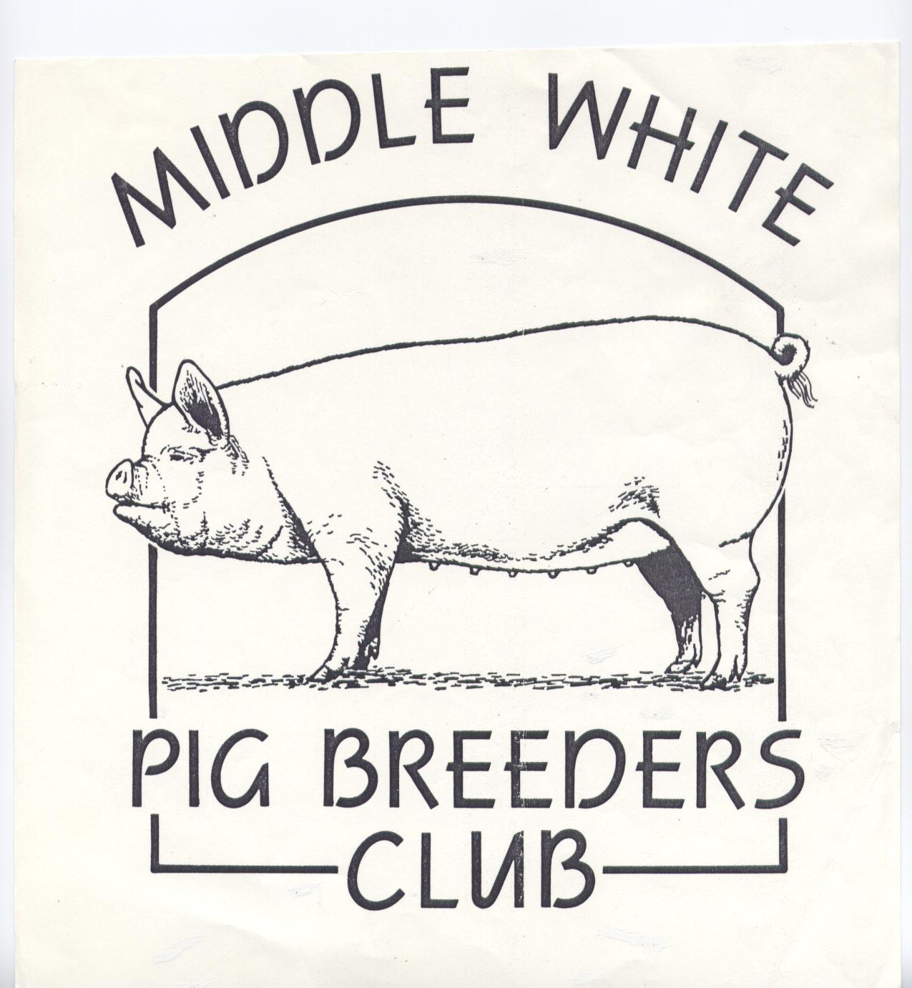

MIDDLE WHITE
PIG BREEDERS CLUB

(PATRON: ANTONY WORRALL THOMPSON)



NEWSLETTER
WINTER 2004

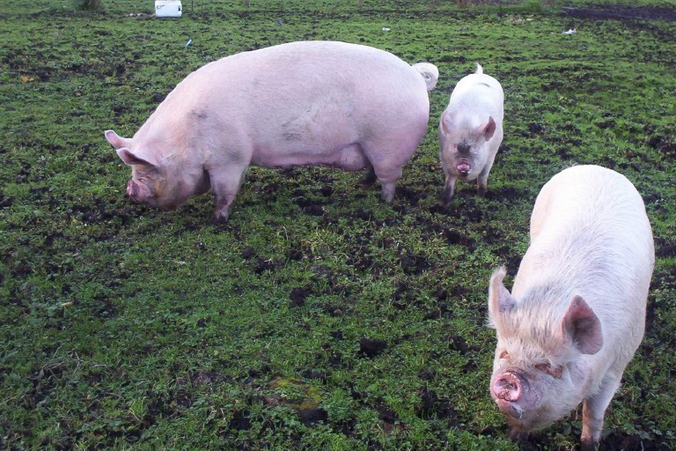
Photo courtesy of Tracey Bretherton

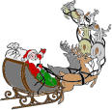



OVER 150 YEARS OF THE MIDDLEWHITE

 |  |  | 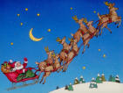

Letters from some of our younger members

Hello, we are Edward and Aimee Wilson and we are 11 and 12 years of age. We want to tell you about our three Middle White pigs .We have always enjoyed helping out on the family farm and this summer decided to get a few pigs to fill some of the sties which were standing empty. We saw Middle Whites at Great Eccleston Show and thought these would be a good breed to have. A few weeks later we bought two sows and one boar from Tracey and Ian Bretherton. They are called Betsy, Bella and Basil.

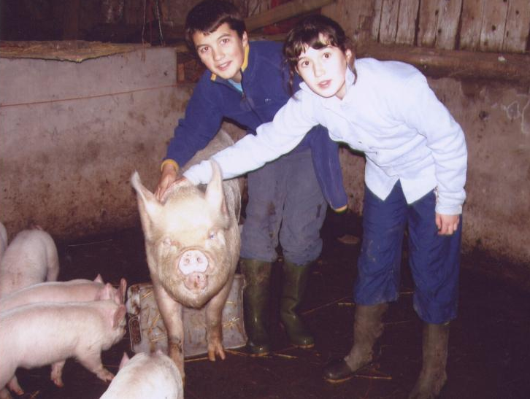

To our delight Betsy had 8 piglets on 15th of October. Along with our cousins we watched the birth and kept Betsy happy by feeding her bananas. Our little cousin said it was the most exciting day of his life! A few weeks later, 10th November, Bella had 7 little piglets in the middle of the night. We try to take the pigs out each day even though they usually escape and are always found getting up to some mischief around the farm! Basil’s favourite thing is being rubbed with a sponge and eating bananas! He has a big personality and is so funny.
They are great pets and are the star attraction of the farm. Everyone loves coming to see them.
Left: Edward and Aimee give one of the new mothers some much appreciated attention.

Melissa Herbert writes;
October 26th was a very exciting night for me as my sow Dappleheath Fair Lady 5th gave birth to her second litter of pigs by Dappleheath Sovereign 6th. I wasn’t able to see the first litter of pigs be born but was determined to see the second. She began to farrow at around half past ten on a very wet, windy and cold night. I wrapped up warm knowing that I could be out there for a long time. I stayed out at the pigpen until I was sure she had finished farrowing which was about half past twelve. She had a total of eight piglets but unfortunately 2 were born dead As you can see from the photograph the remaining six

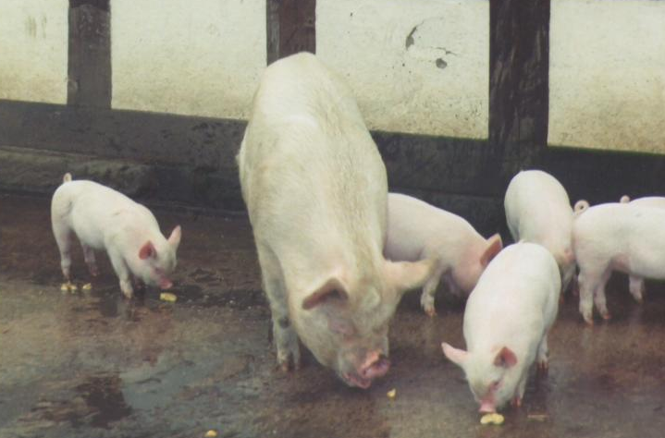

2
are doing well. This is obviously down to the fact that she is eating nine pounds of meal a day so she can feed them. The piglets love running round the yard wallowing in the mud and ferreting around for pieces of apple. They also have become very tame and like nibbling my Wellingtons.

Left: Dappleheath Fair Lady 5th with her second litter.

A MESSAGE FROM OUR PATRON
Another year has flown by and it is time for me to write a few words as patron of the M.W.P.B.C.
It has been another extremely busy year for us, with the opening of another restaurant, Kew Grill in London. Which in turn means more small porkers to produce, as pork is a very popular dish with our clientele.
Once again the Hatfield Show was the only event I could attend, (though we were at the Royal Show for a cooking demonstration), after filming Saturday Kitchen, a live TV show, in the morning.
Unfortunately my sow was beaten down into third place this year – I had wanted to beat Geoff Parker, but it was not to be. Dinner, as she is known at home, is getting on a bit now, though aging gracefully and still producing good litters.
My thanks to Mary Card for bathing and showing her on the day, and to Duncan Staig for the transport, with my Stockman Billy’s Lop sow. This was Billy’s first time at anything like this and he and his brother in law Steve (co owner) and their families thoroughly enjoyed themselves. They hadn’t known what to expect and were nervous, but thanks to the friendliness and help of all the piggy people they managed.
Jay joins me in wishing you all a Merry Christmas and a good crop of January piglets.
Antony Worrall Thompson
Kew Grill - 10b Kew Green Richmond Surrey
TW9 3BH, telephone 020 8948 4433
PRESIDENT’S LETTER

It’s that time of the year again when we look back on the year just ending and look forward to the year ahead.
Once again we have to congratulate Geoff Parker and John Herbert on their outstanding 2004 show season. I do hope that in 2005 more of our members will support the shows, especially those that stage Middle White classes. The show ring is still, by far, our best shop window and at the same time can be great fun.

Miranda often tells me that she has had members and prospective members, from all parts of the country, wanting to buy in-pig gilts. She also tells me how difficult it is to find them. May I suggest that some of our members hold back one or two gilts more than they need for their own herd replacements. I feel that unless more pedigree breeding stock is available for sale our breed will stagnate.

Now that more people appreciate just how good Middle White pork can taste, it would be a shame if supplies are limited to the few regions of the country where Middle Whites are now kept.

May I wish you all a very happy Christmas and a prize winning new year.

Jack Howlett

3

 |  |  |  | CHAIRMAN’S LETTER
Dear Members,
My first job is to apologise to you all for the absence of a Chairman’s message in the last newsletter, that is of course if you noticed. All down to the fact that I’m afraid I had a bit of a tantrum about something I passionately believe in and threw all my toys out of my pram! Sorry. I don’t feel quite so guilty about it anymore though since I heard the remark “Quite right too, if you didn’t the pram would get far too heavy!”
Anyway, enough about that, I would just like to say “Welcome” to all our new junior members, it’s very reassuring to know that the younger generation are taking an interest in the conservation of our favourite traditional breed, but, a word of caution “Remember, a pig is not just for showing”.

Those of you that do show will be, I’m sure, very interested to hear that from 2005 there will be a “Young Pig of The Year” competition, open only to pigs born in the year of the show, in addition to the ‘Pig of the Year’ competition. The final for the “Young Pig of the Year” competition will be held at the Hatfield Show, and further details will be published in our next newsletter. Good Luck with all your January farrowings everyone!
I have asked Miranda to include in this newsletter a very favourite recipe of mine for your Christmas Gammon, I know Middles are maybe not your first choice for Bacon Pigs but they are ‘The Premier Pork Pig’ and as far as I’m concerned it’s a case of ‘Horses for Courses’.
It just remains for me to say “A very Happy Christmas and a prosperous and successful New Year to all our Breeders and Readers”.

 |  |  |  |  | “Best regards”,  Mary Card  Chairman  MWPBC

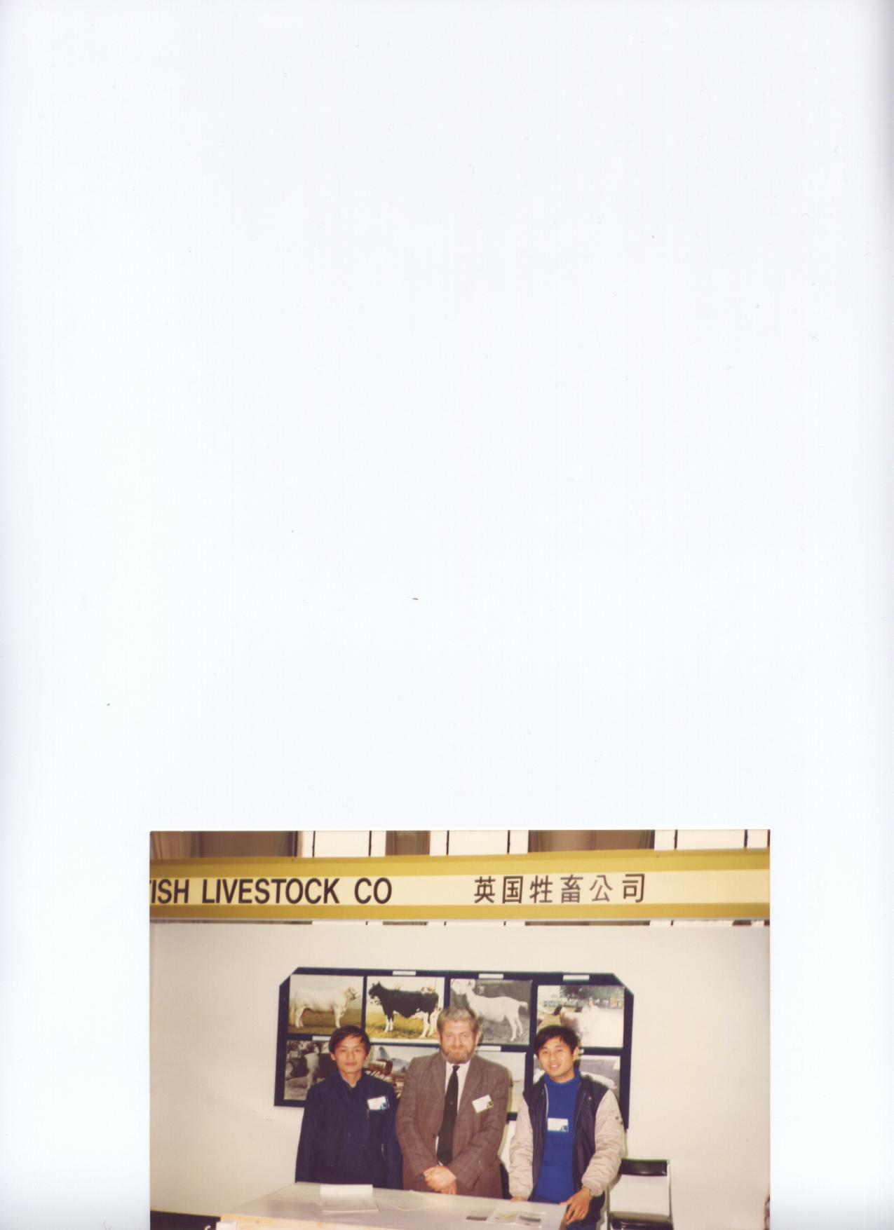

Left: At the Beijing International Show.

Centre is MWPBC President Jack Howlett, on his left is “The Interpreter” and on his right is “The Explainer”.

See Jack’s article later in this edition.



ANNUAL GENERAL MEETING
Advance notice of our next AGM is hereby given. This will be held on 17th April 2005, and will take place in the British Charolais Cattle building, at the Royal Agricultural Society Showground at Stoneleigh. Our meeting will be held in the morning, and will be followed by a joint lunch with the Large Black Club who are once again sharing the venue with us and are holding their AGM in the afternoon.

Catering will be by Christine Vaughan, so it will be well worth going just for that! Final confirmation of date, time and location and cost of lunch will be included in the Spring newsletter.
4
SUBSCRIPTIONS – DUE 1ST JANUARY 2005

Stop a visit from this old hag by paying up promptly

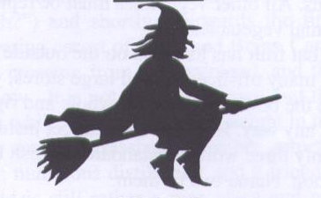

Once again it is time for the Old Witch to squeeze your hard earned cash out of you. If there is a form enclosed with this newsletter then you need to renew now. At the AGM it was decided to increase the subscription to £15.00, as the old price was barely covering the cost of newsletters and postage. I look forward to hearing from you shortly.

All those of you who pay by standing order had a form sent to you in October, with the Autumn Newsletter, to complete and send to your bank to increase the rate to £15.00.

When I get the January bank statement I will be able to check and if you have not instructed your bank to increase the rate I will be in touch.

PLEASE do try and cut down my workload and the unnecessary cost to the club of a stamp or phone call and ensure that you have increased your standing order, or that your cheque is sent promptly. Thank you.

SECRETARY’S NOTES

Hi there,

Well the time to put pen to paper has arrived again, how time flies when you’re busy and I
The wintery weather has now arrived with all the extra work to be done outside and less time to do it in daylight. Fortunately down here in the South we have had only one really sharp frost which finished off the summer bedding, but none of the snow, just some very raw dreary days.

Most of you won’t know that back in October Mary Card was feeding her horse when something spooked him and he spun round and knocked her over and managed to tread on her back, leaving a lovely hoof print! It also left her with multi fractures of ribs and pelvis. Mary was very shaken and has been in a lot of pain, it all hasn’t helped her osteoporosis.
Not being able to move around, sit, stand, lie or whatever without being in pain has left her being very frustrated. She is, I am pleased to report, on the mend (after liberal doses of pain killers and alcohol – but not together!) and looking forward to being able to get out and about next year. I’m sure that you will all join me in wishing her well and a speedy recovery.

Jack Howlett was telling me the other day of a remedy for cold hands. When he had the butchers shop they used to go in the morning and put their hands in the pickle pot, kept in the back of the fridge for the salt beef. This gave you the “hot aches” for a while but once worn off you didn’t get cold hands all day. I think I’ll pass on that one!

Apologies for the incorrect spelling of obituary in the last newsletter, it was the typist NOT Jack who
5
got it wrong, and we failed to spot it in the proof reading.

Jack has asked me to mention the pigs at Smithfield. For the first time for many years The Smithfield Club had live pigs in a presentation. All breeds of pigs were represented by a pair of gilts born July/August. Jack was very impressed by the quality of pigs on display.

Elsewhere you will see another puzzle from John Herbert, not a wordsearch, something a little more taxing to try after a few mince pies. We have the answer (in a sealed envelope). Though both Andrew and I did it independently and got the same answers, though we didn’t need to use all the grids. Anyway a bit of fun we hope and to make it even more interesting there is a small prize for the first correct entry sent by post and drawn out of the hat after 30th Jan 2005. This will give you a chance to include your subs!! Thanks to John for his efforts in doing these puzzles. Has anyone else got any ideas for something similar?

Did any of you see a recent article in one of the papers about a certain supermarket selling pork pumped with water for more than their standard chops. They said that they add the water to stop the meat becoming tough after cooking! I feel they need to buy some proper porkers that are full of flavour and definitely NOT tough after cooking. I don’t know if the meat was of British origin or not. We need to push our traditional breeds more. I think the message is getting through to some people, with more Farmers’ Markets and butchers becoming more aware with more people asking for it.

It was heard by my brother at a recently attended AGM for another club that there wasn’t much in the monthly newsletter. It was pointed out to the person complaining that newsletters are only as good as the articles sent in by members. The same applies to this newsletter. So PLEASE if you have an interesting story or anecdote to tell or an article inside you, and they say there is a book in everyone of us, then don’t keep it to yourself, send it in for all to share. Relevant snippets from the press, with contact details of the publisher if possible, are always welcome.

Thank you to three of our younger members have again written something for this issue, so I think the onus is on you, Sophie, Ben and Taldo for something for the Spring issue.

I will close by wishing you all a very Merry Christmas and a Happy New Year.

Miranda Squire

SHOW NEWS
The last show of the season was the R.B.S.T. East of England Support Group’s Autumn Show on October 10th. The Judge was Mr J. Milland. With only two Middle Whites forward in the white classes H.M.P. North Sea Camp’s Colony Frieston Carnation 42nd was placed 4th, behind a Lop and two Large whites, in the gilt born after 1st September class. Sarah Kiddy’s Cestrian Revival 14th beat the Lop in the January boar class and went on to be Champion Male, Middle White and best pig of opposite sex to the Champion.

Mary Card told me an amusing tale recently, while she was suffering with her cracked ribs.
As she is not able to do anything much while laid up, Bryan has had to shut the chickens up for the night. Every evening he had been having problems with the Marsh Daisy Cockerels, with them running around the hut or flying up into the tree to roost. This particular night, being frustrated by the usual problem he managed to catch one. Coming in later than usual he said to Mary he had caught one, and was just about to put it in the hut when he thought, I’ll have the same problem tomorrow night, “so I’ve rung its neck and plucked it”. Revenge was sweet, the next day “he tasted delicious!” said Mary.
Miranda

6
www.middle-white-pig-breeders-club.co.uk

Club Chairman Mary Card writes:

Did you know we have a website for the Middle Whites?

Well we have a website address – which is a start. But we really need some help putting a site together.

The other breeds are leaving us behind – you can all click onto www.largeblackpigs.co.uk and find out the latest breed survey results or if you are interested in buying an Oxford Sandy and Black you can see what’s for sale on www.oxfordsandypigs.co.uk, you can browse through www.berkshirepigs.org.uk and see who the winners were at the last show or ask fellow Old Spots breeders for advice on the noticeboard of www.oldspots.com. We don’t want the rest to think we Middlewhiters are technical dinosaurs so if you’ve got any experience at all in creating a straightforward website I’d be really pleased to hear from you.

There is a small budget for getting the site off the ground and once up and running it will be a great forum for promoting the breed and keeping everyone up to date with Middle-White news and of course the BPA will provide a link from their site to direct any interested parties in our direction.

Do get in touch either by phone on 01725 552 651 or email me on muthwestham@tesco.net

------------------------------

Mary’s Recipe for Cider Bacon
INGREDIENTS

Joint of Gammon or Boiling Bacon
Dry Cider + or- 1 Litre
About a Dozen Whole Black Peppercorns
2 or 3 Carrots
2 or3 sticks Celery
1 small Swede or Turnip
1 Large onion
1 Teaspoon mixed dried Herbs

METHOD
Put the Joint in a saucepan and cover with cold water, leave to soak overnight
Bring to the boil, boil for about 10 mins and then strain off all the water
Peel and chop carrots and Swede into 1-inch cubes and add to pan
Peel and dice Onion and chop Celery
Add to pan with peppercorns and Mixed Herbs
Add enough of a mixture of ½ and ½ cold water and Cider to completely cover Bacon
Cook in the usual way; 20 mins per LB + 20mins extra at a gentle simmer
Remove joint and strain liquid through a sieve into a jug or bowl and save
Use this liquor ½ and ½ with milk to make a white sauce to accompany the Bacon
The chopped vegetables can be served with the bacon but remove the peppercorns first.
Enjoy!

7

PEDIGREE LINK UP CREATED BY BPA
Reproduced by kind permission of Farmers Weekly
By Jonathan Long
A WEBSITE linking butchers and small retailers with pig producers was launched by the British Pig Association at Smithfield.
The site will enable local high street and family butchers to go online and locate traditional breed pigs of the right breed and age for their needs, said BPA chief executive Marcus Bates. “All pedigree breeders have surplus stock to sell for meat and many butchers want to buy this meat.
“The difficult part has always been linking the two together. With the website, butchers will be able to key in their location and find breeders in their area with pigs of the right age to kill.”
The website will use information entered into the BPA’s pedigree database. “We record the birth date of every pedigree pig under our auspices, so all we’re doing is making this
information available to potential customers,” said Mr Bates.
He hopes the initiative - funded by a grant from BPEX - will also help maintain, and possibly increase, pedigree pig prices. “By providing more opportunities for breeders to sell surplus stock, they will gain a better return and be less tempted to sell them as breeding animals.
“In time, we hope the website will become a tool for pedigree pig sales between breeders. Consumers can also benefit by finding out which butchers or other outlets, such as farmers’ markets, are selling traditional-breed pork in their area.”
The whole idea is to reconnect the supply chain to allow producers, butchers and consumers to work together for a better future, he added.

Niche market develops as traditional pig breeds attract fresh interest
Reproduced by kind permission of Farmers Weekly
By Jessica Buss
FANCY KEEPING a few pedigree breeding pigs? If you do you will be among a growing number of pedigree enthusiasts, according to the British Pig Association.
The association’s Marcus Bates says 200 new members have joined the BPA, which covers all the traditional breeds, this year, taking membership to 800. The niche market for traditional breeds is developing, he explains.
Some are small hobby-sized units, but family-sized pedigree pig units are being re-established too. “They are finding a market for traditional breed meat, so are building herds back up to the 60-sow plus level.”
Part of the reason pedigree pig breeding has become more practical is the ease of Al and availability of semen. The BPA’s Traditional Breeds Al Scheme is run by Robert Overend of Deerpark Pedigree Pigs in Northern Ireland.
Mr Overend says legally any pig owner can AI their own sows. “We have trained people of 12 to do it, but they must be experienced with the pigs to consider this.
“Pig Al is simple, as unlike cattle you don’t have to put your arm in.” It is preferable for people to take a half day course. However, an experienced pig keeper could show them, he adds.
Semen can only be bought from a licensed Al station. Mr Overend supplies semen from Berkshire. British Lop, Gloucester Old Spot, Large Black, Middle White and Tamworth pigs at present.
“But to get the boar you want order semen when you wean sows, five days before it’s needed.”
Because this is supplied fresh, storage once it’s delivered to the pig keeper is vital, says Mr Overend. When stored well it should last 3- 5 days, possibly up to eight days. It must be kept at 15-20C, normal room temperature.
“When semen is stored correctly and Al done properly, conception should be as good as for natural service.” Normally sows are inseminated twice, depending on how long they remain on heat. They should come on heat five days after weaning, but sows vary so check them often around this time to see when they are standing, he advises.
To ensure a strong heat, he recommends applying pheromone spray on a piece of wood, wooden door or gatepost, rather than spraying it around the sow’s head. “Wood will hold the scent and attract the sow, helping keep her still when inseminating her.”
8

Jack Howlett continues with more tales of his exploits in:-

EXPORTING LIVESTOCK TO THE PEOPLES REPUBLIC OF CHINA (Part 2)

The air freighting of sheep described in my last letter was successful and was the breakthrough we had been waiting for. We were able to reduce our prices as there were savings to be made, in the overall freight charge, crate making and a reduced insurance premium, together with savings for stock attendants and feed during shipment.

We had already used chartered aircraft for shipment to the Philippines, Malaysia and Taiwan, so the procedure was not entirely new to us.

The Chinese were soon wanting more sheep, Border Leicesters seemed to be their choice once again. The Secretary of the Border Leicester Sheep Breeders Association, Mr Alex Bryson, wanted more of his members involved in the export and suggested that Breeders wanting to be included should take suitable sheep to Lanark Market in order that the Chinese could select.

We arrived in Lanark early evening, the day before the arranged day of selection. I asked the Group if they wished to have dinner in the hotel or whether I should look for a Chinese restaurant. Much to my surprise they opted for western food in the hotel. During the meal I asked if they were enjoying eating British food and one of them replied that he thought it was rubbish and that he could not wait to return to China in order that he could drink mares milk.

More than 60 breeders from all over Scotland and northern England brought more than 400 head to Lanark market and the Chinese started their selection and were accepting approximately 80% of the sheep offered. All went well until about half an hour after lunch, when the Chinese started to reject sheep at an alarming rate and said that they were too tired to continue and that they would complete selection the next day.

We then had several breeders asking if the Chinese would look at their sheep as they had travelled 150 miles or more to be there. We did persuade the Chinese to look at two further groups and they promptly rejected them. So the breeders had two choices, to stay overnight or withdraw their sheep. The breeders were, quite naturally, upset. The good idea of the Association started off so well but the Chinese attitude rather spoilt it.

As always the Chinese interpreter was very good and could understand the situation. However, the so called sheep experts were very difficult. They came from the extreme north east of China, a very embarrassed interpreter told me that the region they came from was very remote and almost uncivilised.

Over breakfast next morning as our visitors spread marmalade on their sausages and put salt and pepper in their coffee I stressed the importance of completing the selection as soon as possible as it was a very long drive back to London. The Chinese were in a more co-operative mood, having found an acceptable Chinese restaurant in Lanark the night before.

Selection was completed by lunchtime and I was all ready for the drive south. The Chinese then decided that the restaurant the night before was so good that they would stay in Scotland another night. Needless to say I was not best pleased, but you know the old saying, “the customer is always right” – but I do wonder sometimes!

9

I told the group that we would leave the hotel at 7am next morning and that we would drive non-stop to the south. Soon after leaving Lanark the exhaust on my car blew and as we raced down the M6 and M1 it sounded like a tractor. It was a Saturday so not much traffic and we reached our office in north Hertfordshire at 1.30pm and a colleague volunteered to take the Chinese party on into London.

The selected sheep stayed on at Lanark market, the auctioneers having agreed that the pre-export quarantine could be completed there.

Alex Morton, our vet, had blood tested the sheep almost as soon as they were selected. Alex was by this time the only local veterinary inspector (L.V.I.) with a roving licence which meant that he was approved by MAFF to test and certify stock in any part of the country. This was rather a different MAFF attitude compared to the scolding Alex and I had received having negotiated the Russian protocols a few months earlier!!

Goats also were included in this shipment and we had been lucky for some years in having a wonderful lady from Suffolk to help with goat selection, she was Mrs Pam Carter, who knew every goat keeper in the country and most of the goats as well. Most of the holdings with goats were very small and to put together a group of any size meant goats being purchased from a large number of breeders and then put together for the Chinese approval.

It was during the preparation of this goat shipment that I got myself into BIG trouble. A circular letter regarding vet testing etc. was sent to all breeders involved and my secretary had headed the letter “Nanny Goats for export to China”. I can not remember signing the letter or whether my secretary signed it on my behalf, but a few days later one lady from the West Country replied to this letter complaining that proper goat people never referred to their goats as “Nanny or Billy” and she went on to give me a lesson in goat terminology. The letter, which I will never forget went something like this.

“Dear Mr Howlett,

Goats for export to China

I thank you for your letter of the 7th and was very shocked that you referred to female goats as “Nannies”, this is an expression never used by genuine goat keepers.
For your information and for your future reference –
Goats up to 12 months of age are called Kids.
Goats 12 months to two years of age are called Goatlings.
Goats over two years of age that have given birth to a kid are called “Females”.

Please remember this for the future.

Yours sincerely,

P.S. On our farm we also keep Moo Cows, Ba Lambs, Gee Gees and Goosey Goosey Ganders”

Funnily enough about that time we had a lady working in our accounts office who kept goats as a hobby and had a husband named Bill, and when she talked about Bill we were never quite sure if she was referring to her husband or her stud goat!!

I had never had a lot to do with “Billy” goats in large numbers until this shipment and never realised just how foul they smelt, they also had some of the most disgusting habits, that I would rather not talk about!

10
The next Chinese delegation came for pigs and we noticed that an extra blood test was being called for. The Chinese Commercial Embassy was at that time in Blackheath, South East London. This was before the M25 was completed and was a difficult area to visit.

At our first meeting the Chinese said that they required a blood test for Toxoplasmosis. I explained to them that MAFF had agreed in the past, for pigs being exported to Japan to have this blood test. However the antigen used for the test was imported from Japan on a special licence as it was unknown in this country. We told the Chinese that we would make enquiries as to whether the antigen was still made in Japan and if it could be used on pigs being exported to China.

The Chinese said that they could not agree to this as Japan was not a friendly country to China, We now were in a deadlock situation and I arranged for a further meeting with a senior vet from MAFF Headquarters to take place.

MAFF was represented by John Cross, a Regional Veterinary Officer and again we went through any procedure we could in order to comply with their request. After about 4 hours and 12 gallons of cold China tea the head of the group said “what would you say if we told you that we have brought the antigen called Toxoplasmin with us”. John Cross’s head almost hit the roof as this was obviously an illegal import and could put all UK farm livestock at risk.

John Cross then said “can we see it?” Several of the Chinese left the room and more Chinese tea was served. John said to me “we are in a rather difficult situation”, without the antigen being thoroughly tested in this country, in no way could it be used, also as it was in the Chinese Embassy it could not be confiscated as Embassies are regarded as foreign territory.

A wooden box was then produced and when it was opened there were 12 unmarked bottles. This made the matter even more serious as nobody officially knew what the bottles contained.

The meeting ended, the Chinese returned to China. What happened to the illegal import of Toxoplasmin I do not know. The Chinese never asked for this blood test again!

This incident could well have led to a serious breakdown in the nation’s animal health status.

The next step in the China story was an International Agricultural show in Beijing. This show had the full support of the British Government. Twenty U.K. companies exhibited and were supported by the Minister of Agriculture, Michael Jopling, (now Sir Michael), the Chairman of B.A.E.C., Earl Ferris, and MAFF chief vet Howard Rees. They were probably the most important group ever to represent British agriculture at an overseas exhibition.

We notified CABS of our participation and asked for a meeting during the show to try to heal some of the damage done during their previous visit to the UK, CABS acknowledged our invitation and agreed to meet us during the show.

This was to be my first of many visits to mainland China. Several friends of mine told me that I must visit “The Forbidden City”, that was to be found in the centre of Beijing. So on the Sunday afternoon I took a taxi and along with thousands of Chinese families wandered through this very famous landmark. To be honest I was very disappointed, I expected to find buildings that were very old, but instead the whole place was made up of replicas and models, each with a plaque with a description in Chinese and English stating that the exhibit was an exact replica of the original and was built in,say,1920.

The exit from the “Forbidden City” takes one direct into “Tiananmen Square” and over the exit gate
there was an enormous portrait of Chairman Mao. The square was, on this Sunday afternoon, full of families and individuals flying kites, which I was told was a popular pastime. The scene
11
was quite tranquil and little could one imagine that within four years there would be massive bloodshed during the student revolt in this same square.

You will remember that the revolt was put down by the Chinese military and that an unknown number of students lost their lives fighting for human rights. However this was a turning point in modern Chinese history and the very harsh human rights restrictions were gradually relaxed.

At the show we had delegations from many Chinese provinces and each in turn said they wanted to import Genetically Improved pigs. We told them we would be prepared to offer quotations. However we had been instructed that all imports had to be through CABS, each province was quite adamant that they now had autonomy and could import independently.

On the first day of the show we were allocated 2 students, one to act as an interpreter and the other called himself an “explainer”. They were both friendly and well mannered young men and very helpful. “The explainer’s” English was not too good but he had an agricultural background and could talk to prospective buyers with far more authority than the average interpreter. We had been told not, under any circumstances, to give tips or presents to the students. They were so good that I was quite determined to reward them. I went to the main shopping centre to find some gifts, this proved to be a waste of time as there was nothing in the shops at the time that would have been suitable.

One day at the show a young girl came to our stand and the boys told me that she was a classmate and that she wanted to talk to me in English. She said her name was “Little Peach” and that she was called “Little Peach” as she was “so pretty”. I did not think that “Little Peach” was particularly appropriate, although she was very sweet.

Other visitors to our stand included a group from Inner Mongolia that had visited our company in the UK to study embryo transplant and the freezing of embryos. The refrigeration equipment for this practice is very technical and expensive. The group told us that Inner Mongolia could not afford the equipment and so they improvised by hanging a test tube containing the embryo with a piece of string to the hand of a clock in order that the embryo was gradually lowered into a tank of liquid nitrogen – needless to say it did not work!

Despite the large number of interested groups we had visit our stand, up to lunchtime of the last day of the show, no sign of CABS! This was a disappointment as they were still our best chance of substantial business.

After lunch the CABS group arrived and invited us to a party that night, they also wanted a meeting, not at the show but in my hotel room. This was arranged for 8 am the following morning.

The group again was led by Mr Li Juxing and he apologised for the “Toxoplasmosis” fiasco and said that he knew nothing about it until the group returned to China without pigs or a contract. Mr Li Juxing said that it was the idea of one of the selectors from a remote province who also provided the unmarked bottles.

Mr Li had no idea how the bottles managed to get as far as the Chinese Embassy in London.

I told him how seriously the British MAFF had reacted and he promised that it would never happen again.

By 11.30am that morning we had agreed a contract for the supply of 500 plus pigs and the possibility of a further 200 dairy goats.

Jack Howlett.
12
BRITISH PIG ASSOCIATION
November 2004
Traditional Breed Pigs can get PMWS
Herd Health and Biosecurity Courses to start this month

Earlier this year two cases of Post-weaning Multisytemic Wasting Syndrome (PMWS) were confirmed in a herd of Traditional Breed pigs. Since then the BPA has been consulting some of the leading authorities on this disease. The purpose of this article is to explain the results of those consultations and inform members of the BPA’s policy on dealing with this disease.

What is PMWS?

PMWS is a wasting disease that usually affects pigs aged 7 to 14 weeks. An increased number of piglets appear as poor doers, slow growing and hairy, and there will be higher levels of mortality.

What causes PMWS?

This is the question that is baffling researchers worldwide. Porcine Circovirus 2
(PCV2) is strongly linked to the disease but it is not the simple cause.

So why do some herds with the virus get PMWS and others don’t?

The disease requires some form of trigger for it to produce clinical symptoms. There are several suspects including stress and other diseases. Researchers are working hard to pin down a single causative agent but so far none has been found. Even so it is thought most likely that this trigger factor is most commonly an infectious agent.

Are Traditional Breeds at risk from these triggers?

Luckily the management systems used for most traditional breed herds are ideal for minimising the disease. Small herd size and low stocking densities are just two of the factors in our favour, which explains why there have been so few cases identified in Traditional Breeds.

Is it a new disease?

No. Gordon Allen, one of the world’s leading researchers in the field states that:
“Antibodies for PCV2 were widespread in pigs from as early as 1973 and PMWS occurred from at least 1986”.

What can we do to stop the disease occurring in Traditional Breed pigs.

It is generally accepted that the PCV2 virus is widespread in pig populations all over the world. We know this because researchers looking for virus free herds have found it almost impossible to find herds that have not been exposed to the virus. The presence of the virus does not mean that you are going to get the disease so testing all our pigs for the virus would tell us very little other than to confirm what we already know which is that the virus is everywhere.

Shouldn’t I shut up shop completely to keep my pigs safe?

Firstly this is not a disease like Anthrax that will cause all your pigs to die. Of course nobody wants their pigs to get sick but the consequences of a clinical outbreak in your herd will be some increase in mortality after which the herd will recover and stabilise. Shutting your doors is unlikely to be successful as we don’t know exactly how the disease spreads and what causes the disease to

13
become clinical. Some of the UK’s top breeding companies have farms with the very best
biosecurity which had been successful in keeping out diseases such as Enzootic Pneumonia for many years and yet they have still succumbed to PMWS.

Secondly traditional breed populations are very small and so inbreeding is a serious risk. Increases in inbreeding can also lead to increased mortality or reduced productivity. Many of our herds rely on moving sows to boars and the population as whole in each breed needs to move genetics around to keep inbreeding under control. So even if we thought that keeping all our pigs at home would keep the disease out there are some serious consequences for our traditional breeds which could seriously affect their long term viability

Can’t we test for the disease?

There is no simple test to confirm the disease. A full diagnosis requires clinical signs and then a combination of typical post-mortem, specific histological changes and demonstration of PCV2 in the lesions. Incubation periods can be as long as nine months so clinical tests on slaughtered pigs would not give us a definitive answer.

If I get the disease should I cull all my pigs and buy new stock?

A successful restock requires four things:
• You must know what you are trying to get rid of
• You must be sure that you are able to get rid of it
• You must be able to buy in clean stock
• You must be able to keep them clean

Since the answer to all these questions with regard to PMWS is either “no” or “don’t know” the chances of a successful restock are lower than most people would accept. When you add in the fact that we are talking about breeds with less than 500 sows each then we should think twice about culling for disease control unless we are really sure of success and are certain that the cure is not worse than the disease itself.

Is there a vaccine?

A vaccine is being trialled in some European countries on a very limited basis. However we should understand that this is not a vaccine like Small Pox or Erysipelas where the outcome is the complete control of the disease. This vaccine will help to minimise the effects of the disease but it will not eradicate it.

So what should I do?

Let’s summarise the situation.
• We know that PMWS is associated with PCV2 virus but since almost all pigs have the virus, testing for PCV2 won’t get us anywhere.
• We don’t know exactly what causes clinical outbreaks of the disease, there appears to be an infectious (as yet unidentified) trigger agent, but other diseases and some management practices can also be triggers.
• Shutting our doors and isolating our herds is likely to cause more damage through inbreeding than the disease itself.
• Restocking is not an option for our situation.

• There is no simple test on live pigs.
• There may be a vaccine available soon but it will only minimise and will not eradicate the disease.

14

Traditional Breeds are mostly kept in small herds in extensive low stress management systems. This greatly reduces the chance of a clinical outbreak of PMWS, and is also likely to reduce the impact of any outbreak that occurs. Experience with this disease has shown that herds with high health status which do get an outbreak do not suffer as much mortality and recover sooner than those with a low health status so it is worth trying to make sure that your pigs are as healthy as possible.

But what if I do get the disease?

There is no simple injection that you can give your pigs to get rid of the problem. The commercial industry have developed a number of treatment plans to deal with PMWS. The BPA is working with Jake Waddilove, a leading pig veterinarian in East Anglia, to develop an adapted control plan for traditional breeds which will minimise the effects of the disease. This plan will be launched as part of an overall Herd Health and Biosecurity Plan at a number of workshops starting in November.

The BPA have kindly allowed this article to be reproduced from their November 2004 Newsletter.

--------------------------------

A FARMING PHILOSOPHY

Winston Churchill himself intervened when the survival of the British White Cattle breed was last threatened.
With Britain’s airforce fighting against the numerical odds, France overrun and a German army waiting 25 miles from the Kent coastline, Churchill authorised the shipment of six British White Cattle to Pennsylvannia - he could not be sure an invading army would preserve Britain’s breeding heritage.
Those were the days when politicians really did care about our breeding heritage. However, discerning food consumers need not worry. Where Churchill took the lead, Shaun and Michelle Partington, with their traditional farm in Cumbria, are among the producers who have now taken up the baton for Britain’s native breeds.
Built within the lush Lythe valley, Savin Hill Farm would be many people’s idea of a perfect holidaying location. Instead, Michelle and Shaun Partington’s 50-acre farm keeps around 20 British Middle White pigs and 40 British White cattle.
The duo have been named Producer of the Year for the second consecutive year at the Manchester Food and Drink Festival; North West Producer of the Year by North West Fine Foods; and are the inaugural winners of the British White Cattle enterprise trophy.
This small family business is producing pork and beef and specialises in a range of pies, pâtés and terrines. Most of their meat is sold at farmers’ markets within the North West, although they have also now started supplying restaurants, like The Bridge in Manchester. A local caterer makes their pies and pâtés, including the steak and damson pies, which uses Lythe Valley damsons.
Shaun, who looks after the day-today running of the firm and his sister, Michelle, who markets and promotes the produce, are both first-generation farmers and the story of Savin Hill farm is very much one of innovation.
It has been a long project for Shaun, a former dairy worker, who started the farm on his own eight years ago, after buying a small plot of land at Savin Hill. “I always fancied keeping some cattle myself,” says Shaun, a former dairy worker. “I didn’t want to keep Limousins or Holsteins because I knew we would never be a large-scale 500-odd acre farm.
“What I wanted was something that looks nice, tastes nice and is good to manage.”
Shaun was first attracted to rare breeds during time spent doing building work at a finishing yard for rare breeds. “I could see, with the owner supplying a local butcher, that there was a good market for rare-breed meat,” explains Shaun. Not long after starting at Savin Hill, the farm became a family

15
business. “When my sister Michelle joined me, we decided to market it ourselves and it has just grown and grown from there”, says Shaun.
Michelle had been teaching art and design at Harrogate College before she teamed up with her brother Shaun to promote the farm’s produce. She still makes the journey back once a week to teach at the college, although the pressures of a growing business are making this harder to keep up. Demand for their produce is growing all the time and both of them feel the need for more help on the farm.
“I suppose if it carries on like this she won’t be teaching next year,” says Shaun. Michelle herself admits to finding it hard letting farming take over the whole of her life. “With all these rules and regulations you can get a hit disheartened with it all,” says Michelle. “So it’s nice to have something else going on as well really.”
The pressures they now face in running the business as just two bears testament to the success they have had in promoting themselves, as providing the highest standards in animal husbandry.
This is not just about providing space for the animals and feeding them on naturally-fertilised grass or where necessary, non-GM supplementary feed. Shaun also makes a special effort to ensure the animals are treated well and gives each of them an individual name. As pedigree pig breeders, all their animals are also given individual identification numbers and letters so that they can be traced back to Savin Hill Farm.
By knowing them by name - Henry, Rupert, Becky, Milly - Shaun has created a bond between himself and the animals and says this is probably the reason why he will never slaughter the animals on farm. “I bring them into this world, I don’t ever want to take them out,” he admits. “We could probably do better financially farming different breeds, but there’s no way we would abandon these now,” says Shaun. Michelle agrees: “If you start cross-breeding then it dilutes the breed. We are trying to get across to people the importance of keeping these rare lines going, of keeping them pure. Our farming philosophy is to keep alive the farming heritage of this country.
“The cattle here date back 500 years and the pigs over 150 years. Once they’re gone, that’s it,” says Shaun. “There’s no Cumberland pig - it’s extinct - so you can no longer buy a genuine Cumberland sausage.”
While Savin Hill will never go for large, assembly line-style production, going against the trends of diversification and economies of scale does have its difficulties. Shaun has already been forced to sell his house to raise funds to build new pig units and now lives in a mobile home.
“We can get loads of funding for my side of the business for promoting and going to farmers markets,” says Michelle, “but what we need is to pump money into the farming side,” she adds. “We’re not trying to diversify, we’re trying to farm.”
The gratitude and kind words from people buying their produce is a great source of encouragement for Michelle.
“I had a lovely lady who came up to one of my market stalls who had eaten one of the steak and damson pies on a previous market day.” says Michelle. “She came running over to say, ‘I’ve been looking everywhere, I’m so pleased I’ve found you’. It’s so nice to think she had remembered us and enjoyed the pie so much,” says Michelle.
Although Shaun and Michelle joke about the Churchill connection, it has also bought the breed notoriety. “There is a British White Cattle of America Association and we had a chap here just last week,” says Michelle. “John was trying to get on with the building work here and the man was here for three hours - he just wouldn’t shut up.
“He was wanting to know technical details, like the liveweight gain of the pigs.” explains Shaun. “I was giving him a rough idea and he was saying that’s not right. He didn’t seem to realise we were not a large commercial farm and that we are dealing with a breed that’s 500 - years old, not something you pump with hormones to make big T-bone steaks.
“I had to explain to him that good things come to those who wait,” says Shaun. “You have to chuck the rule book away and forget about a hybrid pig that can rear 14 piglets every time and three litters every 18 months. You’ve got to look at the quality of the end products.
“We get customers coming onto the farm saying they can get such and such from their butcher at a cheaper price, but you can’t get this anywhere else, it’s unique,” says Shaun. “They look at our pies

16

and say, ‘I can get a pork pie for 50 pence’. What’s in it, I say? And where can you get a Middle White pie? You might have to scour the whole country and then end up coming back to us for one.”

Savin Hill produce is available to buy at farmers markets in Hoghton, Kendal, Orton, Penwortham, Poulton-Le-Fylde and Ramsbottom and at the Manchester Christmas markets throughout November and December.
Visit www.savin-hill.co.uk or call 015395 68410

The above article, which was accompanied with pictures of Shaun and Michelle with their Middle Whites and British White cattle has been reproduced by permission of the Country View section of the Farmers Guardian.

---------------------------------------

BRITISH PIG ASSOCIATION SAUSAGE COMPETITION held at SMITHFIELD SHOW

We had two judges as normal, the butcher was David Lidgate of Lidgate Butchers in Holland Park, London. He uses many of the traditional breeds of pigs in his shop and was very interested in what we were doing. The other judge, the “foodie”, was Charles Campion who amongst other things writes for the Evening Standard and The Times, and edits a number of food books.
Both judges were particularly impressed by the quality of the pork of all the sausages and the high meat content. They did point out that some entrants needed a little more attention to detail in the filling of sausages etc. but generally they were pleased with all that they tasted.

The Results were as follows:

Pork Sausage 17 entries
1st HMP Sutton Park, Maidstone, Kent Saddleback
2nd Sally Lugg, Primrose Herd, Cornwall Glos Old Spot
3rd Stephen Sword, Saxmundham, Suffolk Glos Old Spot

Speciality Sausages 21 entries
1st HMP Sutton Park, Maidstone, Kent Saddleback with Sage
2nd HMP Sutton Park, Maidstone, Kent Saddelback with Hops
3rd Stephen Sword, Saxmundham, Suffolk G.O.S. with Leek

Overall Champion
Res Champion
HMP Sutton Park with Saddleback with Hops
HMP Sutton Park with Saddleback with Sage

The Overall Champion is now eligible to go forwards to the Champion of Champion Sausages which is held in London in .January and organised by the Meat Trades Journal.

The next sausage competition will be held at the Devon County Show in the middle of May 2005. Details will be sent out to you. Please enter again, each time we have two different judges and obviously their tastes are different.

Deborah Custance Baker

(There was only one lot of Middle White sausages entered and they were not placed unfortunately. Ed.)

17

A Day out at Mervyn Forster’s Workshop

We were up with the lark and made an early start. It was a good journey down, even the rain didn’t spoil a great start to the day. We arrived at 9:35 to be met by Mervyn and Angela and were swept of our feet to a fabulous breakfast.

Mervyn then gave us a talk on the rare breeds that he keeps. After breakfast and all the introductions were over we were all provided with our overalls and went out to snare a Tamworth boar. And a very lively chap he was. Having snared him Mervyn went on to explain how to cut tusks, inject and tag, also taking a sample of blood and putting a ring in his nose.

We then moved on to the next pen where Rose Bayliss, a lady from a neighbouring farm, kindly came to show us a new device called a masterject which makes it very easy to inject, especially if you are on your own.

Next we went on to have 3 pigs out in the paddock to practice showing, there was a Middle White lady, a Large White and a very lively Tamworth. Some of the group hadn’t had a lot of practice using a board and stick but everyone had a good go and Mervyn gave some very helpful advice.

Following on from that we then went up to the caravan where Angela had prepared a superb lunch.

After lunch we moved on to tattooing. Mervyn had a Tamworth girl with 11 piglets. This proved to be rather challenging, Mervyn having to show his ability to leap out of a pen doing the high jump. The sow got rather agitated with all of us watching so she was loaded into a trailer and her piglets were weaned. Mervyn went on to explain about tattooing and how to pick your best piglets.

As the light started to fade we went back down to the farm for afternoon tea and Mervyn went over licensing and DEFRA ruling. Sadly it was the end of our day and we had to say goodbye. A big thank you to Mervyn and Angela and team for an absolute fantastic day. The workshop was a great success, everyone had a brilliant time and we all want to have a reunion next year to see how everyone has got along.

Thank you to Mervyn and Angela, we all would recommend more people to go and experience the workshop, to learn from Mervyn’s experience.

Tracey, Brian and Angie

Tracey Bretherton

(Many thanks to Tracey and co. for this report – there are some photos taken at the session on page on page 23. Ed.)

19

WANTED

Barren young sows/gilts for sausages. Will collect.

Contact Jill or Roger on 01789 488306 (Midlands)

FOR SALE

Clarendon Fair Lady 262 Born 20th June 2002
Clarendon Captain 250 Born 26th May 2002

Andrew Randall, Craigen Hall Estate Office, Stirling. Tel 01786 833858

---------------------------------------

FOR SALE

Foxall Revival 12th 10-10 WMX/2 born 1st March 2003
Is being offered for sale as an unrelated boar will be needed for his progeny.

Tel 01908 543204 Towcester.

------------------------------



20

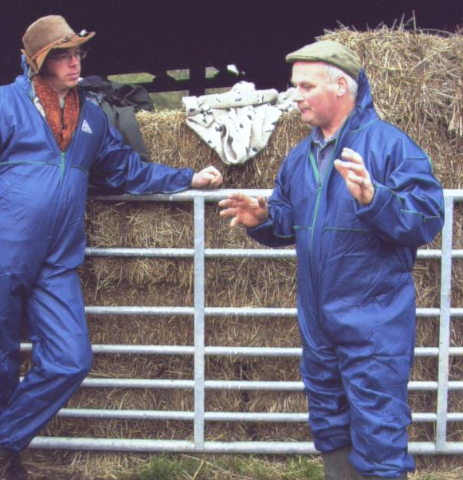

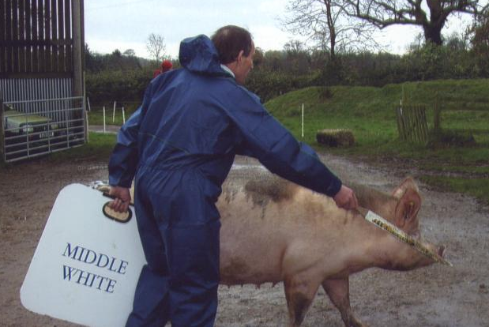

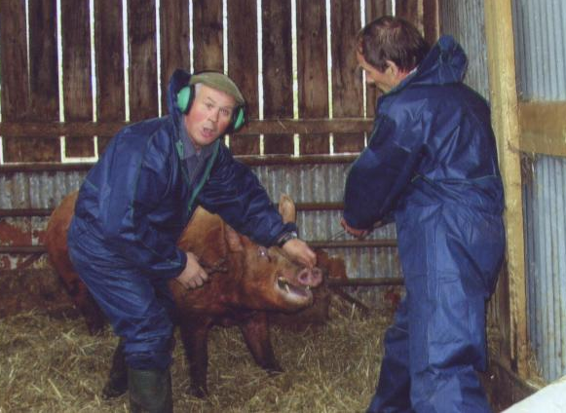

Some pictures taken at Mervyn Forster’s Workshop. Courtesy Tracey Bretherton.

Left: Mervyn relates the tale off the “one that got away” to one of the “students”. Was that a fish or a high speed Tamworth?

Below: The sole Middle White being put through her paces by Brian Merry.
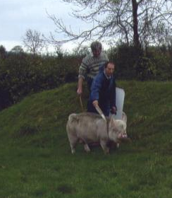

Left: Well at least the board says Middle White…. Brian Merry again, this time with a Large White.

Left: We’re not sure who’s making the most noise here, Little Boy Blue or the Tamworth, but shouldn’t that Tamworth be allowed to have ear defenders as well. (He can chatter on that Mervyn!).

23

 |  | 
 |  | 

 | THE COMMITTEE OF THE MWPBC WISH YOU ALL A VERY HAPPY CHRISTMAS AND BEST WISHES FOR 2005
  
 |  |  | 

