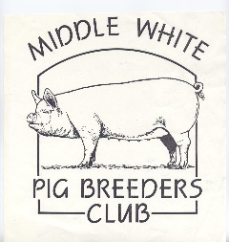

MIDDLE WHITE
PIG BREEDERS CLUB
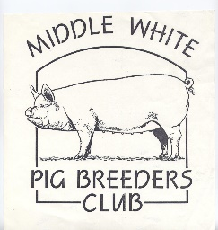

(PATRON: ANTONY WORRALL THOMPSON)

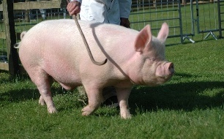
NEWSLETTER
AUTUMN 2005

Brian Merry (left) with Elgany Woodlands Lady 192nd and David Steel with Mary Card’s Westham Fair Lady 471st in the July Gilts Class at the 2005 Royal Show.
All Pictures Courtesy Tracey Bretherton

OVER 150 YEARS OF THE MIDDLEWHITE
BIDGIEMIRE PIG ARCS
The one stop Pig Shop

- Extremely low cost delivery including Scotland and the Islands

- Export enquiries welcome

- Now available, The Plastic Carbery Arc

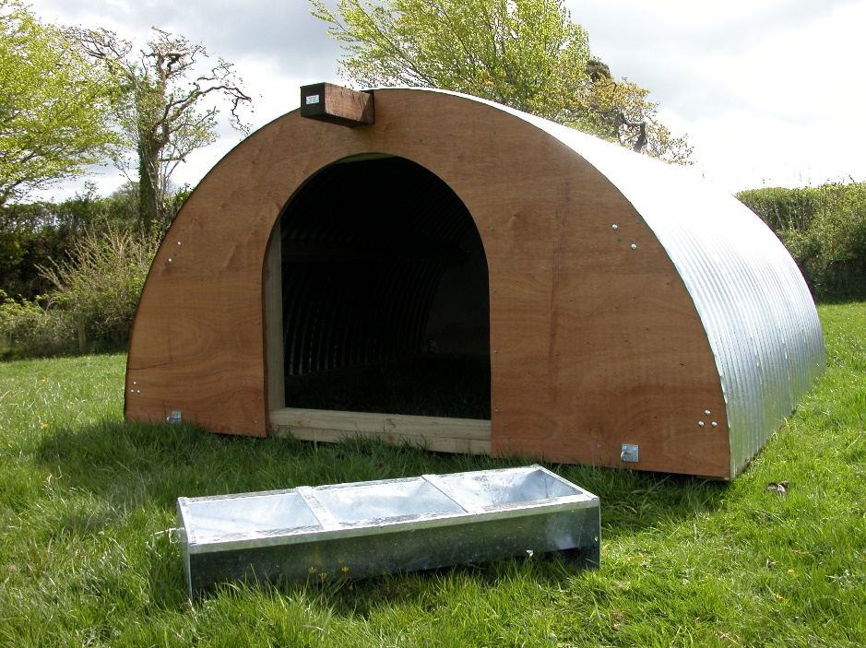
- Probably the widest selection of arcs and pig accessories for the smallholder you will find

- Everything you need for your pigs on a day to day basis

- From tagging and slap equipment to Pig Manuals
Telephone 01237 431 450
www.pig-arcs.co.uk

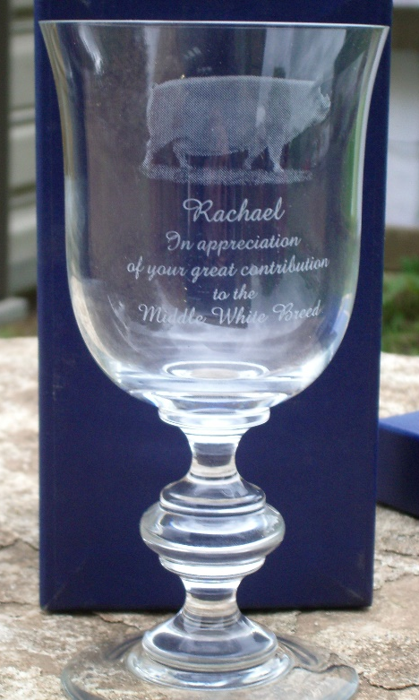

This is the glass presented to Rachael Wylie, see over for story.
Picture courtesy Peter White

The Jack Howlett Memorial Trophy Cup, seen here prior to its refurbishment. This cup is for the Young Pig of the Year Competition which was inaugurated this year. Picture by Marcus Bates

Chairman’s Letter
Dear members,
Well the Middle Whites certainly go from strength to strength! We not only get qualifiers for the Pig of the year but also Qualifiers for the Young pig of the year, we figure in most of the Interbreed classes where Middles do not have classes of their own but compete for a place with either other traditional breeds or other white Breeds. Congratulations to all of you who have achieved such high standards.
My congratulations too, to those of you who have exported Middles or allowed their boars to be used by other breeders, either by standing them at stud or loaning them out to the one or two sow breeders. If we can succeed in finding a suitable boar for the Deer Park and the blood testing runs smoothly we will hopefully soon have semen available from another boar line for A.I.
Good boars seem to be in short supply this year, only 2 or 3 entered for the sales at The Three Counties and Melton Mowbray. Also there seems to be a lack of in-pig gilts, maybe we should follow the example set by the Tamworth breeders Club and have a Breed Co-ordinator, whose job it is to hold records of all stock for sale and deal with all telephone enquiries about the purchase of stock.
My letter to you this time will have to be very brief as I am yet again holding up the publication of this current newsletter by my tardiness, I know the daylight hours are getting shorter but either I am getting slower by the day or the actual days and hours themselves are getting shorter.
We have now lost a much-respected Middle White Judge from our lists. Rachael Wylie has now retired and was presented with an engraved glass and a card to thank her for all her services to the Middle White Breed after judging the pairs of pigs at the Royal Show this year.
Unfortunately at that moment the heavens opened and most exhibitors and spectators ran for shelter, but I did hear Rachael say that if any breeder of Middle Whites was in need of any help or advice not to hesitate to call her. Thank You Rachael for everything you have done over the years for the Middles. …………Mary Card

Rachael Wylie

On page 2 is a picture taken by Peter White of the glass presented to Rachael Wylie at the Royal Show. Rachael is retiring from judging this year and this was decided as a fitting tribute for all that she and her family has done for our breed. Rachael continued her father’s (Mr Chandler) love of Middles but she has now moved on to a larger animal (Charolais), so she is now to be found in the cattle sheds.

Rachael writes:

Dear MIranda,
Sorry I have not written a proper letter, but very busy on show circuit.
Please thank all your members for the lovely gift they presented me with, the glass , with the ALMAROSE sow and the writing, meant a great deal to me, which I will treasure the rest of my life. It is in a glass cabinet in the kitchen so I see it many times in the day, and reminds me of all the good times I had with MIDDLE WHITES.
I wish you all success and keep up the great work in breeding to the quality they are all today,
If I can ever be of any help to the club or any members just ring 01608685526 or e mail, do not be frightened too.
Thank you all again for such a kind thought, which I will treasure for a long time.
All the best
Rachael

3

Secretary’s Ramblings

Hi Folks

Well I feel summer is finally over and all the shows are finished, except the Autumn Exhibition at Peterborough. Well done to all of those of you who turned out for the shows, so keeping our breed in the public eye.

Mervyn Forster recently purchased one of these Bidgimere Pig Arcs, see advert on page 2, at the Royal Show. He is extremely pleased with it, nice and solid and the pigs are very happy in it.

There have been reports of ear numbers not being very clear. Whether this is the fault of the paste used or not, I don’t know. Perhaps it is not being rubbed in enough after putting the number in the ear. I know that people have their own pet theory of the best way to do it. Some advocate a clean ear, others say not, some say put paste on the numbers as well, others don’t. I have also heard of a breeder who mixes black and green paste together and gets good results. Geoff Parker has just tried a new paste, which he says is better than the one he was using, it’s much thicker. It is called ‘Tatowierzangan’ fur Schweine Rinder and is made by Hauptner Herberholz, and is a thick paste in 600gram tubs. I am sure that Geoff can provide more details if you are interested in trying something different.

We have one more short story from Jack Howlett, when his family were clearing out his flat they found all his rough copies of previous articles which were passed on to me and this one he had started about his trip to Africa was in there. I assume that it was unfinished and I’m not sure if all the names are spelt correctly, but we have done our best with it and hope you enjoy it.

When England won the ashes I thought how pleased Jack would have been as cricket was one of his sporting passions. I have just seen in a Sunday paper that some pork sausages that won first prize in a national competition were made in Buntingford by a Jeff Pigg. This was Jack’s hometown. I wonder if it was his butcher friend, who was going to make some sausages for him?

Miranda Squire

EXPORTING LIVESTOCK TO THE AFRICAN CONTINENT
The final instalment of Jack Howlett’s memories

Nigeria

My first trip outside Europe was to Ibadon in Nigeria. Ibadon is said to be the biggest all black conurbation in the world.
The reason for my visit was to accompany a consignment of pigs that was being imported by the local university.
There were about 100 head, all Large White and Landrace and each pig was approximately 30 Kgs live weight. This I have always believed to be the ideal weight for exporting pigs by air. The main reasons being that at this weight the pigs are strong enough to withstand a long journey, many pigs of this weight would fit into a pallet without harming themselves and probably the most important reason of all, the pigs had time to acclimatize to their new environment prior to breeding.

The flight was uneventful and everything was ready for unloading. On arrival at the University Farm the pigs were accommodated in a new purpose built barn with open sides. I was very

4

impressed by the “Sprinkler System” which was used to keep the pigs cool.
After spending the night in Ibadan I was to be taken to the International Airport in Lagos. It was intended that I fly from Lagos to Rome and stay in Rome overnight. Having never been to Rome before I was looking forward to seeing some of the famous sights. After Rome I was planning to fly to Sofia, the capital of Bulgaria.

At Lagos Airport there was the usual crush and it took some time to get as far as the immigration desk. I then handed in all my documents. This being my first visit to Africa I had made sure that all my relevant health papers were up to date and in order, including a yellow fever certificate and documents indicating that I had had the necessary “jabs” for malaria etc.
My passport and documents were taken to a back room and five minutes later I was informed that I could not fly to anywhere in Europe as I had no health papers. I told the officials that they were attached to my passport.
I knew that Nigeria was corrupt, but how could I get out of this mess? I suggested that I had the vaccinations re-done at the airport, I was told that it took 10 days for the yellow fever to “work” and that would mean another 10 days at least in Lagos. I offered a bribe which was the usual way of getting things done.

At last I had to agree to fly to London where my “lack of documents” would be acceptable, being a UK citizen.

On arrival in London I was able to change my ticket and still arrive in Sofia the next day on time! On another visit soon after I was invited to Kano, in the north of Nigeria to look at a large pig farm.
That, like so many other things, had fallen into a state of disrepair. The farm had for years been run by a Danish company and was big enough to house 1500 sows and their progeny. The problem was labour, Nigeria is mainly Christian in the south and Muslim in the north and it had always been difficult to keep a Muslim labour force to look after pigs. Eventually the Danish management gave up and very soon there were only a handful of pigs left on the farm.

There were so many things in favour of a pig farm on the site, plentiful supplies of pig food were close to the farm, mainly sorghum, and a slaughter house and processing plant in easy reach.

I took with me a builder to advise on the materials required to bring the farm up to date, but after many recommendations etc. the improvements were never made and as far as I know the farm has never been modernised.

Our agents in Nigeria were Greek. The firm “Leventis” owned the Mainland Hotel in Lagos and many other trading companies. They suggested that I, together with one of their senior local staff, should make a 2 or 3 week tour of the country in order to meet potential buyers.

I remember that my companion was Simion and he had, at one time been a British soldier and one of his 4 wives had worked in the Cumberland Hotel in London. We had a young driver, no more than 17, and we set off

to tour the country. I realised from the start that the car had no brakes, but we managed to avoid any major problems.

The original plan was to visit senior state agriculturists, however after the first 2 days I realised that it was a tour of Simion’s relations, including his 3 lesser wives. We stayed in some very ordinary Travel Lodges, many without air conditioning, and the food in many places was poor.

5

After two of the worst weeks in my life we arrived back in Lagos and I was able to stay in the comfort of the Mainland Hotel, prior to catching a plane to London, or at least that was the plan!
We left the hotel early in order to be in good time at the airport. On the way, in a very busy part of Lagos, the crowds started to run and there was complete mayhem. Simeon said “there has been a murder, we will take refuge at my house”.
Simeon’s house was a hut with a tin roof, the radio was playing martial music, and every few minutes an announcement was made, which told everyone to stay indoors or they would be shot. The announcer went on to say that the President had been shot dead, together with his driver.

As time went on there were further announcements, telling the country that there would be a general curfew until the assassins were caught. The man they were looking for was Col. Dimca and he was to be caught dead or alive, along with his henchmen!

--------------------

And here we sadly end Jack’s tales of his exploits abroad, in the animal export business. We hope that they have entertained and amused you.

------------------------

Club Raffle

The Club raffle was drawn at Hatfield on Sunday 21st August. The winners were as follows.

1) £350 Leisure Vouchers Philip Kennedy Ticket 5137
2) Ladies and Gents watches, Donated by Road Range Geoff Parker 1974
3) Case of Wine, Donated by Massey Bros Feeds Ltd Sally @ Sallco 0651
4) Hamper from Savin Hill Products Lewis Vaughan 3824
5) Pair of Fleeces Jane Worrall 1138
6) £25 High Street Vouchers (donated by a club member) Carol Knights 0979
7) £20 High Street Vouchers Jimmy Allen 0058
8) £15 High Street Vouchers Peter & Ros Ragg 2225
9) Club T Shirt Paula Ferrari 5259
10) £10 High Street Vouchers (donated by a club member) C Dinan 0575
11) £10 High Street Vouchers C Pierce 4173
12) £10 High Street Vouchers Ray & Liz Wright 2467
13) £5 High Street Vouchers Sandra Reed 0783
14) £5 High Street Vouchers Robbie 2156

The profit from the raffle was £707.25. We had 250 books more than the last big raffle but not so
many tickets were sold. That Parker fellow appears in the winners again, I think if he fell in the
cut he’d come out dry.

We are very grateful to all of you who worked so hard to sell tickets and also to those who
donated prizes, which made this result possible.

6

Show Results

Royal Show 3 - 6 July Judge – Ann Uglow

Boar born before 1st Jan 2005 5 Forward

1) Cestrian Revival 6th Geoff Parker
2) Ferrylane Rajah 2nd Ian and Tracey Bretherton
3) Shortheath Rajah 2nd Chris Pedley
4) Dappleheath Captain 21st John Herbert

Boar born on or after 1st Jan 2005 3 Forward
1) Dappleheath Captain 22nd John Herbert
2) Cestrian Mischief 17th Geoff Parker
3) Cestrian Mischief 18th Ian and Tracey Bretherton

Sow born before 1st July 2004 5 Forward
1) Iverlane Silk Geoff Parker
2) Westham Fair Lady 285th Bryan and Mary Card
3) Cestrian Yootha 24th Ian and Tracey Bretherton
4) Westham Dorothy 347th Marquess of Salisbury
5) Cestrian Woodlands Lady29th Geoff Parker

Gilt born 1st July – 31st August 2004 5 Forward
1) Westham Almarose 407th Bryan and Mary Card
2) Elgany Woodlands Lady 192nd Brian Merry
3) Westham Fair Lady 471st Bryan and Mary Card
4) Littleacorn Fair Lady Taldo Ferrari
5) Elgany Woodlands Lady 193rd Brian Merry

Gilt born 1st Sept – 31 Dec 2004 5 Forward
1) Oakbrae Yootha 19th Belinda Hobbs
2) Shortheath Fair Lady 22nd Chris Pedley *
3) Cestrian Woodlands Lady 35th Geoff Parker
4) Oakbrae Yootha 17th Belinda Hobbs
5) Crane Modiste 4th Marquess of Salisbury
* This gilt belongs to Chris’s grandson, Lewis Bennett, although it is still registered in Chris’s name for the time being.

Gilt born on or after 1st January 2005 4 Forward
1) Dappleheath Purity 12th John Herbert
2) Cestrian Woodlands Lady 38th Grace Bretherton
3) Shortheath Fair Lady 33rd Chris Pedley
4) Cestrian Woodlands Lady 36th Geoff Parker

Male Champion Reserve Male Champion
Cestrian Revival 16th Geoff Parker Dappleheath Captain 22nd John Herbert

Female Champion Reserve Female Champion
Oakbrae Yootha 19th Belinda Hobbs Iverlane Silk Geoff Parker

7

Champion Middle White Reserve Champion Middle White
Oakbrae Yootha 19th Belinda Hobbs Iverlane Silk Geoff Parker

Flack Trophy - Traditional Breeds
1) Saddleback
2) Middle White John Herbert

And in the final, against the modern breeds, the outcome was the same with the Saddleback pair taking the overall prize with John Herbert’s Middle Whites taking reserve.

GREAT YORKSHIRE SHOW 12 – 14 JULY Judge Tom Alty

Boar born before 1st January 2005 2 Forward
1) Cestrian Revival 8th Geoff Parker
2) Cestrian Mischief 14th Trisha Horsley

Boar born on or after 1st January 2005 3 Forward
1) Dappleheath Captain 22nd John Herbert
2) Cestrian Mischief 17th Geoff Parker
3) Acaster Mischief 472nd Trisha Horsley

Sow born before 1st July 2004 2 Forward
1) Iverlane Silk Geoff Parker
2) Acaster Carnation 40th Trisha Horsley

Gilt born on or after 1st July 2004 6 Forward
1) Templeson Fair Lady Trisha Horsley
2) Grangefarm Woodlands Lady 56th Middlesborough B.C.
3) Elgany Woodlands Lady 192nd Brian Merry
4) Cestrian Woodlands Lady 33rd Geoff Parker
5) Grangefarm Woodlands Lady 58th Middlesborough B.C
6) Elgany Woodlands Lady 193rd Brian Merry

Gilt born on or after 1st January 2005 3 Forward
1) Dappleheath Purity 12th John Herbert
2) Cestrian Woodlands Lady 36th Geoff Parker
3) Acaster Carnation 470th Trisha Horsley

CHAMPION MALE CHAMPION FEMALE
Cestrian Revival 8th Geoff Parker Iverlane Silk Geoff Parker

CHAMPION MIDDLEWHITE
Iverlane Silk Geoff Parker

MID DEVON SHOW 23 JULY Judge Mary Card

Gilt born on or after 1st July 2004 3 Forward
1) Yasmyns Almarose 6th Jamie Champion and Claire Stephenson
2) Crane Modiste 4th Marquess of Salisbury
3) Littleacorn Fairlady 2nd Taldo Ferrari

8

Sow Born before 1st July 2004 to have forrowed and reared a litter to 3 weeks 1 Forward
1) Iverlane Almarose 13th Jamie Champion and Claire Stephenson

Gilt born on or after 1st January 2005 2 Forward
1) Yasmyns Almarose 8th Jamie Champion and Claire Stephenson
2) Yasmyns Almarose 9th Jamie Champion and Claire Stephenson

Shutevale Challenge Cup for Best Middle White
Champion
Iverlane Almarose 13th Jamie Champion and Claire Stephenson

Reserve Champion
Yasmyns Almarose 6th Jamie Champion and Claire Stephenson

Mid-Devon Show – Mary Card writes:
I was very surprised and pleased when I was asked to judge the classes of Middle Whites at The Mid-Devon show this year and even more pleased that I had a nice number of pigs to judge, the quality was excellent, and with some very able assistance from Steve Loveless who was stewarding for me I had a very enjoyable day. Thank you exhibitors, I hope you did too!

LANCASHIRE SHOW 27 – 28 July Judge – Christine Vaughan

Boar born before 1st January 2005 2 Forward
1) Ferrylane Rajah 2nd Ian and Tracey Bretherton
2) Cestrian Revival 16th Geoff Parker

Boar born on or after 1st January 2005 2 Forward
1) Cestrian Mischief 17th Geoff Parker
2) Cestrian Mischief 18th Ian and Tracey Bretherton

Sow born before 1st July 2004 2 Forward
1) Iverlane Silk Geoff Parker
2) Cestrian Yootha 24th Ian and Tracey Bretherton

Gilt born on or after 1st July 2004 5 Forward
1) Cestrian Woodlands Lady 33rd Geoff Parker
2) Gracebank Yootha Ian and Tracey Bretherton
3) Elgany Woodlands Lady 19th Brian Merry

Gilt born on or after 1st January 2005 5 Forward
1) Cestrian Woodlands Lady 38th Grace Bretherton
2) Cestrian Woodlands Lady 38th Geoff Parker
3) Iverlane Silk 6th Ian and Tracey Bretherton
4) Iverlane Silk7th Ian and Tracey Bretherton

Champion Middle White Reserve Champion Middle White
Iverlane Silk Geoff Parker Cestrian Woodlands Lady 38th Grace Bretherton

Interbreed Reserve
Large White Phil Brown Iverlane Silk Geoff Parker

9

OSWESTRY SHOW 6 AUGUST Judge Stan Samuels

Boar any age 2 Forward
1) Eaves Captain 3rd Mick Paddock and Sarah Marsden
2) Cestrian Mischief 17th Geoff Parker

Sow 1 Forward
Cestrian Woodlands Lady 29th Geoff Parker

Maiden or in pig Gilt 8 Forward
1) Large White Geoff Parker
2) Eaves Dorothy 3rd Emily Paddock
3) Eaves Almarose 6th Mick Paddock and Sarah Marsden
4) G.O.S. Mr Williams
5) Large Black Tom Edwards

Champion
Geoff Parker with a Large White

Reserve
Cestrian Woodlands Lady 29th Geoff Parker

Our roving reporter, Brian Merry, writes:-
The Interbreed was won by the blasted sheep again, and the reserve was a Red Poll bull.
Mick paddock was the first to arrive and soon had all the nettles pulled out of the pens and his 3 pigs settled in. Next to arrive was Geoff Parker, who also had the task of nettle pulling. But this year with the weather being quite overcast for most of the day, until the last hour Geoff didn’t have to put up his elaborate sunshade, made out of 6’ 6’’ 4’’ X 4’’ timbers and wagon sheet. Geoff had to call on Frank Miller in the Championship to take the Middle White sow out, as he also had the Large White to show. A good day was had by all.

HATFIELD HOUSE COUNTRY SHOW 19 – 21 AUGUST Judge Duncan Staig

Sow born before 1st July 2004 3 Forward
1) Cestrian Woodlands Lady 29th Geoff Parker
2) Westham Dorothy 347th Marquess of Salisbury
3) Shortheath Fair Lady 16th Chris Pedley

Gilt born on or after 1st July 2004 6 Forward
1) Yasmyns Almarose 7th Jamie Champion and Claire Stephenson
2) Cestrian Woodlands Lady 33rd Geoff Parker
3) Shortheath Fair Lady 22nd Chris Pedley
4) Eaves Almarose 6th Mick Paddock and Sarah Marsden
5) Crane Modiste 4th Marquess of Salisbury

Gilt born after 1st January 2005 10 Forward
1) Dappleheath Purity 12th John Herbert
2) Cestrian Woodlands Lady 37th Geoff Parker
3) Yasmyns Almarose 9th Jamie Champion and Claire Stephenson
4) Cestrian Woodlands Lady 38th Grace Bretherton
5) Yasmyns Almarose 8th Jamie Champion and Claire Stephenson

10

Boar born after 1st January 2005 3 Forward
1) Dappleheath Captain 22nd John Herbert
2) Cestrian Mischief 17th Geoff Parker
3) Shortheath Rajah 4th Chris Pedley

MIDDLE WHITE CHAMPION
Cestrian Woodlands Lady 29th Geoff Parker

RESERVE
Yasmyns Almarose 7th Jamie Champion and Claire Stephenson

Well, what can you say about this Show, after a terribly wet day on Friday the Saturday dawned to a beautiful day, but with plenty of cloud cover to give shade and keep the temperature down. The Sunday was much hotter – too hot for the pigs, but it certainly brought the crowds out.
There were just over 200 pigs entered and the Saddleback Champion of Champions was held on the Sunday together with the Young Pig of the Year final.
Sadly Jack Howlett didn’t live to see his long held idea finally reach it’s first final, but, with a minutes silence held before the presentation of the newly purchased Jack Howlett Memorial Trophy I’m sure that he was in many people’s thoughts.
This hugely contested award, held after 12 qualifying heats during the summer, was finally won by a British Lop from M & E Edgar.
It was a brave decision by Lord and lady Salisbury and their team to break away from the Homes and Garden Show and to go it alone, especially as the previous date was the traditional Cricket Match weekend ( see last year’s newsletter) where is hasn’t rained for years.
And then we were back to a very wet day on the Monday.

Some of the little country shows are a super learning place for breeders who are just starting out and waiting to show. They help by giving them confidence, with a few local established showmen and women on hand with some good advice and help.
We all have to start somewhere and where better than at one of these venues, without all the stress and hassle of a major event.

Great Eccleston in Lancashire was one of these, they had not had pig classes for 50 years, but last year Tracey Bretherton had take some for display. So this year, with Tracey as Chief Pig Steward they got nine classes together. Phil Brown judged on the first day and Geoff Parker on the second.
Phil commented on the high standard of some of the pigs forward and that 2 had been in the Pig of the Year final at Yorkshire.

The overall Champion was Tracey’s Ferrylane Rajah 2nd with Geoff Parkers Cestrian Yootha Sow in reserve.

Other such shows included The Westmoreland on 8th September, with Tom Alty judging. This was mixed classes, Traditional and modern. The January Boar class, with 6 forward, being won by a Saddleback with Geoff Parker’s Cestrian Mischief 17th placed second. The Sow class with 8 forward was won by Geoff Parker with Cestrian Woodlands lady 29th, which also won best Traditional breed and Supreme Champion.

Penistone on 10th September had Kevin Mathews judging the Whites and Coloured classes. It was a thoroughly wet and miserable day, with the pigs penned in the open. Geoff Parker triumphed with both his January boar, Cestrian Mischief 17th and gilt, Cestrian Woodlands Lady 36th. I think everyone was glad to pack up and go home.

11

Singleton on 24 July was judged by Kathleen Pile. There were only 2 breeders present, Lord Salisbury with Middle Whites and Dave Overton with his Gloucester Old Spots. Again it was a very wet day, but at least the pigs were in a marquee and I heard that the public were in the pens, so that the pigs could be judged in the clear space!

Okehampton was held on 11 August and judged by Phil Fowlie. There were only three Middle Whites forward, all in the July gilt class. The placings were:
1) Smallicombe Fair Lady 6th Ian and Maggie Todd
2) Littleacorn Fair Lady Cataldo Ferrari
3) Littleacorn Fair Lady 2nd Cataldo Ferrari

The Todd’s gilt was best Middle White.

On 25th August Sharon Barnfield had about 60 pigs to judge at Melplash, but sadly there were no Middle Whites forward.

At Dorchester, on 3 & 4 September, Julian Collings had a similar sized field to judge. Lord Salisbury flew the Middle White flag with the October gilt Crane Modiste 4th and his sow Westham Dorothy 347th being the Champion Middle White.

And finally an apology for omitting the results of the Newark Group of Three in the last Newsletter.

Chris Pedley was second and Mick Paddock and Sarah Marsden were third, both with groups of Middle Whites.

----------------------------------------------

Exporting Pigs

Tim Harris, livestock exporter and club member wrote this article following a query about exporting a particular breed, but the article applies to all breeds.

How do I export Pigs?

This is a good question, and could be a useful outline for any breed or animal. I am therefore copying my answer to various editors of Club Journals in case it is of interest to their members.

Exporting is not trivial. It requires much attention to detail. However it is more profitable than selling for meat, is far more interesting, and puts you at the head of the queue at the Bank. You will do well to use the services of an experienced shipper simply because of the mass of details associated with selection, health controls, paperwork, transport, international regulations, transits, export licences, import licences, crating requirements, aircraft types, flight bookings, routes, handlers, insurance, payments, bank details etc. In addition to this you may require translations, and your geographical location may mitigate against ease of access / time available for overseas visitors.

Minimum considerations are:

1. Do not farm pigs, pugs, peccaries or porcupines with the sole view of exporting. Life and nature will conspire against you to stop exports -- disease, foreign controls, fussy customers etc.

12

What you must do is plan for sales WITHIN UK. The 'better mousetrap' principle. Get known for good pigs at home, and the foreign buyers will pay attention.

2. All pigs must be pedigree registered.

3. Keep good and detailed records and be ready to share these with buyers.

4. Take stringent health precautions. If you show pigs, you always run the risk of bringing something nasty back home. Keep show pigs separate for at least 30 days before reintroducing them to the main unit.

5. Build a website to post all the animals you have available -- litters born -- prizes won -- sales made etc.

6. Consider the special requirements for export isolation. This is more stringent than show isolation. I can supply details if required. Basically -- a separate airspace in a solid building that can be disinfected at least 30 yards from any animal. I know of several excellent breeders who can never export simply because they have no suitable isolation available. This could possibly be arranged on a neighbour's unit if necessary.

7. Secure a 'multiple pickup licence', in case animals for sale have to be collected from several sources including yours. This is free, by application to your local DVM, though there may be fees for veterinary supervision / reports etc.

8. Check that your vet has LVI [Local Veterinary Inspector] status in order to sign export certificates. Not all are so approved by DEFRA.

9. Consider how and where you will show your animals to prospective buyers. Small herds may not be able to afford viewing rooms, but boots and clothing should be supplied for visitors, and careful consideration paid to the tidiness of the unit. A shambolic unit does not sell pigs, any more than a shabby forecourt sell cars.

10. Know what to ask in terms of prices for your stock. Too low is a waste of everyone's time -- especially yours and your fellow club members. Too high may lose a sale to others, but there is no shame in that, and remember that traditional breeds are not so widely available, so do not be afraid of asking realistic prices, and offer discount for quantity. Prices should include 2-generation export pedigrees and all your time and effort in isolation. Vet testing and transport are normally extra depending on the details required of the importing country.

11. If you think you can meet all these requirements, keep me posted of your families, litters born, availabilities, success etc. It assists me greatly if you complete and return the attached form. Export enquiries always appear completely without warning, and I can only promote those herds that are ready willing and able to export.

I look forward to hearing from any breeders interested, and will be pleased to advise anyone with any export enquiries.

Tim Harris, Harris Associates Ltd, Box 251, Redhill, RH1 5FU, tel +44 (0)1737822249
harrisassociates@btconnect.com

13

For Sale

July Born Gilts

Captain X Purity and Sovereign X Woodlands Lady.

July Born Boars

Sovereign X Dorothy

John Herbert, 01889 500269, Stow-by-Chartley, Staffs

-------------------------------------

In-Pig Gilts

Captain X Fair Lady

2 July 2004 born Captain Boars

Chris Impey, 01291 641218 Shirenewton, Mons

----------------------------------------

July Born Birth Notified Pigs for sale

Dam is Woodlands Lady

Ann Storer 01473 830264 Baylham, Suffolk

-----------------------------------------
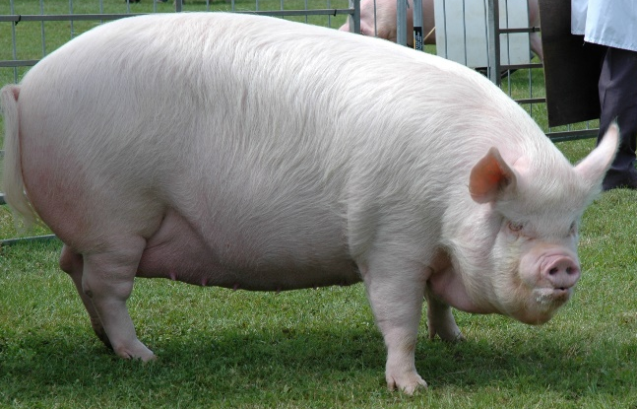 Photo Courtesy Tracey Bretherton
Edited and published by Miranda Squire on behalf of The Middle White Pig Breeders Club.
Benson Lodge, 50 Old Slade Lane, Iver, Bucks, SL0 9DR
Tel: 01753 654166
Email: Miranda@middlewhites.freeserve.co.uk
14

