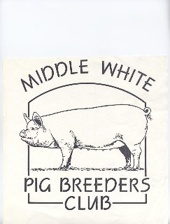

MIDDLE WHITE

PIG BREEDERS CLUB

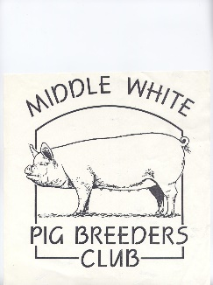

(PATRON: ANTONY WORRALL THOMPSON)

[](http://images.google.com/imgres?imgurl=www.adventurepostoffice.com/cards/easter/bunny99-05-l.gif&imgrefurl=http://www.adventurepostoffice.com/cards/easter/bunny.html&h=300&w=287&sz=14&tbnid=6THRMkqxoEIJ:&tbnh=110&tbnw=106&prev=/images?q%3DEASTER%2BBUNNY%26start%3D60%26hl%3Den%26lr%3D%26ie%3DUTF-8%26oe%3DUTF-8%26sa%3DN)

NEWSLETTER

SPRING 2004

[](http://images.google.com/imgres?imgurl=www.adventurepostoffice.com/cards/easter/bunny99-05-l.gif&imgrefurl=http://www.adventurepostoffice.com/cards/easter/bunny.html&h=300&w=287&sz=14&tbnid=6THRMkqxoEIJ:&tbnh=110&tbnw=106&prev=/images?q%3DEASTER%2BBUNNY%26start%3D60%26hl%3Den%26lr%3D%26ie%3DUTF-8%26oe%3DUTF-8%26sa%3DN)

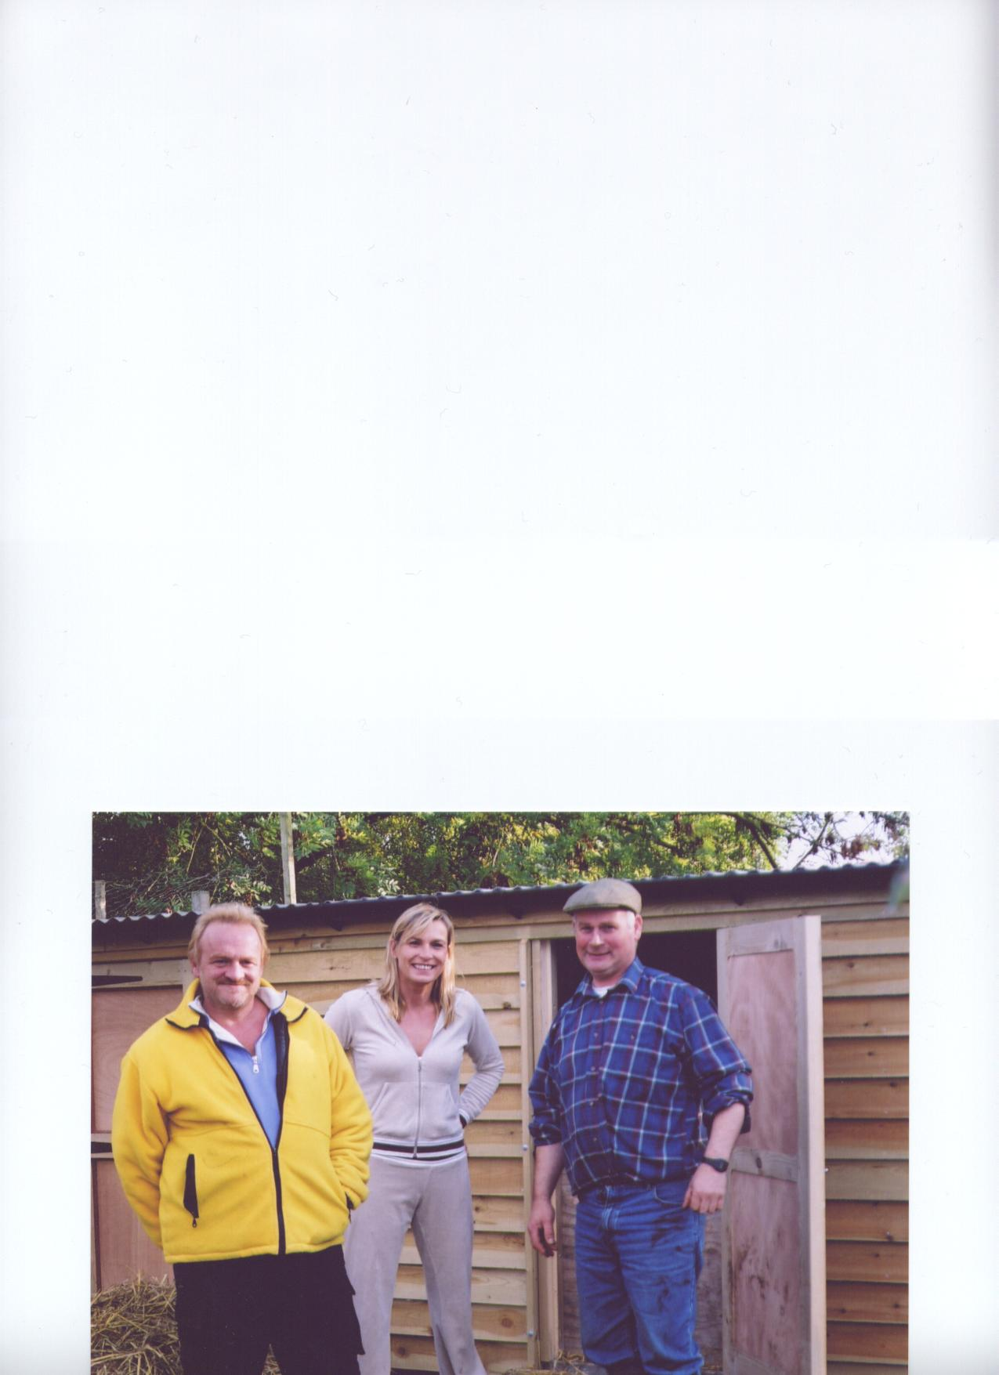

Antony with wife Jay and Mervyn Forster

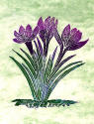OVER 150 YEARS OF THE MIDDLEWHITE

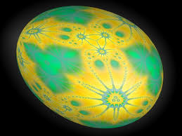

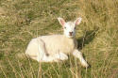

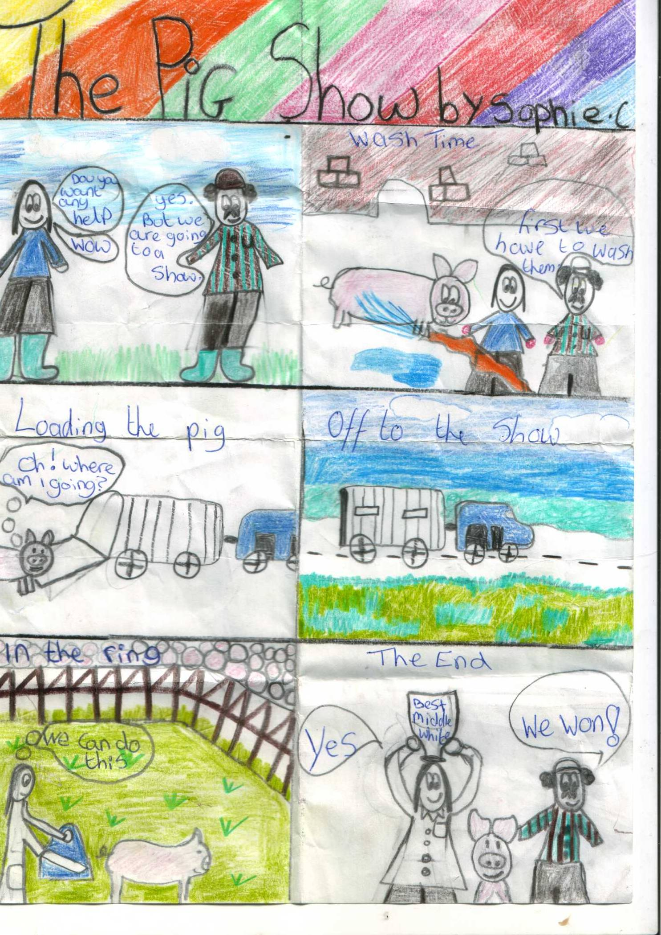

Our youngest member, Sophie Court, is looking forward to this year’s shows, and has drawn this colourful cartoon in anticipation of things to come. Well done Sophie, let’s hope that it will be you holding the cup.

2

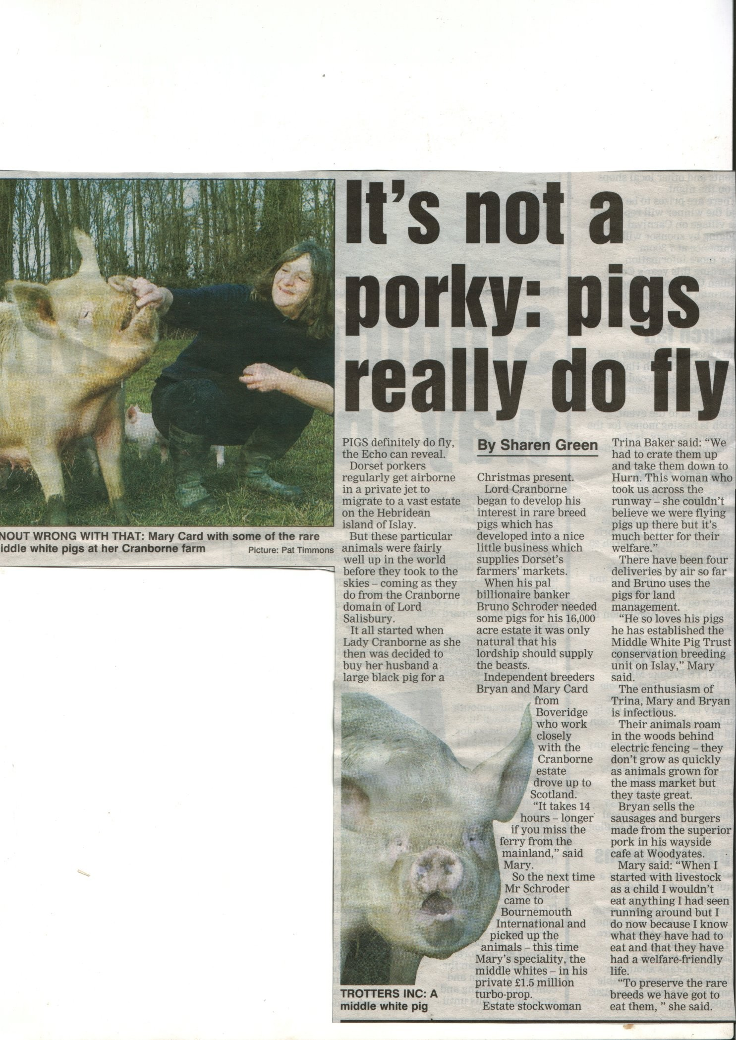

Our very own page three girls!

Dear Members,

Well it’s that time of year again when Miranda has to nag and I have to rack my brains for something interesting to say to you all!

Please, Please, if any of you are reading this and you have not returned your survey forms or have lost, mislaid, or just couldn't be bothered to return them, do it now or yesterday if you can possibly manage it! It is so important should we have another serious disease outbreak, like foot and mouth, that the B.P.A. know where vulnerable and endangered bloodlines are so as much as possible can be done to safeguard them.

As you can see by the article and 'photo ,a remark made by our patron AWT about flying pigs led to Bruno Schroder's estate manager, and Lord Salisbury's personal secretary and then myself being bombarded with requests for interviews and 'photos .

I soon succumbed to the flattery though, even though the other parties stood firm on the basis that it’s all good publicity for our pigs!

I'd like to thank our president Jack Howlett, who as many of you may not be aware has been unwell and in hospital for some time, as, despite this he has again written an interesting, informative article for us. Hopefully more than making up for your chairman's poor literary skills.

At the last B.P.A. Traditional Breeds meeting Marcus Bates informed the breed reps that an order for nine Middle Whites was in place for America, for as many bloodlines as possible, selected from January/ February born litters. Tim Harris will be handling the export, and I am sorry but cannot yet tell you the exact protocol but I can tell you that pre-testing at the vendor’s expense for PRRS is a requirement; also the on-farm Quarantine period is sixty days. Both John Herbert and I have details from the BPA of all birth notified litters born in January/February, so if you have not notified any eligible litters and would

be interested in supplying stock for this export please contact either of us as soon as possible.

One more request, it would be so nice to see more of our Members at the AGM on 18th April and to hear about any problems, ideas, worries you may have. It is as much a social event as an AGM with an excellent lunch, a small raffle, and a chance to meet other breeders, especially if you do not show your stock and miss out on the social aspect of the exhibiting side of breeding Middles.

Best wishes, Mary Card



3

**A few pictures to accompany the following article by Jack Howlett.**

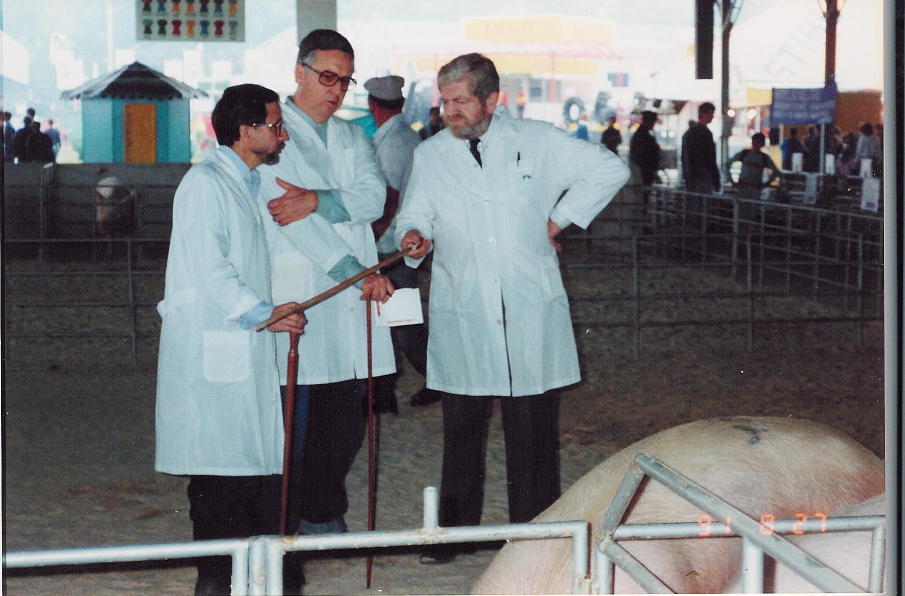

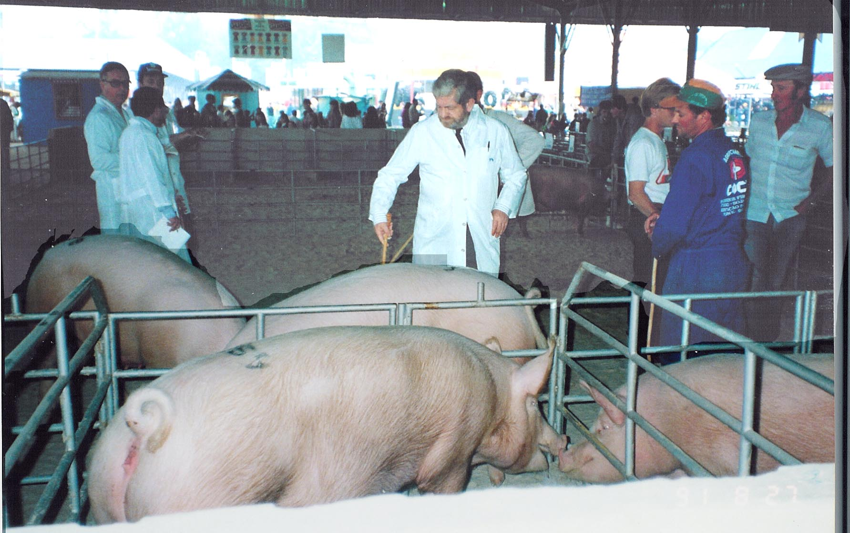

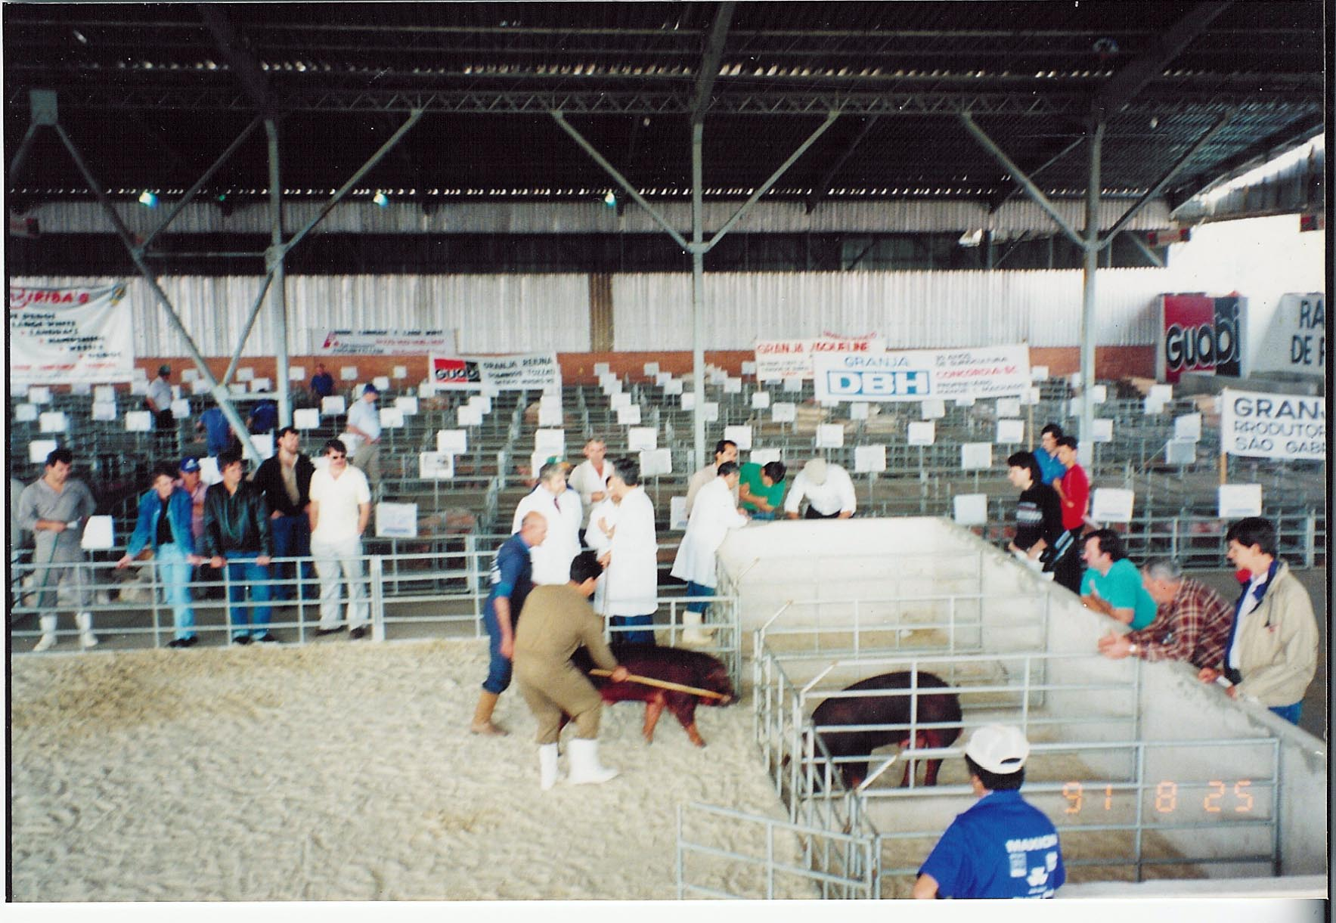

Left – Jack, to right of photo, with his interpreter and a steward.

Below – Part of the Pig Barn at the Porto Alegre Show.

Bottom – Jack has a last look at the winning Large Whites.

4

**EXPORTING TO BRAZIL**

**(PART 2)**

Jack Howlett continues the tale of his exporting adventures…. Read on.

For those of you that read part 1, published in the M.W.P.B.C. Winter 2003 Newsletter, you will remember that I described the build up to our participation in the 1974 “Expointer” Show to the point of take off with the first load of livestock.

It was a very warm Sunday in August and the first words the pilot said on becoming airborne was “I have had one of the water tanks filled with fresh orange juice, that should be enough for all of us for the entire flight”. Those words were very welcome.

There was a flight crew of four and our crew consisted of the 18 year old Donald Bigger, who is now one of most respected judges of beef cattle in the world, he has also served as Chairman of the Royal Smithfield Club, and in the New Year’s Honours List this year he was awarded an OBE for his services to agriculture. Also present were Graham Rowles Nicholson, who, with his brother had just inherited the Limestone Farming Co. in Lincolnshire, and Chris Wilson, son of a Tasmanian farmer, who had worked with us for some months preparing cattle in quarantine prior to export to the USA, and myself.

Donald and Chris were to help prepare the cattle and Graham to help with the sheep. James Pigg travelled with the second shipment; he had already had considerable experience with livestock in transit.

The boys worked so hard during the two weeks they were in Brazil and I could not have wished for a better team.

The flight was smooth and uneventful and the fact that it was a jet ensured that we reached our destination, again via Dakar and Recife, in good time.

The only thing of interest was during our “pitstop” in Dakar I let the two dogs out of their boxes to stretch their legs etc, they both were very calm so I thought they might like a bit of roast rib of beef. I cut it up and they devoured the lot!!

When we arrived in Porto Alegre, everything was ready, with good ramps for unloading and plenty of help. The size of our entry had already created a lot of interest in Brazil and there were was a large number of spectators and pressmen waiting to see what the UK had to offer. Sr.Cerne Lima was there to pick up his bulldog and to sneak a preview of the Devon cattle we had on board.

The young British vet was there to collect his dog “Trousers” and the reunion of man and dog must rank as one of the my highlights or treasured moments of the whole trip, it brought tears to my eyes, but then I always was a big “softie” where dogs are concerned!

The cattle and sheep travelled well and very soon settled down at the show. We took a lot of fodder with us, however it was important that the stock was introduced to the kind of food they would be expected to eat in their new country.

The sheep barn was so full that we had to transfer about 12 Hampshire Down ewes to a farm nearby. We imagined that this would affect the price as they would be sold unseen by the buyer. This proved not to be the case and I will deal with the sale later.

It was now time to return to the airport to receive the second shipment, and there, representing the “Lincoln Red Cattle Society” were “The Three Grumpy Old Men”.

5

The plane landed on time, James Pigg was first off and he told me that breed leaflets, brushes and curry combs from the Lincoln Red Cattle Society had been left behind. James then went to the Society’s reps and told them what had happened. He also told them that their cattle had travelled well and were in good condition. The latter seemed of little importance to the “Grumpy Old Men “, and they turned on me.

Now, what had happened was that while we were all at the airport loading the first consignment the Lincoln Red Cattle were delivered, and whoever supervised the offloading of the cattle etc. told the lorry driver to leave the breed leaflets etc in a shed. James was told, but with so much going on, he forgot until airborne with the second shipment. He apologised profusely and promised that the leaflets would be brought out to the show with another colleague, who was due to fly out two days later, still long before the show opened. When our colleague duly arrived at the show and delivered the leaflets to the Lincoln Red booth our friends did not even say thank you.

In no way did I want to “pass the buck” but I was not there, so in no way was it my fault. Unfortunately the “Three Grumpy Old Men” were not only staying at the same hotel as myself, but were also on the same floor, and whenever I went to the lift there they were, still wittering on about their curry combs.

I told my team that they must see that the Lincoln Reds had their full attention otherwise we would never hear the last of it.

By now we were beginning to realise what a massive show it was. In the Dairy section there were more than 500 Holsteins and over 400 Jerseys. The beef barn was overflowing with over 3000 entries. The Sheep Shed was twice the size of our Royal Show Sheep Building, and as opening day approached more and more stock arrived from all parts of Brazil and several neighbouring countries.

About 50 British breeders and Breed Society representatives attended the show, including Lord Glenkinglas, formerly Michael Noble, president of the Board of Trade in the McMillan Cabinet, and then Chairman of the British Agricultural Export Council, Sir Henry Plumb, president of the N.F.U., later to be Lord Plumb, a senior member of the European Parliament.

Jack Rennie, President of the Ayrshire Cattle Society, Derek Carter, President of the English Jersey Cattle Society, Michael Tory, President of the Hampshire Down Sheep Breeders Association were also all in attendance, together with the Secretaries of the Aberdeen Angus, Devon and South Devon Cattle Societies.

Sir Henry Plumb judged the Ayrshires, and with little South American opposition the 6 cows and heifers we exhibited won all the top prizes. Our South Devons had the show to themselves, as did the Lincoln Reds, which should have made there representatives happy, but they were still worrying more about their missing brushes and curry combs.

Despite strong competition from Argentina Donald Bigger won the Supreme Champion Beef Shorthorn with a bull. These wins were all on the first day of the show.

The “Famous Grouse” whisky that had been donated through the Angus Society was at last proving to be a great attraction in the British pavilion. We had had to wait at least a week to get it

through customs and at least a dozen bottles had been given away in order to get it to the show on time. So great was the demand that after two days we had to limit the drinking of the genuine scotch until after 5pm. Before that time each day we offered the “local brew”, it tasted alright, but it did tend to leave the heavy drinkers with a severe hangover.

6

The Hampshire Down Sheep buyers entertained Michael Tory and myself with wonderful hospitality, and “wined and dined” us at the very best restaurants in Porto Alegre. One lunch time they took us to their purpose built barbecue area, where a team

of workers were turning a spit cooking a whole lamb. Dotted around the complex were large tubs full of ice in order to keep the wine cool. When lunch was served I was sitting next to Michael Tory, and when asked if he was enjoying his lamb he replied “it’s a bit tough”, to which our host replied “it shouldn’t be, it was only slaughtered at 8am this morning”. It must therefore have been put on the spit to cook before it was even cold, no wonder it was tough!

I always judge a country on the quality of its food. In Brazil my favourite restaurants are the “Churrascarias” where beef is cooked on a spit and often brought to the table on a sword or just sliced off to your liking. It is best if you know a bit about beef, you can then wave away the poor quality cuts and wait for the better cuts to come along, and then eat as much as you like. I once asked about vegetables and was told “they are over there”, when at last I found the table there were a few burnt chips and some very limp lettuce. After that I did what the Brazilians did, eat beef on its own, then more beef, and then perhaps even more beef!

The national drink of Brazil is called “caipirinha”, which literally translated means “Little country Bumpkin”. It is made by crushing a fresh lime in a glass with 2 tablespoons of granulated sugar and then adding 3 tablespoons of Brazilian raw white rum and stirring in crushed ice. It has a kick. If you drink more than two at any one time you can be in trouble!!

On the second day of the show the remaining breeds of cattle and sheep were judged. In the very strong Hereford section one of our bulls won a first prize. This was good, taking into consideration that our cattle were competing with some very good stock from both the U.S.A. and Canada. In 1972 I had taken note of the length, size and general conformation of both the Herefords and Aberdeen Angus from North America. In 1974 both breeds were bigger and better and made our cattle look very short and small.

The Angus and Hereford story had been unfolding since 1965. Up to this point U.K. breeders were producing cattle that were neat and short coupled in order to attract buyers from both North and South America. At the Perth bull sales held in February each year many bulls were sold to the American continent and most of them at high prices, the top price being 60,000 guineas.

In 1966 the prices paid by American buyers started to drop and by 1970 the trade had almost gone. The Americans were looking for cattle with more scope and a faster growth rate etc. Our breeders were “caught with their trousers down” and it took several years to rectify the situation with some brave men importing blood lines back from North America to put size and conformation back into the breed. The Angus breed has now re-established itself as the “Best Beef Breed in the World”. The Hereford are now bigger but still have a lot of catching up to do in order to compete with imported European breeds.

Getting back to the show in 1974 the large jersey entry was judged by an English judge who had assisted in the selection of the imported Jerseys. Overall the English Jerseys were superior to the local cattle and won many of the top prizes, however when it came to breed champion the judge saw fit to place a 6 month old calf at the top in order to please the local breeders. Many, including Brazilian breeders thought this to be wrong and Derek Carter, the English Jersey Cattle Society President, was particularly incensed.

The only problem for me was that I had agreed to have dinner with the judge and Derek Carter that night. The food we ate was OK but you could have cut the atmosphere with a knife!

7

British Hampshire Down and Suffolk sheep repeated their success of 1972 and won both breed championships.

At 7am on the 4th day of the show I had a phone call. It was a message from the show’s veterinary to inform me that 10 of our cattle were showing symptoms of foot and mouth disease and all 10 had been moved to a quarantine station for further observation. I arranged to meet the vets at 9am and by that time it had been confirmed that tests on all 10 cattle had been proved positive.

All our stock had been vaccinated on arrival and this outbreak was 10 days after vaccination. We were told that all our other sheep and cattle were negative and could stay at the show and that having spent time in quarantine the infected cattle could be sold.

The cattle involved were the only 2 Angus and 8 of the 10 Herefords.

On the same day the sales started and first up were the Lincoln reds! Our boys had prepared them very well and all 10 looked superb. Just before the sale started I was walking through the Lincoln Red lines when the least grumpy of the “Three Grumpy Old Men” took me by the arm and said “there seems to be no interest at all in our cattle, I think we shall have to give them away”. I am very happy to report that all 10 sold for more than the previous world record price for Lincoln reds, the average price was £4,400 with a top price of £10,500. The 3 “G.O.M.” were so pleased that they celebrated in the hotel that night by cracking a half bottle of whisky!!

The Hampshire Down sheep sold very well, all selling for more than £1,000 and this did not include the Royal Show winners as they were pre-sold.

The secretary of the Devon Cattle Society was so worried about the sale that he was ill and had to spend 2 days in bed. As the society had invested all its money in supporting the show, he was concerned that his job was at stake. He shouldn’t have worried as after all expenses the 10 cattle sold to make a profit of £5,000.

After the show ended I had to stay on in Brazil to negotiate the sale of the 10 foot and mouth infected cattle. I was proud of the fact that I sold all 10 to average £2,400, with a top price of £3,400 for the first prize Hereford bull.

Two months after returning to the U.K. I was invited to a dinner to celebrate the success of the Lincoln Red cattle in Brazil. All three of the “Grumpy Old Men” made a speech and each in turn told the dinner guests how hard they had worked in preparing the cattle for the show and not one word of thanks for our boys who in fact had done all the work. Perhaps this was my punishment for the non-delivery of the curry combs!!

Everyone in the livestock business in the U.K. was looking forward to 1976 but it was not to be. The financial situation in Brazil again was a problem, the show authorities intended to limit the number of stock in each category and there was no more interest free loan money available from the U.S.A.

In fact it was 16 years before I returned to the “Expointer” show in Porto Alegre when I was invited to judge the pig classes. However I did visit Brazil on several occasions during those 16 years.

We did exhibit Suffolk sheep at an exhibition in Curitbia, in the state of Parana, in the late 70’s and I visited Brazil as part of a British Agricultural Export Council Delegation when we visited several states, including Minas Gerais, where we were guests of the State Minister of Agriculture.

8

The Group had the use of the Minister’s plane and I remember that during one day we made 9 flights to various agricultural projects in the state and then at the end of the day visiting several clubs and bars in the state capital “Belo Horizonte”. It did not take the imagination to be stretched too far to realize how the city got its name!

We also visited the Federal capital, Brasilia, with meetings at the British Embassy and Ministry of Agriculture to talk about various health requirements for the future. I think the meetings were worthwhile as changes were made to our advantage.

In 1989 I took part in a trade mission to Brazil, organized by the British Board of Trade. I was the only member with agricultural connections. There were various trade interests included in the group, ranging from Rolls Royce cars to high quality bone china.

I had indicated before the trip that I wished to visit the south of the country, as this was were most of the livestock interests were. The British embassy arranged that an English born business man named Don Foster should act as my interpreter. Don had originally gone to Brazil as a young man to sell Singer Sewing machines. Later he set up a company selling soya beans world wide. Don had arranged a programme for me to visit some very large companies with pig interests. He became so interested in what we were talking about that he asked if could be our agent in Brazil. He also suggested that I make another visit in order that we could visit farms and companies in the State of Santa Catarina. This trip was organized for December 1989 and we travelled hundreds of miles in the interior with the most fanastic scenery, it was like the Highlands of Scotland on a much larger scale. We finished up at the wonderful coastal resort of Florianopolis and our hotel overlooked the Atlantic.

The following year I was invited to judge the pig section at the “Expointer” show. I enjoyed the task, however I was very dubious regarding the age of some of the pigs, the Large White champion boar and reserve and the champion female and reserve, I found out later, were all out of the same litter and could be traced back to pigs I had purchased from Andrew Thomas’ Monkey mead Herd in Somerset 20 years before.

In the early 90’s several more consignments of pigs were exported to Brazil, however in more recent times, due to disease restrictions and financial problems exports to Brazil have been very limited.

In 1994 I was again invited to judge all the pigs. I accepted with one condition – that was, if I considered an animal to be over age for its class I would have the agreement of the Brazilian Pig Breeders Association to disqualify the animal. This was agreed. The word must have circulated in pig breeding circles and there were no pigs with even a suspicion of being over age.

In my next instalment I intend to cover the former Soviet Union.

**Jack Howlett**

**9**

**Middle White AGM 2004**

Notice is hereby given that our AGM will be held on Sunday18th April at 11am prompt, at Newbrook Farm, Frankley, by kind permission of Caroline Keys and Phil Childs. As has been usual for the last few years we will again be sharing the day with the Large Black B.C., whose AGM will be at 2pm. The agenda and directions are at the back of this newsletter.

At 12.30 Sue Barker from the Large Black B.C. will give a short talk on Aloe Vera, (see elsewhere in this newsletter). Lunch will be soup and a ploughman’s etc. at 1pm, provided by Lewis and Christine Vaughan, price £5.00 per person, payable on the day. There will be time to ask Sue questions during the dinner break.

Please complete the enclosed slip and return it to me by 12th April to enable us to let Christine know how many lunches are required.

We have the second instalment of Jack’s articles about exporting to Brazil. This time it’s about the three grumpy old men. We are lucky to have this following Jack’s accident, falling over and breaking his ankle on 2nd January. He was in hospital in plaster, then he had a pacemaker fitted, (which is working well). As he lives alone he hasn’t been allowed home because he wouldn’t have been able to manage on his own, for food etc. and at the moment he is in an OAP home in Royston. His family have sorted a place in a warden controlled unit and he is waiting to move in. He managed to get a lift to his house to collect the started article and so was able to finish it. Marcus Bates has been visiting him when possible and I know you will join me in wishing Jack a speedy return to better health and fitness. He certainly sounds more positive and this move will not leave him so isolated as before, which is not so easy when you are dependant on other people for shopping etc.

**SUBSCRIPTIONS**

There are about a dozen subscriptions still outstanding, if you have a cross in the box below and your envelope is marked then you are one of these. If you still wish to be a member could you please send a cheque for £10.00 payable to M.W.P.B.C. to me at Benson Lodge, 50 Old Slade Lane, Iver, Bucks, SL0 9DR. A renewal form was included with the December Newsletter.

|  |
| --- |
|  |

The Club trophies will be presented at the AGM, so could last year’s recipients please make sure that they are available. If you hold a trophy but are unable to attend the AGM please will you either pass them to someone who is attending, or post them to me.

I will keep this year’s winners under my hat although I expect most of you will have worked at least one out!

# Aloe, aloe, aloe…

You may already know about Aloe Vera – there are various national advertising campaigns featuring products that include it – washing powders and toilet tissues as an example. Some of you may already use Aloe yourself – either breaking bits off your Aloe Vera houseplants to put on a burn, or using some of the products currently on the market, such as health drinks or cream for insect bites. But did you know that Aloe products can be used on your animals as well?

11

Sue Barker from the Large Black Pig Breeders club will give a short talk on this and how she has used Aloe on her pigs, after our AGM on Sunday April 18. There will also be an opportunity to try some Aloe on yourself.

**Jack Howlett Writes:-**

I would like to take this opportunity of thanking members who, in various ways, sent me “get well messages” during my recent indisposition. In all I’ve spent 12 weeks in 3 different hospitals, including 6 weeks convalescing in a small geriatric cottage hospital. At the age of 71 I felt very much “the boy”, as the vast majority of the patients were over 85 and some more than 95.

The men and women were strictly segregated, I asked the reason why and was told “it was to prevent unwanted pregnancies”!

**Peter Ragg**

It is now almost a year since Peter had his stroke, he is still making slow but steady progress, after 8 months in hospital, now at home. Hopefully he might feel up to joining us at our AGM, it would be lovely if he could as he has been missed all round for the last year.

**A.I. and Middle Whites**

Artificial Insemination is an option for breeders with only one or two sows who do not wish to have the additional expense of buying and keeping their own boar. It also gives any breeder the opportunity to use a wider range of blood lines than would be available if restricted to their own boars.

The R.B.S.T. has been using a system of A.I. for some years but the B.P.A. is in the process of negotiating the possibility of setting up their own A.I. project. This would involve the storage of some ten to twelve straws for each breed within the B.P.A. The idea would be to use 25% of these each year on a continuous basis which would then be replaced.

The costs of this project could be met jointly by the B.P.A. and the Breeders Clubs – it is suggested about £75.00 from each Breed Club.

There is one Middle White Boar available for A.I., but there has been very little demand for straws and there is a danger that this facility is to be lost. The message is **“Use it or lose it”.**

**John Herbert - Middle White Breed Rep**.

**WOOD FLOUR**

Wood Flour is available and can be taken to the AGM if required. Will anyone wanting a sack, at £20.00 each, please let me know by Easter so that the right number can be obtained. Miranda at the usual contact addresses.

IF YOU HAVEN’T SENT YOUR SURVEY BACK YET PLEASE DO IT NOW – THANK YOU.

12

**Heat Stroke in Pigs**

Since some of the newer exhibitors and stock attendants will not have experienced Heat Stroke in pigs, the following notes are issued for their guidance.

**What is heat Stroke?**

Generally the cause of Heat Stroke is interference with the heat-regulating centre of the brain. If, due to high external temperatures, the opportunity to lose body heat is reduced, the body temperature of the pig may rise to 100-111 degrees. The result is paralysis of important nerve centres.

**Contributory Conditions**

Conditions likely to cause Heat Stroke are (1) direct sunlight on the body; (2) close confinement/inadequate ventilation; (3) intensely hot weather with high air temperatures; (4) a closely sheeted pen on a hot, humid day without sun.

**Prevention**

The following steps should help to minimise the risk of Heat Stroke.

1. **Feeding before travel**

Pigs should not be fed immediately before being moved. A small feed, of a sloppy nature, may be given several hours before loading, if the journey is a long one.

1. **Travel and the vehicle**

**VENTILATION IS OF THE UTMOST IMPORTANCE**

***DO NOT PARK IN THE SUN*** (or even in the shade) in extreme conditions of heat. Maintain air movement through the vehicle. ***AIR INLETS ARE ESSENTIAL ALONG THE SIDE***, preferably at about snout level. Heads should face outwards to take advantage of incoming air. The quantity of bedding used should be related to anticipated weather conditions on the journey. Cut down when very hot and, in any case, slightly dampen.

**3 Time of Movement**

**In hot or muggy weather, pigs should be transported at night, when air temperatures are likely to be lower than during the daytime, and there is less likelihood of traffic hold-ups.**

1. **At the Showground**

As soon as the pigs are unloaded allow them to walk for a short period before penning, to give them an opportunity to empty themselves.

Feeding should not take place until they have had time to settle in their new surroundings. Ensure adequate ventilation – any unnecessary sheeting must be avoided.

Use a minimum of bedding or remove the straw, and soak the earth of the pen with cold water, even to the extent of providing a ‘wallow’. This is particularly appreciated by the old sows and boars.

**Clinical Signs**

Breathing becomes rapid, followed by gasping through the mouth. Frothy mucus appears at the mouth and nostrils. There is trembling of the limbs. Many animals are unable to rise, and make only convulsive movements. Those that can stand, stagger and are uncoordinated. Death can occur very rapidly.

**Treatment**

Send for a Veterinary Surgeon.

Provide shade without restricting ventilation. Freely apply continuously cold water by sponging, douching or spraying over the head and upper part of the body. This must be continued until the body temperature starts to fall. Water soaked sacks, wrung out and laid over the pig, then renewed as required, also form an efficient method.

Revised – 16 November 1999

13

**PREPARING PIGS FOR EXHIBITION**

By the late Don McLean – who had 50 years experience of exhibiting pigs.

*(Times and practices may have changed since this article was first written, where do you get Hessian sacks from nowadays, or an inoculation for a £1.00 and exhibitors and judges are just as likely to be female, but there is still much good advice in this article. See also the article with more current thinking on the treatment of heat stroke)*

Black pigs, white pigs, ginger pigs and spotted pigs, all need similar attention. Observation is most critical. First, select your pigs according to the age and classification in the Agricultural Society schedule.

Try to give yourself flexibility with selection. If possible pick at least two or three pigs for each classification, or keep two or three pigs under observation. If you have only one pig to work on, then nothing must go wrong.

When the ‘pros and cons’ of each breed have been taken into consideration and the Standard of Excellence has been studied, a start can be made to put on the pigs’ ‘Sunday Suit’.

**SKIN AND COAT**

My initial preparation is to get out the oil tin. Give the animal a thorough oiling, from the tip of the snout to the tip of the tail; front legs, between the hind legs; the belly. At this point count the teats – fourteen well placed and for boars, four teats in front of the penis. Don’t forget the ears. They should be wiped out with an oily cloth.

The oil should be vegetable – groundnut, sunflower, rape, coconut etc. Avoid any oil based on paraffin. These sometimes burn the skin and bring up large red patches.

The process of oiling should be carried out once a week. At the same time the Flowers of Sulphur tin should come into play. A cocoa tin with a perforated lid (nail holes) will enable you to shake the sulphur into the ears and down the middle of the back. This should also be done once a week.

**FEEDING**

My next consideration is feeding. We all have our own theories. My preference was ‘wet and warm’ and a good coarse ration. So many pig meal rations today are ground too fine. When mixed with water they sink in the pail. That is why I insist on a coarse ration mixed in warm water. This swells to an easily digested consistency.

Remember the old adage…”half the pedigree goes in at the mouth”. A skilled feeder can improve a bad pig; an unskilled one can spoil a good animal. By feeding a warm mash well soaked the pig requires less energy to heat the food to body temperature and the meal is half digested by soaking. Whether this can be proved scientifically, is still open to question. No two pigs have the sameappetite, so discretion must be used regarding the amount fed to each one. “A good feeder puts it on and walks it off. One must be careful not to overfeed as young pigs are inclined to go off their legs. I had many successes on this system in both carcase competitions and live pig classes. Three feeds a day are better than two. Little and often avoids over filling the stomach. This all helps to keep a trim, shapely pig. A dose of liquid paraffin once a week assists freedom from constipation. In warm weather a pinch of sulphur in the food helps to cool the blood.

May I stress at this point, there are no half measures or short cuts. Unless you are prepared to marry the job, which is time consuming, you are unlikely to make a success of it. A pig turned out in first class order is a credit to its owner, but an under-fed and badly turned out pig is no advert to anyone.

**FITNESS AND TRAINING**

The third consideration is exercise and cleanliness. Pigs are clean if kept clean and bad habits can be altered. On arrival first thing in the morning at the sty, pen or loose box, let the animals out so

14

they may defecate away from the pen. If time permits, this should be carried out before each feeding. After a few days most animals will learn.

For bedding my preference is clean wheat straw. If this is unobtainable barley straw is the next best, (oat straw is for feeding not for bedding). I am not happy with shavings. They retain moisture and if the pig has urinated on its bed, yellow stains appear on the coat and are difficult to eliminate. Straw acts as a filter; shavings retain all fluid.

Exercise should be given at least once a day – a walk with a purpose. Make the animal do what you want it to, not what it wants to do. With your FLAT PIG BAT, not a round or walking stick, constantly tap each side just behind the front legs. Don’t hit the pig in the middle of the back – this will make it drop its back. A little tap on the side of the face will direct it to the left or right. At all times keep its head up. Nothing looks worse than a pig with a humped or dipped back. Constantly talk to the animal. A pig will learn to respond to your voice.

I always insisted that every Show pig I took out was rung”. A small copper ring in the snout is a deterrent to rooting. It also helps to keep the head up. After months of work to present a clean pig, you finally put it in a show pen with soft green turf. Naturally it will want to “root”. The result is a dirty animal. The little copper ring will make it think twice.

When exercise takes place keep the animal on soft ground away from stones and anywhere it can lame itself. Even a sprain can make a pig limp. Judges don’t take too kindly to lame pigs so keep a bottle of embrocation to hand. At the first sign of stiffness, cramp or lameness, give the joints a vigorous rubbing, but do look first to see if there are any cuts in the pad, if so, call your vet. May I also recommend that when the vet is in the yard, all your show pigs are injected against erysipelas. May and September seem to be the two months when this disease flares up i.e. when there are warm days and cold nights. After months of hard work and good money spent, on show day you do not want your pig to go down with the “purples”. For the sake of a £1.00 or so, have your pig injected and sleep soundly at night.

These are a few basic points to follow. Remember that prizes are won at home, not just on the Showground.

**WASHING**

After weeks or months of painstaking feeding and exercising, you can look forward to a Show date. All this time keep the oil tin at hand. Avoid washing your pig too early. Wait until about a week before your first show, then wash it. If you don’t have a clean pen to use, cut up three bran bags lengthwise and nail or tie them around the pen. This prevents the pig from rubbing on the walls. Use warm water and green soft soap (keep away from detergents). The warm water will remove the oil and dirt, then give the pig a good wash all over and underneath from snout to tail. Remember inside the ears. I found a wad of cotton wool in each ear ensured no water got in. After washing with a soft brush, sponge and cloth, rinse of with a pail of warm water. Stand behind the pig and pour from tail to head. DO NOT THROW WATER INTO A PIG’S FACE and avoid it entering the ears. Once all the soap is off and the ears are clean, dry off with WOOD-FLOUR (ground sawdust). Use it freely, rubbing well into the skin but KEEP IT AWAY FROM THE EYES. Then into a pen with fresh straw and the animal will remain clean. After this first wash apply oil each day until the day before the show, then repeat the washing performance once more.

On show day, white, ginger and spotted pigs are shown with the wood-flour brushed out, but black pigs in some cases are shown “in the oil”. This treatment applies to males and females and mainly to the Berkshire, British Saddleback and Large Black breeds. Black pigs kept in loose boxes are apt to lose their colour, so keep these breeds outside as much as possible. Use discretion when turning out, avoiding cold nights and very hot days. There is one important thing to remember. If you are feeding in movable troughs, pans or tins, remove them from the pen and wash them clean after the pigs have finished. Don’t leave anything to chance in case an animal lames itself on the trough left in the pen.

15

**THE SHOW**

Unless warm water is supplied by the Show society, arrange to take some with you. Use a milk churn, or better still a copper and a calor gas cylinder. This should give you enough water for feeding, cleaning and washing.

IN YOUR SHOW BOX you will need: white coats, green soft soap, brushes (wet and dry), sponge, cloth, embrocation, hammer and nails, pails, wood-flour, oilskins, boar boards and pig bats. If it is not supplied by the Show Society, arrange to take plenty of clean straw to give your pigs a good bed, also a bundle of sacks to nail or tie round any dirty pens you have been allocated. When pigs are penned in open pens, it is advisable to purchase Show Pen sheets 9ft by 7ft in size. These can be stencilled with your Herd name and address as a form of advertising.

Don’t forget a large cold bottle of VINEGAR in case a pig has heat stroke. Under no circumstances put water on an overheated pig. Using the vinegar, soak a sponge and bathe the head, behind the ears, the neck; between the front legs and down the middle of the back. A pig is the same as a dog; it pants but does not perspire, so must be cooled down. If any green feed is available from sheep lines collect an armful, remove all straw from the pig and lay the green feed round it. This will also help cool it off.

Rope, ringers and pig rings should also be in your Show box. Like a good boy scout – be prepared.

**TRAVELLING**

“Bum bags” are Hessian sacks filled with straw. Depending on how you pen your pigs in either lorry or trailer, tie these bags on the side, behind the pig, to prevent chafing or rubbing on the vehicle during the journey. Road motion could cause loss of balance and injury.

If you travel to a show early in the morning, do not feed beforehand. Instead give a late feed between 9 and 10pm the previous evening.

On returning home after a show, repeat the preparation process all over again, even if you have another show to attend within a short time. Out with the oil can and sulphur tin to keep the skin right and supple. A pig’s skin is like a woman’s, soft as silk if cared for.

In some cases a pig refuses to feed after the first outing. If you return from a show in the evening, don’t feed till the following morning. Then give a little appetizer in the form of a tablespoon of cider vinegar added to the feed. A teaspoonful of brewers yeast also helps.

**IN THE RING**

Preparation is 75% of a show pig. The other 25% is showmanship and that is another story. By making best use of the ring, keep your pig under the Judge’s nose so that every time he turns round you are there in his sights. If your pig looks better at a distance, make use of any high ground. Keep to the middle of the ring and out of the corners. Don’t use boards with females; make use of your pig bat; keep your white coat done up; hands out of pockets; no smoking in the ring. A smart turn-out of you and your pig is a very good combination. A first impression by the Judge is always the best.

**AFTER JUDGING**

The clever showman watches points. Having observed, he uses commonsense through deduction and attention to detail. Coupling this with patience and perseverance he succeeds, but must also be prepared to lose and to do so gracefully. Always remember – everyone has good pigs until they meet someone with better.

In the competitive world of the show-ring only one pig can win the top award. All the others are losers. Try to win. If you are lucky, accept success in a polite manner. If you lose – and you will do that more often than winning – just return to the pen quietly and without complaint, however disappointed you may be. Adopting this policy will earn respect.

The saying”There’s no people like Show people” certainly applies in the pig lines. Someone is always willing to help and advise you.

16

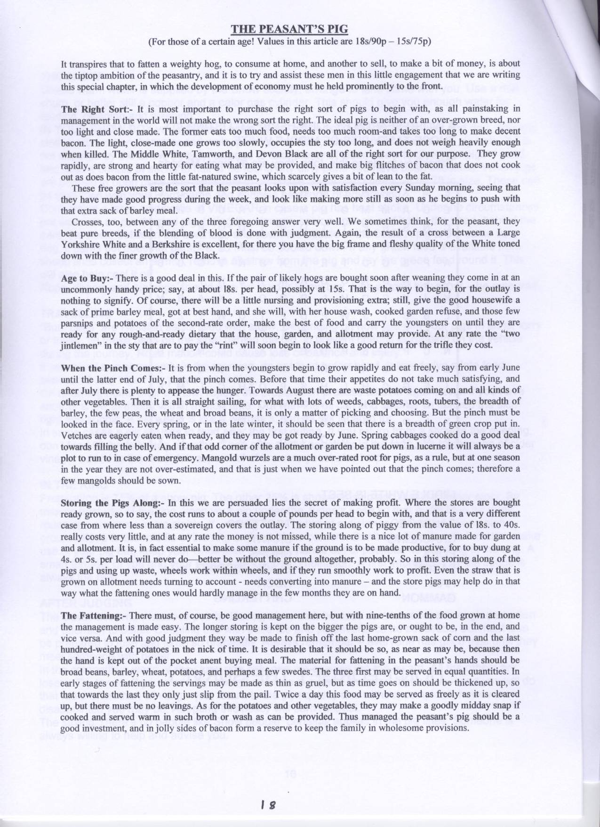

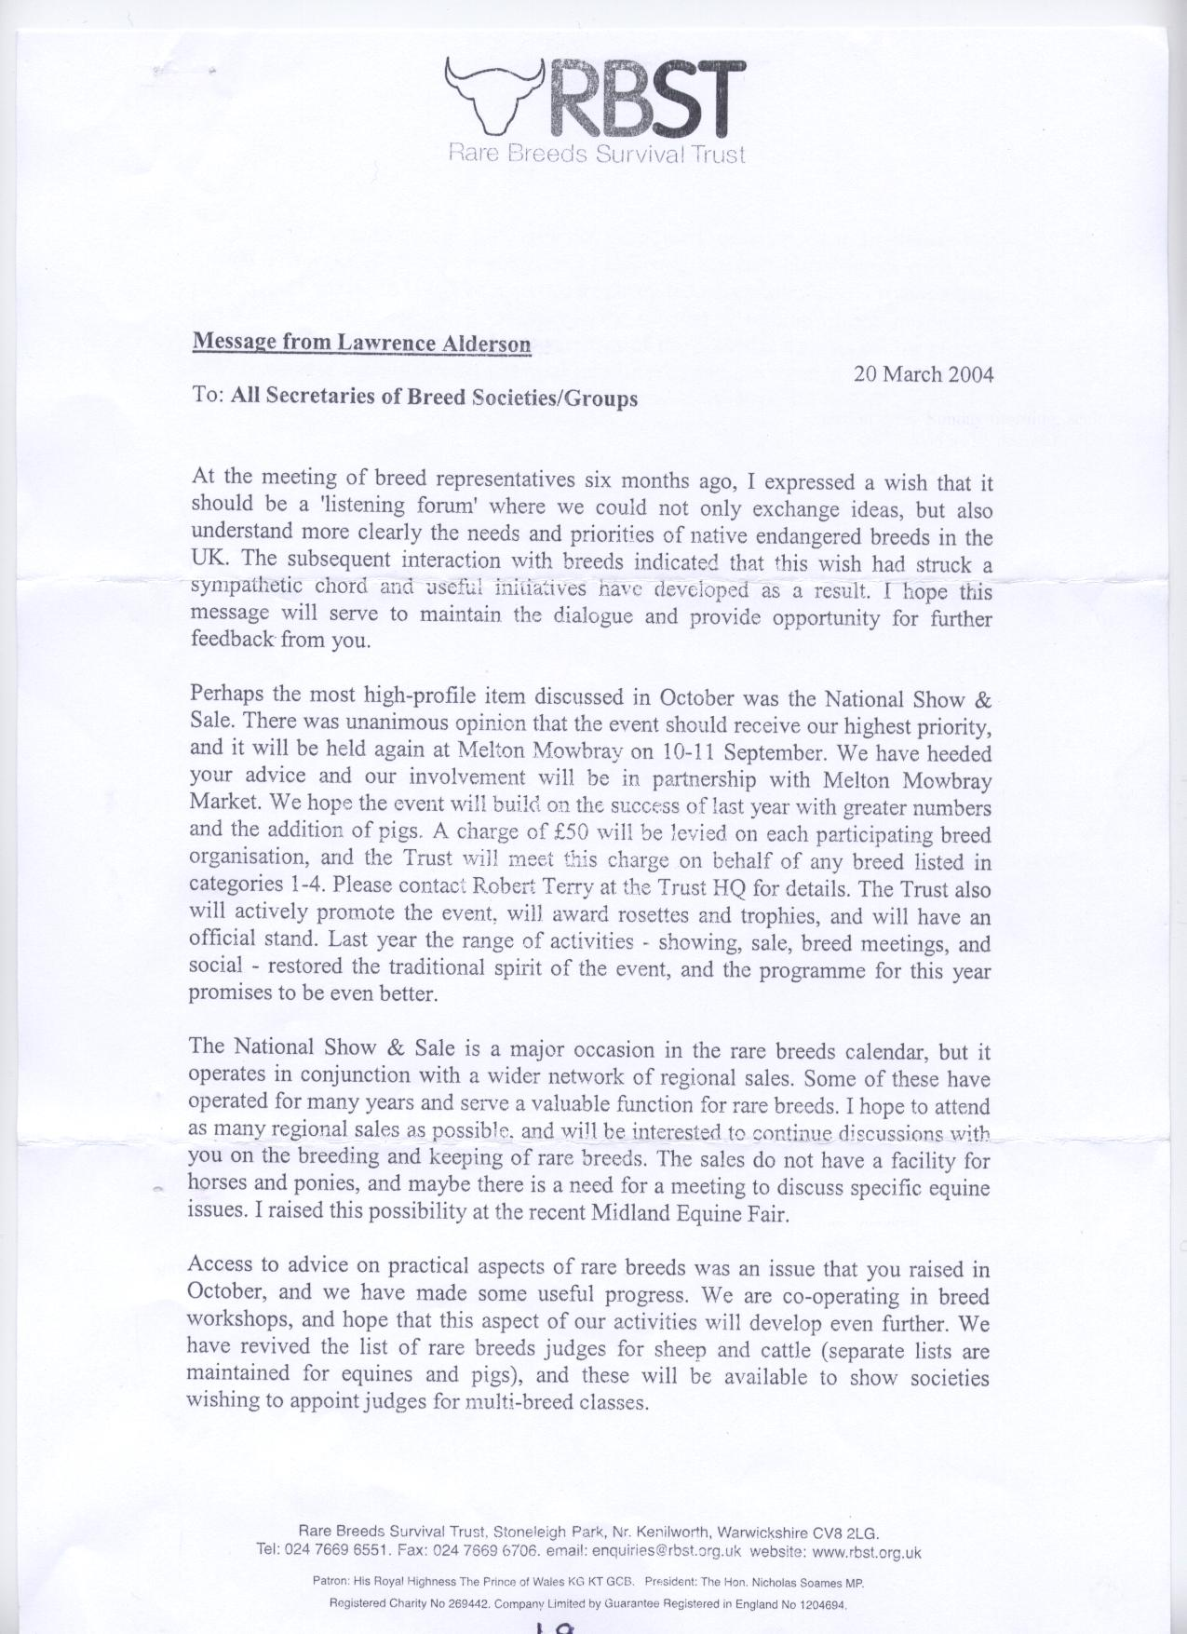

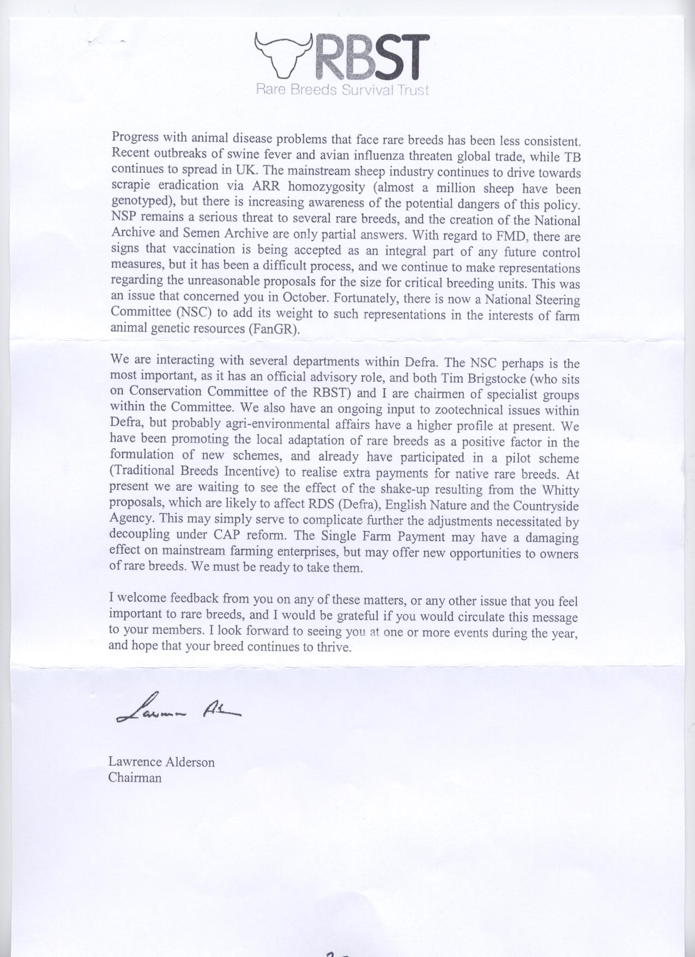

Pages 21 & 22 were the address lists

**MIDDLE WHITE PIG BREEDERS CLUB**

**NOTICE OF MEETING**

**ANNUAL GENERAL MEETING**

WILL BE HELD ON

**SUNDAY 18 April 2004**

AT

**NEWBROOK FARM, FRANKLEY, BIRMINGHAM**

**11 AM PROMPT**

**AGENDA**

**1** - Apologies for Absence

**2** - Minutes of the AGM held on 27th April 2003

**3** - Matters Arising from the Minutes

**4** - Chairman’s Report

**5** - Secretary/Treasurer’s Report

**6** - Election of Officers and Committee

(a) President

(b) Chairman

(c) Vice Chairman

(d) Secretary/Treasurer

(e) Members of the Committee

**7** - Any other business

AS IS CUSTOMARY WE WILL BE HOLDING A **RAFFLE** TORWARDS CLUB FUNDS **DONATIONS OF PRIZES** WILL BE VERY GRATEFULLY RECEIVED

---------------------------------------------------------------------------------------------------------------------------------

**10.30 am Coffee/Tea and Biscuits.**

**11.00 am PROMPT – AGM**

**1.00 pm Buffet Lunch**

**DIRECTIONS TO NEWBROOK FARM**

M5 Junction 4 exit. Take **A491** signed to **Stourbridge** then **1st Right** on to **B4551** (Honey Lane). In approx 1.5 miles – with **Manchester Inn** on the **left** – turn **Right** signed to **Frankley.** Take **Next left** into **Newton Lane** – carry on **past Yew Tree Lane** on the right – and **Newbrook** is next **on right.**

24