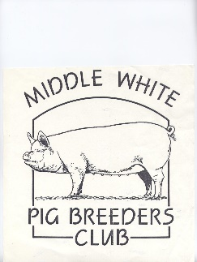

MIDDLE WHITE

PIG BREEDERS CLUB



(PATRON: ANTONY WORRALL THOMPSON)

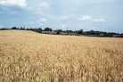

NEWSLETTER

SUMMER 2005



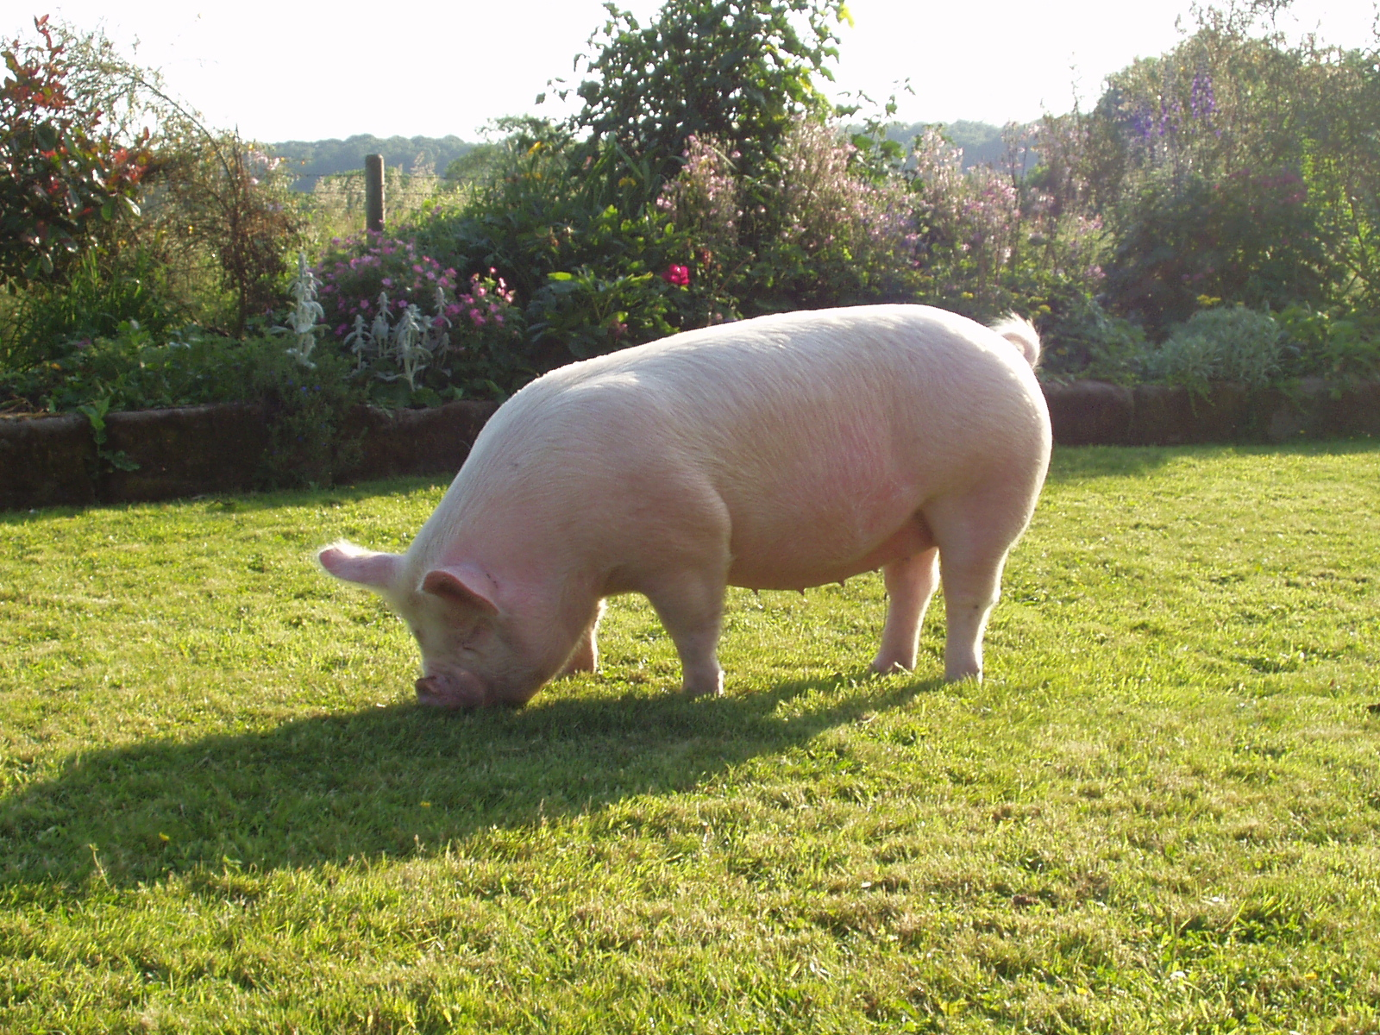

**Eaves Alma Rose 6TH**

OVER 150 YEARS OF THE MIDDLEWHITE

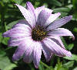

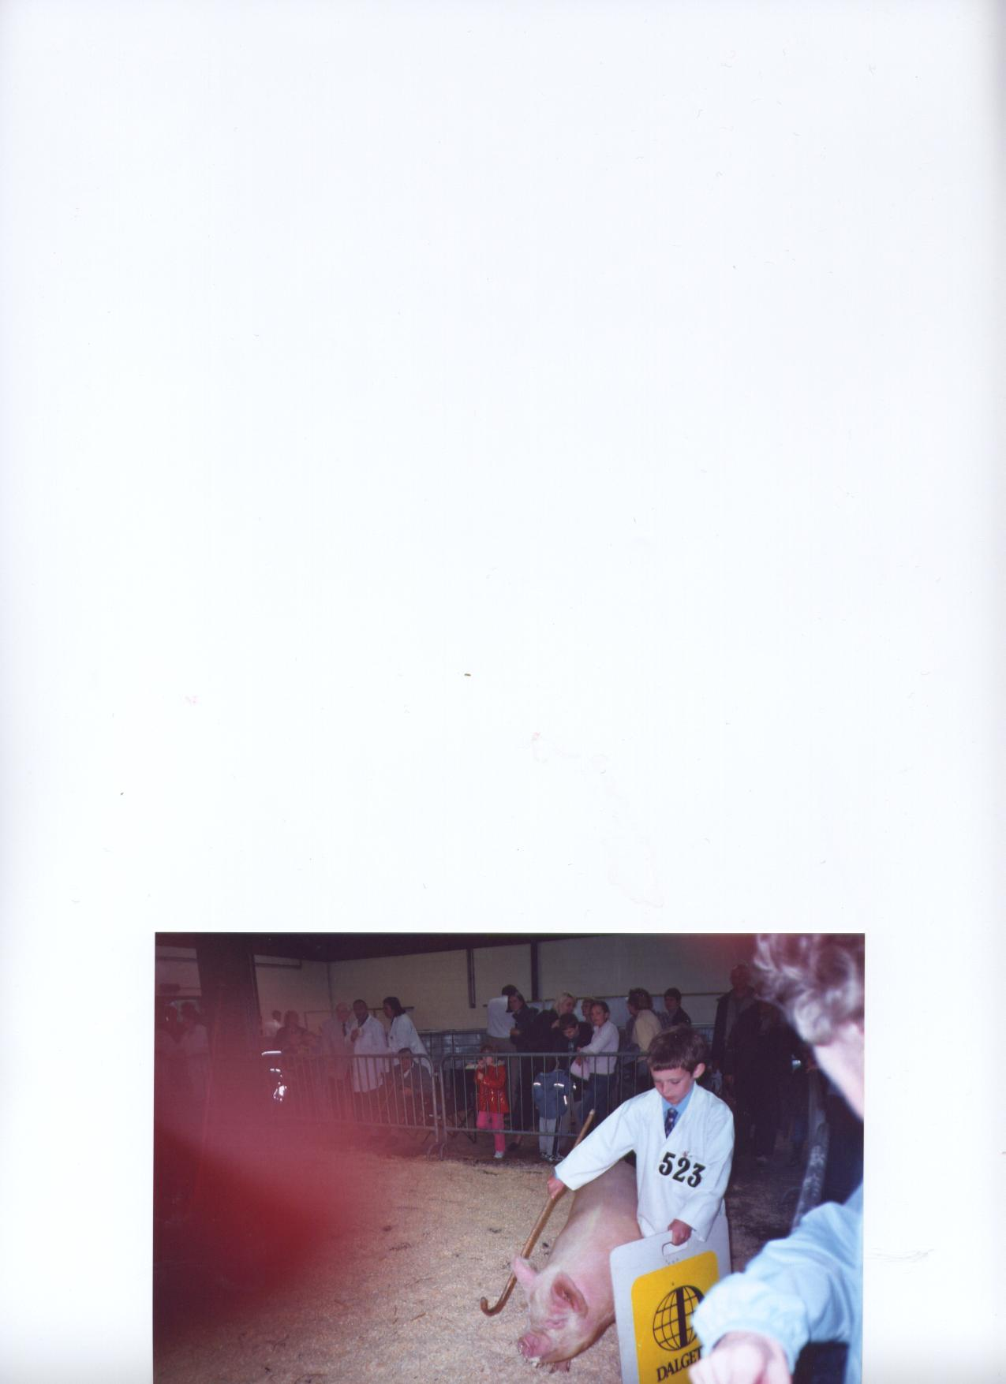

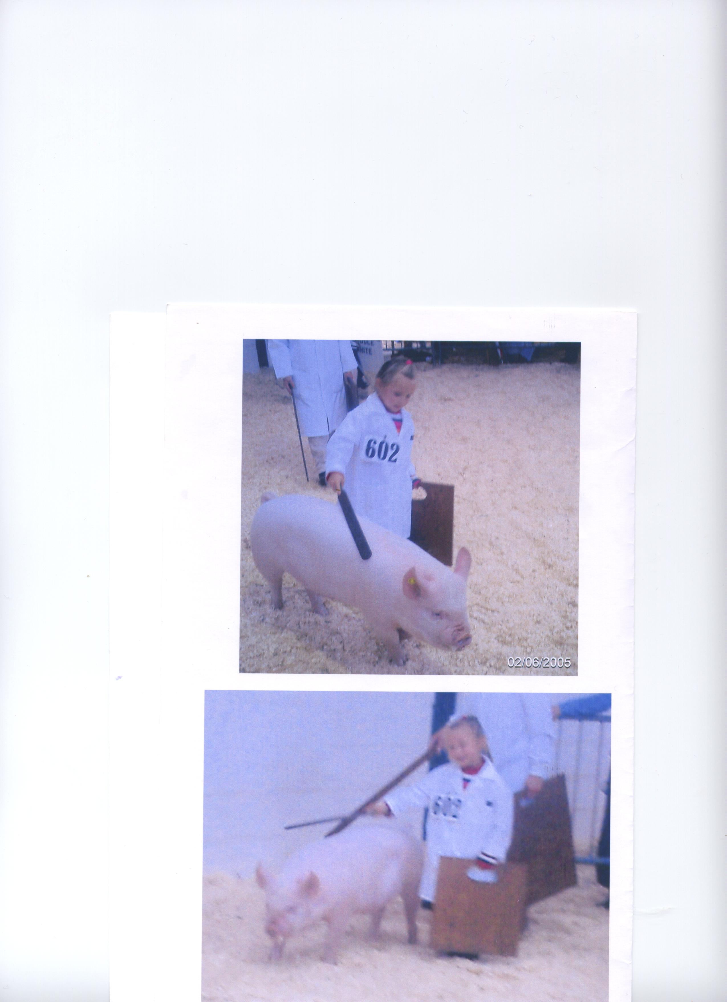



Left: Lewis Bennett showing the September gilt Shortheath Fair Lady 22nd his pig given to him by his granddad Chris Pedley

Below: Brian Merry seen here in spotless white overalls during his Auto Grass Racing days. This picture must have been taken before events got underway.

Left: Grace Bretherton, showing her January gilt, Cestrian Woodlands Lady 38th under the watchful eye of mum Tracey, although Grace, aged 4, walks her every night at home.

How lovely to see two more youngsters having a go, and enjoying, showing pigs. Both are very keen so let’s hope that they continue to be and so keep our breed going. We need them for the breed to survive.

Cover Photo:

Mick Paddock’s and Sarah Marsden’s Champion gilt (Katie) at Stafford Show, photo taken by Sarah at home. It saves on a lawn mower, let’s hope she keeps to the grass

Edited and published by Miranda Squire on behalf of The Middle White Pig Breeders Club.

Benson Lodge, 50 Old Slade Lane, Iver, Bucks, SL0 9DR

Tel: 01753 654166 Email: Miranda@middlewhites.freeserve.co.uk

2

**Chairman’s Letter**

Dear Members,

Much has happened since I last wrote to you all, the saddest news being about the death of our president Jack Howlett.You will see his name mentioned many times throughout this newsletter but I feel that I must write my own personal tribute to Jack before anything else.

From the very first time I showed my Middles at a major Show Jack was there with helpful constructive advice telling me that “you were very lucky to win with that sow” or “you were very unlucky not to be placed with that boar”!

It was entirely due to Jack that we have AWT as our patron and fellow breeder raising the profile of the club enormously. Antony was at that time keeping Vietnamese pot-bellied pigs, why I can’t imagine so I don’t think Jack had to work too hard to persuade Antony that Middle Whites were the breed to keep. Many people in the ‘pig world’ will sadly miss Jack and this will be the first newsletter for a long time that Miranda has had to produce without an interesting article from Jack about his life and times as a breeder and exporter of pedigree livestock.

Since my accident last October and I haven’t been able to look after my own pigs and I’ve had to rely on Bryan to cope with not only his own large blacks but my Middles as well, a situation which has led to more than a few ‘ domestics’ regarding management etc!

I have attended several shows and I’ve had the opportunity to observe from the ringside classes of all breeds and do a little bit of unofficial judging myself. Sadly one of the things that have struck me has been the number of badly presented pig of all breeds that have been forward. Dirty pigs, badly or untrained pigs, mangy pigs, pigs with calluses on their knees and hocks, dirty ears, and worst of all lame pigs!

Jack always said that the shows were the best ‘shop window’ for the promotion of the breed but unless the pigs are well presented they are not going to be a very good advertisement for the breed. I know what hard work it is to get and keep a white breed immaculate before going into the show ring, they always decide to wallow or root just before the steward calls your number or in the case of gilts come on ‘heat’ so any attempt to move them results in the gilt standing stock still, ears erect in anticipation! Baby oil, Flowers of Sulphur, Woodflour and plenty of TLC are all you need as well as a good diet, parasite control, and plenty of clean bedding; Good luck!

**……………Mary Card**

**Secretary’s Notes**

It’s that time again to put pen to paper, although this issue is a little late as too many things have cropped up that had to be done.

First of all I must tell you that sadly Jack Howlett, our President, died on 14th June aged 72. He hadn’t been well for some time with diabetes and waiting for dialysis and also having problems with his pacemaker in March and only coming out of hospital two days before our AGM on April 17th. He was able to attend that courtesy of Marcus Bates of the BPA, but he didn’t look well. This didn’t prevent him from chairing the meeting and taking an active part in all the proceedings. Not long afterwards he suffered a stroke and was again hospitalized. At Jack’s funeral on June 16th the Club was represented by Chris Pedley and Duncan Staig. Unfortunately owing to serious traffic problems on the M25 Viki Mills and Martin Snell who were going and representing others were unable to get there.

I had known Jack since the 1960’s when he came to Joan and Duncan Staig’s Sladepark herd to select large White pigs for export. They then purchased their first Middle Whites in the mid 60’s. I will certainly

3

miss our phone chats that we have had over the last few years. Any query it was phone Jack, he’ll know the answer.

The sausage competition was his idea, as he said that we needed something to show that the traditional breeds could produce as good a product as all the modern/hybrid breeds. He was also instrumental in getting the live pigs back at Smithfield, albeit only for demonstration.

The BPA and the MWPBC have jointly purchased a trophy in Jacks memory. It was jointly chosen by the MWPBC Committee members and the BPA, the cost being met equally by the two. This is now being engraved “Jack Howlett Memorial Trophy” with a plinth and band added for the winners names to be engraved on.

The trophy will be presented to the winner of the “Young Pig of the Year” competition to be held at the Hatfield Show in August. If anyone wishes to make a personal donation towards this please send a cheque payable to the MWPBC to me at Benson Lodge, 50 Old Slade Lane, Iver, Bucks SL0 9DR, with a covering note to say that it is towards the trophy.

The show season is in full swing and there have been a few surprises. Some of the things noted by Judges are bad underlines, dirty pigs, and pigs not walking out well. The actual comment was “don’t people walk their pigs anymore?” I know it’s easy for me to say this when I’m not doing it, but believe me I spent many years preparing pigs for showing and have “been there, done that and got the Tee shirt”. These comments were not just about Middle Whites but across all breeds.

**Incorrect Subscriptions**

There are still 11 of you who have not yet changed your standing orders to the new subscription rate or sent the £5.00 balance, outstanding from January.

A reminder was included in the last newsletter. If you address label and this passage are highlighted then THIS MEANS YOU. I will be grateful if you could send the balance and the new standing order to me as soon as possible,

**Web Site for Small Producers**

The following has been received from the Meat & Livestock Commission.

“British Pig Executive have part funded a new web site for small scale producers and farm shops, butchers etc selling top quality pork to promote their businesses and get closer to the consumer. The site is at www.localpork.co.uk and to register either your business or businesses that you supply just log on and click 'register'. I would be grateful if you could promote the site to your members.

Thank you again for your help”

Tony Goodger   
Meat & Livestock Commission   
Trade Sector Manager - Foodservice.   
Direct Telephone 01908 844114   
Mobile Telephone 0777 5535212   
www.mlc.org.uk   
www.localpork.co.uk

**AI**

A new group of boars will soon be going over to the AI Centre at the Deerpark in Ireland. At the AGM it was suggested by Jack and decided by vote that the Club would pay £300 to keep a boar at stud there for 6 months. This should mean there will be supplies of fresh semen available for all breeders during this period. Selection and testing is on going at the time of writing. More details will be available at a later date.

4

**Display Boards**

We have some new display boards this year, kindly donated by Geoff Parker, Kelsall Pig Farms, Tarporley. The old Marler-Hayley boards were very heavy to keep lugging around and awkward to put up, so Geoff suggested these. The pictures are lasered onto the fabric and the base filled with water to make them stand.

**Raffle Tickets**

Many thanks to those of you who have sold and returned the stubs etc.

A reminder to all of you who have raffle tickets to sell. Please do what you can and return all unsold tickets, stubs and money back to me as soon as possible. Hopefully this reminder will save me having to chase up too many of you, taking time and money for phone call etc.

**Club Trophies**

At the AGM the club cups were presented as follows:

The Joan Staig Memorial Trophy for Champion Middle White – John Herbert with Dappleheath Captain 15th.

Reserve - Geoff Parker with Cestrian Revival 4th

The Marshlands Trophy for opposite sex – John Herbert with Dappleheath Dorothy 51st

Reserve - Tracey & Ian Bretherton with Cestrian Yootha 24th

The Rose Bowl for Youngstock – Geoff Parker with Cestrian Revival 16th

Reserve - Geoff Parker with Cestrian Woodlands Lady 29th

The Gillhouse Novice Trophy – Maggie Todd

**Miranda Squire**

**Jack Howlett**

As president of The Middle White pig Breeders Club, Jack will be greatly missed.

He was a fount of knowledge and always keen to pass this on to members of the Club. His articles about the history of the Middle White were very informative and of particular interest to new members of the Club.

For many years, Jack was active in the field of livestock export and his accounts of trips abroad and the various characters that he met in the course of this work were amusing as well as interesting.

Jack was one of the instigators of the Pig of the Year competition and it was always his intention that this should be for pigs born on or after 1st January of that year. The new Young Pig of the Year competition has brought his idea to reality and The Middle White Pig Breeders Club, in conjunction with the BPA are in the process of instigating the Jack Howlett Memorial Trophy to be presented to the winner of the Young Pig of the Year final at Hatfield in August.

**John Herbert**

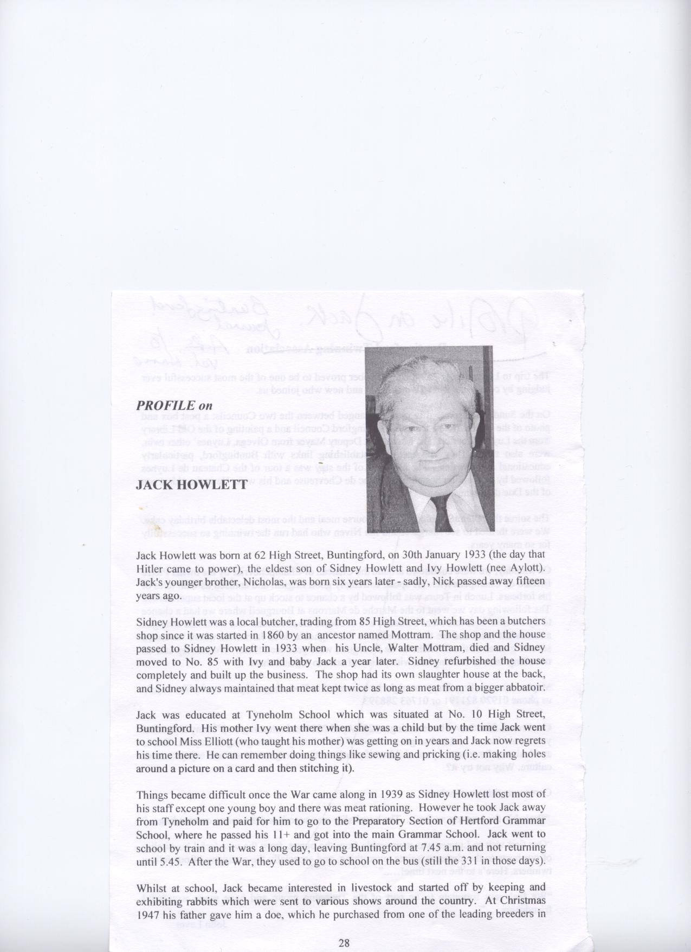**PROFILE on JACK HOWLETT**

The following article about Jack has been reproduced from The Buntingford Journal by kind permission of the author, Val Hume.

It was written in 2004, with a particular slant on the Howlett family’s place in the history of Buntingford, Herts.

Jack Howlett was born al 62 High Street, Buntingford, on 30th January 1933 (the day that

Hitler came to power), the eldest son of Sidney Howlett and Ivy Howlett (nee Aylott).

Jacks younger brother, Nicholas, was born six years later - sadly. Nick passed away fifteen

years ago.

Sidney Howlett was a local butcher, trading from 85 High Street, which has been a butchers shop since it was started in I860 by an ancestor named Mottram. The Shop and the house passed to Sidney Howlett in 1933 when his Uncle. Walter Mottram, died and Sidney moved to No. 85 with Ivy and baby Jack a year later. Sidney refurbished the house completely and built up the business. The shop had its own slaughter house at the back, and Sidney always maintained that meat kept twice as long as meat from a bigger abbatoir.

Jack was educated at Tyneholm School which was situated at No. 10 High Street, Buntingford. His mother Ivy went there when she was a child but by the time Jack went to school Miss Elliott (who taught his mother) was getting on in years and Jack now regrets his time there. He can remember doing things like sewing and pricking (i.e. making holes around a picture on a card and then stitching it).

Things became difficult once the War came along in 1939 as Sidney Howlett lost most of his staff except one young boy and there was meat rationing. However he took Jack away from Tyneholm and paid for him to go to the Preparatory Section of Hertford Grammar School, where he passed his 11+ and got into the main Grammar School. Jack went to school by train and it was a long day, leaving Buntingford at 7.45 am and not returning until 5.45. After the War, they used to go to school on the bus (still the 33I in those days).

Whilst at school, Jack became interested in livestock and started off by keeping and exhibiting rabbits which were sent to various shows around the country. At Christmas I 947 his father gave him a doe, which he purchased from one of the leading breeders in Nottingham for £30 - a tidy sum in those days but it paid off as it bred a first prize winner at the London Dairy Show at Olympia the following year! Jack was fortunate in that there was plenty of land at the back of No. 85 which went all the way back to Bowling Green Lane, with a tennis court, plenty of room for grazing and space for the pet dogs, always dachshunds, to run around. During the War they had their own cow and a donkey to keep it company, and Jack’s mother made her own butter.

In 1949 Jack passed the School Certificate in six subjects, which was obligatory at that time, and he left school the following year. At his father’s insistence he went to work for Barclays Bank in Royston which Jack hated and it wasn’t long before he resigned and joined his father working at the Butchers in Buntingford. Jack’s father employed two other men, George Hagger and Joe Pinner, who were both expert slaughtermen as well as being good butchers. George’s father, Lou Hagger, was a wheelwright who worked in Buntingford. Jack said he was a fantastic craftsman but very set in his ways. When Lou retired he refused to draw his old age pension and yet lived to a great age.

6

In 1954 Jack went into pig breeding and built a piggery at the back of No. 85, where the Health Centre is now. I have learnt quite a bit about pigs after talking to Jack! They are intelligent animals and very clean if kept properly. A female pig is known as a gilt until after her first litter, when she becomes a sow. Jack bought his first female from Chivers (the jam makers) who were apparently well known for livestock at that time. When she was ‘in pig’ (i.e. pregnant), Jack was keen to start exhibiting from her first litter as he had always been very competitive. He exhibited a pair of pork pigs at the Smithfield Show in Earls Court and won 4th prize but his biggest thrill came when a pair of pork pigs won 1st prize at the Smithfield Show in 1955 and Reserve overall Championship for August horn pigs. Jack was only 22 at the time.

At one of the shows he met Don McLean who was a well known herdsman at that time who taught Jack everything there is to know about pigs. One thing which Don said at Smithfield was: “If you play your cards right and the fact that you come from a butchering family, you will judge

this show one day”. At the time, Jack didn’t believe him but in fact he proved to be right! Jack

has judged at many shows in the U.K. including the Royal Show four times, the Royal Smithfield Show 5 times and the Royal International Dairy Show at Olympia three times. He has also judged in Brazil, the U.S.A., Canada, Thailand and Japan. Jack remained friends with Don until his death about 10 years ago.

The following year he entered a pair of pigs in the show but they only came second. Jack remembers bringing them back to Buntingford in very damp and foggy conditions and the pigs were very poorly, barely able to stand. However, Jack nursed them back to health and was rewarded by one of them becoming Supreme Champion at the Royal Show in Norwich the following year and both went on to win many prizes.

Jack had a setback in 1958 when all his pigs bar one died with swine fever, even though they had all been vaccinated. They were all buried in the grounds behind No. 85, supervised by the police. The pig that survived was Ribvalley Premier Prince (all Jack’s pigs were given the prefix “Ribvalley”) which had been loaned to a friend at the time and he went on to become Male Champion at the Royal Show. Luckily for Jack, he was able to re-stock with six proven sows which he bought from Chivers, who were cutting down on their livestock activities.

In the early 1960s, Jack’s family acquired a Boxer bitch which was previously owned by Peter Sargent (son of Sir Malcolm) and they subsequently bred from her. Only two dogs survived the birth and they grew into big dogs named Rajah and Jasper, with the most placid nature. However, unfortunately they did not like other dogs and one lady customer insisted on coming into the shop with her dog, which was not on a lead. One day the lady walked into the private section of the shop and one of the dogs bit her. Jack’s parents felt that they had no choice but to have the dogs put down. This upset Jack and he named two of his boars after the dogs, but gave Ribvalley Jasper away to someone in Cambridge.

It had always been Jack’s ambition to become a judge at the Royal Show before he was 30

- his father did a lot of judging at fatstock shows, mainly cattle and sheep. In 1964 when Jack was 31 he was invited to judge at the Royal Show at Stoneleigh (which is now the permanent Show Ground) and was one of the youngest judges. He also held various offices, including Chairman of three committees, in the National Pig Breeders Association.

Jack already served on the Buntingford Parish Council but in 1961 he decided to stand as a candidate for Hertfordshire County Council and because he was busy with canvassing he was too late with his entry for the Royal Show that year but Ribvalley Jasper, the pig he had given away, was the Male and Breed Champion that year! The other boar which was named after Jack’s dog, Ribvalley Rajah, was sold to a Mr Wood in Wigan but went on to sire many prize winning pigs and the Rajah line is still considered to be the best. The Pig Breeders Association subsequently insisted that all names should follow the blood line, so therefore Rajah’s male descendants will all be called Rajah.

7

Jack became a member of Hertfordshire County Council and served for 9 years altogether. The business expanded and they took over two butchers shops at Watton at Stone. In 1966 Jacks father sold the land at the rear of 85 High Street and the White Hart Close houses were built together with the Health Centre. This meant that Jack no longer had the space to keep pigs so he went back to breeding Polish rabbits and twice won Breed Championships at the London Championship Show.

In 1970 Jack was given the opportunity of becoming a pig consultant to the British Livestock Company which was based at Sawbridgeworth. Initially this was part time but then Jack decided to work for the Company full time and the Watton at Stone butchers shops were sold, although Jack’s father continued to run the Buntingford shop.

Jack’s first trip was accompanying 60 pigs by boat to Poland and this was his first introduction

to vodka! The crew on the ship over were all heavy drinkers and the captain was so drunk he

had to be put to bed every night! In his first year with the company Jack went by train across

Europe to Budapest in Hungary for the National Agricultural Show and, in the same year, at the

age of 37 he flew for the first time when he had to accompany a load of pedigree pigs to Spain. He liked flying, which was just as well as his new career meant that Jack travelled to 74 different countries world wide and he was responsible for the export of more than 40,000 pigs to 84 different countries. His experiences over the next 25 years reads like a travelogue and it would take a series of Journals to record them all.

The early 70s were very busy for Jack, mainly buying pigs for export. At the same time he took the opportunity of re-starting his own pig herd which he kept on some land at Sawbridgeworth where the Company was based. One of the pigs he bought was a boar from the Rajah family, a descendent of the pig he sold 10 years previously! The boar was judged Breed Champion in 1971 but was unfortunately killed in a fight with another boar the following year.

In 1972 Jack organised the export of some cattle, sheep and pigs to an exhibition in Porto Alegre in Brazil and despite suffering with a cracked rib following a slight accident, he managed virtually single handed to unload the animals and seven of his pigs won second prize. Jack later found out that the first prize winners at that exhibition were from America and the Judge was the man who exported them! The exhibition was even bigger two years later when Jack organised the export of two plane loads of animals. The Aberdeen Angus Society arranged for the British Stand at the Show to be sponsored by the makers of Famous Grouse Whisky, who provided 144 bottles for visitors, which proved a big attraction.

At the same time, Jack and some of his colleagues started a herd of Hampshire pigs, and a

Champion was brought from the Toronto Winter Fair. They were kept on a farm at

Westmill and the herd went on to win Breed Champion at the Royal Show seven times in a

period often years.

In 1972 Jack’s father, Sid, retired and the butchers shop was sold to Mark Doel. Some of the land at the rear was retained and planning permission was obtained. However, Jack says they had problems with the Council over access from the Health Centre and they ended up having to buy a house on the corner in White Hart Close. However in the end they were allowed to make a hole in the wall adjoining the Health Centre and two bungalows were built.

Jack made several trips to Taiwan, starting in 1978, and says that it is a modem, up to date country and over the years he has made good friends there. In 1983 he went to Russia with the British Agricultural Export Council Delegation. They were well entertained with visits to the Bolshoi Ballet and the Kremlin and went by train from Moscow to the Memorial Park in Minsk. Jack said it was so sombre, with a muffled bell tolling every half minute day and night. They were shown plots where it was said that some 50,000 people had been slaughtered by the

8

Germans - although it later transpired that they had been killed under Stalin. Jack has been back to Russia since, just after the counter revolution, and missed his flight to Samara. He had to spend the night in a hostel with no food and all he could buy was a few crisps. The only food you could buy in Moscow was Kentucky Fried Chicken and MacDonalds, with long queues of people wanting to buy, and Jack said the people were desperate to change their roubles into dollars.

His accommodation on a trip to Nigeria was not much better. Unfortunately, on the way back to the airport the Nigerian President was assassinated and the airport was closed. Jack had to spend one week in a mud hut with a corrugated iron roof. Jack said it was very hot and the food was usually pounded yam but the Company agent tried to look after him by going to a hotel to get food, which had gone cold by the time it reached the mud hut!

Jack went to Libya to negotiate with the deputy President, as the Libyan Government wanted

1000 Jersey heifers for a project to provide small farms for retired policemen and soldiers. Jack said they pursued an ‘open door’ policy and there were continual interruptions to the meeting by, as an example, someone coming in to ask if they could buy a new head for a broom!

Jack has done a lot of business in Thailand and visited it about 20 times and made a lot of

friends there. He considered Bangkok to be a safe city, with no mugging, and he felt safer there than anywhere else. He said you are well looked after by the British Embassy if you go on any official visit in the Far East.

On a trip to the Philippines, he spent an enjoyable evening dining at a restaurant in Manila. When it was time to go back to his hotel, he remembered some advice given to him by an old colleague to get a cab as you should never go out alone in Manila; it was too dangerous. Jack hailed a cab but half a mile down the road the driver drew a knife and threatened to kill him. Two men got into the car and went through his pockets but luckily did not take his passport. They then drove round Manila for an hour, dropped him off and gave him a few pesos for a cab home! He found out later that you should only use cabs with the words “golden cabs” on the door, as they are checked.

On a trip to Vietnam Jack had to negotiate one of the precarious bridges over the many rivers and streams of the South Mekong Delta,(unfortunately the picture of Jack is too poor to reproduce here), which is about 4 hours from Ho Chi Min City. Jack says the city is a very lively place, with some good restaurants, but there are beggars everywhere and it can get quite distressing. On one occasion he was walking along when a little boy came up to him and said: “Shoe shine mister?” Next minute, about twenty small children appeared, some with only one leg. If you give something to one, they all want some. He says there seem to be thousands of scooters and he saw some horrific accidents on the way to Mekong involving young people on scooters.

Jack went to Burma on one occasion but says he will never go again. The Agent who met him asked if he could bring gifts for the Government staff but it transpired that he only wanted things to sell. On the way back to the airport Jack was asked if he could post a parcel, but it had to be posted in Bangkok. He got the impression that he dare not refuse to take it and he had a very scary moment going through customs, as immigration officials were very strict. Luckily nothing happened and Jack finally posted the parcel but says that it was the most frightening time of his life.

Things started to go wrong in 1988 with the B.S.E. crisis. Jack’s Company moved its base to Wyddialbury Farm and because of B.S.E. the export of animals was banned; Jack was reduced to doing business on a commission basis only. He sold the house in White Hart close and

9

moved to a flat in Wyddial. He was in Singapore on the way back from a visit to Bangkok and Manila when he suffered a heart attack and stayed in hospital there for five weeks. The British Livestock Company closed in 1995 and for the next three years Jack did consultancy work.

Jack now lives in semi-retirement in a bungalow in Anstey but his services as a Judge are still in demand - hardly surprising when you consider that under Jack’s management, pigs have won in total 37 Royal Show Championships and 57 first prizes at the Royal Smithfield Show at Earls Court, London. This year he judged the Interbreed Championships at the Great Yorkshire Show in Harrogate and the South of England Show - and says he will continue to do so as long as he can. He was told that his heart attack was probably brought on by diabetes and that he may need kidney dialysis.

Jack keeps up his interest in pigs and is still a committee member of the British Pig Association. For the past five years he has been President of the Middle White Pig Breeders Club, which has Antony Worral Thompson as its patron. Antony has his own herd of Middle Whites to supply

quality pork to his London restaurant.

The business which Jack’s ancestor started nearly 150 years ago is still going strong, now under the ownership of Jeff Pigg. Jack says that we in Buntingford are very fortunate to have two good private butchers shops still in the town, both selling good meat. Jack still comes to Buntingford a couple of times a week to see his cousin, Frank Aylott, and tells me that he does not know what he would do without Frank, who takes him backwards and forwards to hospital and is very good to him.

**Val Hume**

One of the two new committee members voted in at the AGM in April was Brian Merry, replacing Nick Hunkin who wished to stand down as he no longer keeps Middles, having got more involved with other breeds. Brian has done a lot for the Club over the years, selling raffle tickets in huge quantities etc., and has been Geoff Parker’s right hand man. It is lovely to see him with some pigs in his own right. As you will see from the following story, the Chorley and District Gardening Society, Auto Cross Racing and Poultry Show’s loss are our gain.

Good luck Brian with your new venture, lets hope that you have as much success with this as your previous hobbies.

**THE LIFE OF BRIAN AND HOW I GOT INTO PIGS**

I have always enjoyed showing. My first experience was way back in 1961 when I won 1st prize at the local horticultural show in the “three carrots short class”. Then after a few years I started Auto Grass Racing and qualified for the national finals on three consecutive occasions, which was no mean feat, but after that it became too expensive, the same as all motor sports. So then I took up showing poultry and eggs which I enjoyed, but I liked showing the cockerels, same as I now like showing boars best.

I did that for about 5 years and decided to go back to flower shows, but in a bigger way, showing all over Cheshire, Shropshire and Lancashire. Then about 12 years ago I met Geoff Parker in the local pub and we became friends. One year Geoff went to the Cheshire Show and saw John Herbert’s Middle Whites and fell in love with them. As he ran a haulage business and also Kelsall Pig Farm he thought he would buy a Middle White as a pet. So, subsequently, as at that time John didn’t have any for sale he bought a Ladys Maid from Wymott Prison and asked me if I would like to go with him to pick her up, which I did.

Nothing more was said till early July when we met up in the pub one night. He said that the

10

chap whom he had bought the in pig gilt off had entered her and a couple of gilts at the Lancs Show. The two January gilts looked a picture. When Geoff asked me if I knew anything about pigs and showing I said that pigs have a leg on each corner and are good to eat, showing that I didn’t know a thing. The judge said the little gilts would have won but the underline was not the best. Geoff and I soon did a lot of learning, and both of us are still learning because you learn something new at every show. I still kept on showing flowers for about another 2 years, as well as giving Geoff a hand with his pigs, but in the end I got plagued with rabbits so the horticultural side of me stopped and I began to spend more time at Geoff’s.

There have been a lot of good times in the showing world with the pigs. You get to know new people, and as the saying goes “there is no people like show people”. When Geoff won the Middle White Raffle draw holiday on the Isle of Islay, Geoff, Jimmy, Geoff’s brother and I had a great time and met Chloe Randall, and it was great to see her again at the Hatfield Show.

The best times for me with the pigs came at the Royal Show in 2000, when Geoff and I won Middle White Reserve Champion, runner up to a wonderful 6 year old sow bred and shown by Mary Card, with our boar “Fred”, Cestrian Revival 2nd. The next was winning the best Middle White at the Royal Show and coming Reserve Champion in Pig of the Year with Cestrian Revival 4th (Ronnie). In a previous newsletter Geoff related how he had to have Ronnie put down.

Watching Geoff win Supreme Champion at the Royal with his sow (Winnie) and all the wins he had with Freda and being handler of Cestrian Purity when she won the glass decanter at Hatfield In the 150th year of Middle Whites and also last year winning the Best Middle White at the Royal with yet another Cestrian Revival boar (16th known as Walter) assisted once again by Tracey Bretherton have all been highlights. That is now two Royal wins for the Cestrian boar line. Geoff has bred some good Revivals over the years.

After the Hatfield Show last year I was going to pack up pig showing for different reasons and Tracey said that if you pack up I will as well. I don’t know whether she would have, but now we will never know as on 11 October 2004, out of the blue, Mervyn Forster rang me and said that he would like to give me Elgany Woodlands lady 192. After a long conversation on the phone it was decided that I would buy the litter sister so that 192 would have some company. So where was I going to put the pigs? Well the back garden became a builder’s yard.

Geoff had given me pig doors, gates, pipes etc. I had nearly finished the inside of the pens so I was somewhere near completion when I eventually went down to Mervyn’s on the 20th March to pick them up with Geoff’s little trailer which he has let me borrow this year.

As it’s the big Middle White Club raffle draw this year everyone who buys a book of tickets from me can enter into a free draw for a small prize. The question they have to answer is how much money did I put in Mervyn’s hand for Woodlands Lady 193. The clue is in her name so come to the shows, wander up and down the pig lines and buy some tickets and have some free goes.

I travelled down to Lambourn for the first show of the season to get some more ideas as I am on the Cheshire and Lancashire Show Committees with Phil Brown and Ian Bretherton. I was talking to Bryan and Mary Card in the pig lines and Mary told me that she was going to give me a Middle White boar but at the time didn’t think that she had one good enough, and that is how I ended up with the gilts from Mervyn.

I have the highest regard for Mary, who is not in the best of health, and it is always a pleasure to see her at the shows she attends, because without a doubt she is currently the no. 1 for knowledge, breeding and showing of the Middle White pig, and was probably the instigator of me having Middle Whites of my own.

Many thanks to Mary and Mervyn and all involved. Regards, **Brian.**

11

**Chris Pedley** writes from the Royal Show,

Dear Miranda,

Would you please print this in the next newsletter. I would like to use this opportunity to thank all the people who helped me, mainly at the Newark and Notts Show, but at all the shows this season.

On a more sombre note, I would just like to inform you that I managed to represent the Club at Jack Howlett’s funeral. I thought it rather appropriate as this season I am showing a Rajah boar, and Jack had bred the first Rajah some years ago. I will also say that at the Cheshire Show all the pig exhibitors had a minutes silence for their show secretary who had suddenly died, but jack was mentioned and included in this tribute.

One of our newer members, my grandson Lewis Bennett has accompanied me to three shows, showing his own gilt, and some of my pigs, and he has capped all of that by winning the junior handlers 10 – 13 class and then competing against the winner of the 14 – 17 class and winning that as well. A photo of Lewis demonstrating his skills is shown on page 2.

Alan rose told me an interesting tale of Jack Howlett. Some years ago when Jack was showing he was stood outside the ring watching proceedings when two boars started fighting, the handlers could not separate them so Jack picked up one of the metal barriers, marched into the ring, smacked the barrier down between the two boars, and without speaking marched out again, job done.

**SHOW RESULTS**

The Show Season started on at the beginning of May, Lambourn being on the 1st. After several heavy showers of rain in the preceding week the Sunday turned out to be windy but very hot.

**LAMBOURN 1st May - Judge Peter Ragg**

A much better entry this year of 27 pigs though not all were forward. The judge was Peter Ragg.

**Middle White Junior - 3 Forward**

1) Marquess of Salisbury with Crane Modiste 4th

2) Bryan & Mary Card with Westham Almarose 401

3) Bryan & Mary Card with Westham Fair Lady 471

**Middle White Senior**

With only 1 forward the 1 Gloucester Old Spot forward was included.

1st place was taken by Mervyn Forster with Elgany Woodlands Lady 184th

The pairs class had 1 pair each from Large Black, M/W and G.O.S. The Middle Whites were placed second to the Large Blacks from Bryan and Mary Card.

The Junior Champion was Mervyn Forster’s Tamworth gilt. The Senior Champion also went to Mervyn with Elgany Woodlands Lady 184th who went on to take Champion.

**Lambourn Show – An Appreciation**

An early start on a wet and thundery morning leaving home at 4.00am Grace and I set off to

12

Mervyn Forster’s. We had been invited to go with them to Lambourn Show for the day.

As we reached Mervyn’s the sun started to shine, the start of a brilliant day. Leaving the farm Grace and I went with Angela and followed the truck and trailer to the show.

The new Middle White Club gazebo was soon erected and it did look very smart and should look very good at other shows with the new Middle White display boards that Geoff Parker has produced.

Mervyn, of course, had to have a go on Miranda Squire’s new scooter, “a test drive” he said, somehow managing not to run anyone over. The day was a successful one for Mervyn with the Middle White gilt winning her class and his Tamworth winning hers. Later they went head to head in the overall championship with the Middle White winning, so he had a great day.

It was a lovely to see everyone and a fabulous start to the season well worth the early start and long drive.

**Tracey Bretherton**

**SOUTH SUFFOLK SHOW 8th May - Judge Mr B Knight**

The Kiddy Family were the only Middle White exhibitors, flying the flag for our breed with a July born Silk gilt. She was in the Specialist Pork Pig classes with the Berkshires from Jo Wykes Sneyd beating her in the gilt classes.

**SUFFOLK SHOW 1st – 2nd June Judge Mr P Briar**

As with the South Suffolk the Kiddy Family were the only breeders showing Middle Whites.

Withersfield Silk was reserve in the gilt born on or after 1st July 2004 behind two of Peter and Monica Reeder’s Welsh gilts and the Kiddy’s Large White.

**NEWARK AND NOTTS 14 -15th May Judge – Mr G Wilson (Breeds not separately classified)**

Group of Three 5 entries

Mick Paddock & Sarah Marsden came third with Middle Whites

Boar Born 1st July to 31st August 2004 5 entries

1) Large Black

2) Berkshire

3) Ferrylane Rajah 2nd Tracey and Ian Bretherton

Boar Born 1st Sept 2004 onwards 7 entries

1) Shortheath Rajah 2nd Chris Pedley

3) Eaves Captain 2nd Mick Paddock & Sarah Marsden

Female Born Before Jan 2004 12 entries

1) Saddleback

4) Shortheath Fair Lady 19th Chris Pedley

5) Cestrian Yootha 24th Tracey & Ian Bretherton

Female Born in 2003 – 1st January to 30th June 2004 11 entries

1) Gracebank Woodlands Lady 1st Tracey & Ian Bretherton

2) Berkshire Tracey & Ian Bretherton

4) Iverlane Silk 1st Geoff Parker

13

Female Born in 2004 1st July to 31st August 14 entries (this class was split Middles & G.O.S. - 7 entries)

1. Gloucester Old Spot
2. Elgany Woodlands Lady 193rd Brian Merry
3. Gloucester Old Spot
4. Elgany Woodlands Lady 192nd Brian Merry

Female Born 1st September 2004 onwards 19 entries (this class was also split)

1) Eaves Almarose 6th Mick Paddock & Sarah Marsden

2) Cestrian Woodlands Lady 33rd Geoff Parker

**Best Middle White Boar**

**Shortheath Rajah 2nd Chris Pedley**

**Reserve**

**Eaves Captain 2nd Mick Paddock & Sarah Marsden**

**Best Middle White Sow**

**Shortheath Fair Lady 19th Chris Pedley**

**Best Middle White Gilt**

**Eaves Almarose 6th Mick Paddock & Sarah Marsden**

**Reserve**

**Elgany Woodlands Lady 193rd Brian Merry**

**Champion Middle White**

**Shortheath Rajah 2nd Chris Pedley**

**Reserve**

**Shortheath Fair Lady 19th Chris Pedley**

Pairs 15 entries

6) Geoff Parker

Commended Brian Merry

Show Team Award

1) G.O.S

2) Saddleback

3) Middle White Tracey and Ian Bretherton

4) Middle White Brian Merry

Results courtesy of our roving reporter, **Brian Merry**

**DEVON COUNTY 19th 21st May Judge Julian Collings**

Boars Born Before 31st December 2004 1 Forward

1) Littleacorn Captain Taldo Ferrari

Boars Born on or after 1st January 2005 1 Forward

1) Smallicombe Revival Ian and Maggie Todd

Sows Born Before 1st July 2004 2 Forward

1) Smallicombe Fair Lady Ian and Maggie Todd

2) Westham Fair Lady 285th Mary & Bryan Card

14

Sows Born after 1st July 2004 3 Forward

1) Smallicombe Fair Lady 6th Ian and Maggie Todd

2) Westham Alma Rose 401st Mary & Bryan Card

3) Westham Fair Lady 471st Mary & Bryan Card

Group of 3

Ian and Maggie Todd

**CHAMPION MIDDLE WHITE**

**SMALLICOMBE FAIR LADY 6TH IAN AND MAGGIE TODD**

**RESERVE CHAMPION MIDDLE WHITE**

**WESTHAM ALMA ROSE 401ST MARY & BRYAN CARD#**

**STAFFORD 1-3 June – Judge Viki Mills**

There were 20 exhibitors in total from as far afield as Anglesy, Cumbria, lancs, Cheshire, Derbyshire, Warwickshire and Staffs. The Middle Whites had their own classes.

Boars Born Before 1st September 2004 2 Forward

1) Cestrian Revival 8th Geoff Parker

2) Ferry Lane Rajah 2nd Tracey & Ian Bretherton

Boars Born on or after 1st September 2004 3 Forward

1) Eaves Captain 3rd Mick Paddock & Sarah Marsden

3) Dappleheath Captain 21st John Herbert

Sows Born Before 1st July 2004 6 Forward

1) Iverlane Silk 1st Geoff Parker

2) Shortheath Fair Lady 19th Chris Pedley

3) Dappleheath Dorothy 51st John Herbert

4) Cestrian Yootha 24th Tracey & Ian Bretherton

5) Gracebank Woodlands Lady 1st Tracey & Ian Bretherton

Gilt Born Between on or after 1st July 2004 6 Forward

1) Eaves Almarose 6th Mick Paddock & Sarah Marsden

2) Cestrian Woodlands Lady 35th Geoff Parker

3) Shortheath Fair Lady 22nd Chris Pedley

4) Elgany Woodlands Lady 192nd Brian Merry

5) Elgany Woodlands Lady 193rd Brian Merry

Boar Born on or after 1st December 2004 3 Forward

1) Cestrian Mischief 17th Geoff Parker

2) Dappleheath Captain 21st John Herbert

3) Dappleheath Captain 21st John Herbert

15

Gilt Born on or after 1st December 2004 4 Forward

1) Dappleheath Purity 12th John Herbert

2) Cestrian Woodlands Lady 36th Geoff Parker

3) Cestrian Woodlands Lady 43rd Tracey & Ian Bretherton

4) Cestrian Woodlands Lady 37th Geoff Parker

Best Pair of Pigs (Mixed Class) 17 pairs Forward

With a lot of pairs forward this class was split into 4 heats with John Herbert’s pair of Middle Whites winning their heat and being the highest placed of our breed at 3rd overall.

**CHAMPION MIDDLE WHITE**

**EAVES ALMAROSE 6TH MICK PADDOCK & SARAH MARSDEN**

**RESERVE CHAMPION MIDDLE WHITE**

**EAVES CAPTAIN 3RD MICK PADDOCK & SARAH MARSDEN**

The weather was very wet and the Middle Whites onwards were judged in Bingley Hall on shavings, which was a shame really as the outside pig rings are a bit like a mini Hatfield, but everyone made the best of things. The best Middle White was the home bred Eaves Almarose 6th from Mick Paddock & Sarah Marsden, a very nice September born gilt (16 teats). I think the only pig this year that I have seen to match her is The Marquess of Salisbury’s Crane Modiste 4th shown by Trina Baker. That one is a very pretty pig, and it would be good to see these two in the ring together, battling it out for the North and South.

Thank you to Brian Merry, our roving reporter, for this report and for collating the results.

**BATH AND WEST 1st – 4TH JUNE Judge Duncan Staig**

Middle White Sow born before 1st July 2004 2 Forward

1) Westham Fair Lady 285th Mary Card

2) Iverlane Alma Rose 13th Jamie Champion and Claire Stephenson

Middle White Gilt born on or after 1st July 2004 9 Forward

1) Westham Alma Rose 401st Mary Card

2) Oak Brae Yootha 19th Belinda Hobbs

3) Westham Fair Lady 471st Mary Card

4) Oak Brae Yootha 17th Belinda Hobbs

5) Yasmyns Almarose 7th Jamie Champion and Claire Stephenson

6) Yasmyns Almarose 6th Jamie Champion and Claire Stephenson

Middle White Gilt or Boar born on or after 1st Jan 2005 2 Forward

1) Yasmyns Almarose 9th Jamie Champion and Claire Stephenson

2) Yasmyns Almarose 8th Jamie Champion and Claire Stephenson

**CHAMPION MIDDLE WHITE**

**WESTHAM ALMA ROSE 401ST MARY CARD**

16

**RESERVE CHAMPION MIDDLE WHITE**

**YASMYNS ALMAROSE 9TH JAMIE CHAMPION AND CLAIRE STEPHENSON**

**BATH AND WEST SHOW Judge’s Report**

In the sow class I placed Mary Card’s sow first as it was slightly longer and had a better head, although not quite as good condition. The July gilts was a strong class but some had suspect underlines. I placed the 2 January gilts (litter sisters) in the order I did because the one that went on to become reserve breed champion was slightly longer.

Very disappointingly there were no boars forward from any of the five exhibitors. As you know a boar is half your herd. That is why we have a boar in a group of three.

Duncan Staig

**ROYAL CORNWALL SHOW 9th – 11th June Judge Kevin Matthews**

Boar Born in 2004 2 Forward

1) Littleacorn Captain 2nd Taldo Ferrari

2) Feadon Revival 3rd R & S Poole

Sows Born Before 1st July 2004 4 Forward

1) Westham Fair Lady 285th Mary & Bryan Card

2) Bluebine Silk 3rd Duchy College

3) Zelah Carnation 5th R Coad

4) Westham Dorothy 347th Marquess of Salisbury

Gilt Born on or after 1st July 2004 7 Forward

1) Zelah Carnation 7th O Hicks

2) Crane Modiste 4th Marquess of Salisbury

3) Westham Alma Rose 401st Mary & Bryan Card

4) Westham Fair Lady 471st Mary & Bryan Card

**FEMALE AND BREED CHAMPION**

**ZELAH CARNATION 7TH O HICKS**

**RESERVE FEMALE AND BREED CHAMPION**

**WESTHAM FAIR LADY 285TH MARY & BRYAN CARD**

**Royal Cornwall Show Judge’s Report**

I was disappointed in the way many of the pigs walked, especially with some of the younger pigs appearing stiff, making me think that the pigs aren’t being walked at home. One or two underlines suspect and overall quality not outstanding. Saying that it was pleasing to see more traditional heads.

One thing that I noticed in all the breeds, many were quite dirty with stains etc. where they have not been washed properly.

Kevin Matthews

17

**CHESHIRE SHOW 21st 22nd June Judge Bryan Card**

Boar Born Before 1st January 2005 5 Forward

1) Ferry Lane Rajah 2nd Tracey & Ian Bretherton

2) Shortheath Rajah 2nd Chris Pedley

3) Cestrian Rajah 16th Geoff Parker

Boar Born on or after 1st January 2005 3 Forward

1) Cestrian Mischief 17th Geoff Parker

2) Dappleheath Captain 22nd John Herbert

3) Cestrian Mischief 18th Tracey & Ian Bretherton

Sow Born Before 1st July 2004 7 Forward

1) Dappleheath Dorothy 51st John Herbert

2) Gracebank Woodlands Lady 1st Tracey & Ian Bretherton

3) Iverlane Silk 1st Geoff Parker

4) Shortheath Fair Lady 15th Chris Pedley

Gilt Born on or after 1st July 2004 6 Forward

1) Shortheath Fair Lady 22nd Chris Pedley

2) Cestrian Woodlands Lady 35th Geoff Parker

3) Eaves Almarose 6th Mick Paddock & Sarah Marsden

4) Elgany Woodlands Lady 192nd Brian Merry

Gilt Born on or after 1st December 2004 6 Forward

1) Dappleheath Purity 12th John Herbert

2) Eaves Dorothy 3rd Mick Paddock & Sarah Marsden

3) Cestrian Woodlands Lady 36th Geoff Parker

4) Cestrian Woodlands Lady 37th Geoff Parker

**CHAMPION MIDDLE WHITE**

**DAPPLEHEATH PURITY 12TH JOHN HERBERT**

**RESERVE CHAMPION MIDDLE WHITE**

**SHORTHEATH FAIR LADY 22ND CHRIS PEDLEY**

The Interbreed (judged by Steve Loveless) Champion was won by John Herbert with Dappleheath Purity 12th , the reserve was a Large Black.

Tracey & Ian Bretherton qualified for Pig of the Year final with Ferrylane Rajah 2nd to be held at Royal Yorkshire.

Geoff Parker qualified for Young Pig of the Year final to be held at Hatfield Show.

**Cheshire Show Judge’s Report**

It was most encouraging to see so many Middle Whites forward. 27 were entered, the highest of all breeds. Some sows were not top quality but the July gilts were generally good. There were

18

two or three good boars, both senior and junior. And January gilts were excellent.

Some underlines were not 100% and this is something that I feel breeders must pay particular attention to.

**Bryan Card**

**ROYAL NORFOLK 29TH 30TH June Judge A.W.Gregory**

With the classes here being any white/coloured breed only the Kiddy Family had a Middle White forward. In the July gilt class Withersfield Silk was placed 4th behind a L/W, G.O.S. and a Lop.

**For Sale & Wanted**

Weaners, (3 months) Gilts and Boar, Yootha X Revival.

Contact:- Brian Waywell, 0151 498 4917 Halewood, Merseyside.

=============================

Gilts running with Middle White Boar available.

Contact:- Chris Impey, 01291 641218 Shirenewton, Monmouth.

==============================

Eaves Captain 3rd, Born 17th September 2004 for sale.

Eaves captain and Eaves Sovereign available for hire.

And WANTED a young boar, about 8 months old.

Contact:- Sarah Marsden and Mick Paddock, 01538 750029, Cheadle, Stoke-on-Trent.

**BPA SALES**

These two Sales will be held on 3rd September at The Three Counties Showground and 10th September at Melton Mowbray Market. Hopefully if you have stock for sale you have entered, or if you are looking to purchase please do support them.

**NEWSLETTER ARTICLES & PHOTOS WANTED**

Now that we have sadly lost Jack’s interesting stories we are looking for articles to publish in future Newsletters. If any of you have stories about how you got into keeping Middle Whites or any other interesting subjects I shall be delighted to hear from you.

Also wanted are any photos, especially of pigs that have won shows this year.

Overleaf are details of a book by Carol Harris on Traditional Pig Keeping. I have a copy but unfortunately haven’t yet had time to read it in detail but it looks to be an informative volume and should be of interest to all, especially those starting out on the pig breeding road.

19