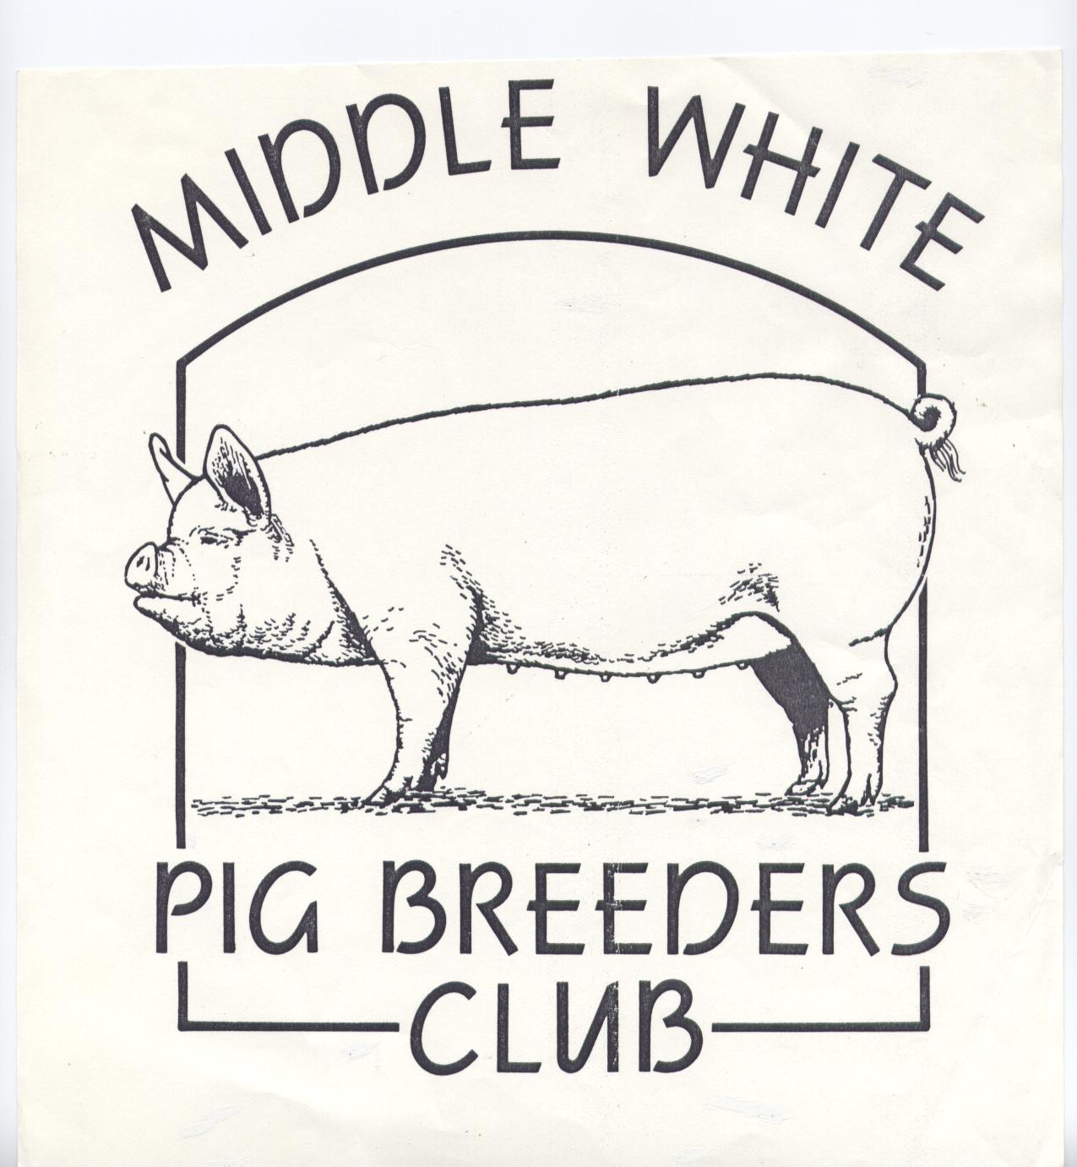

MIDDLE WHITE
PIG BREEDERS CLUB

(PATRON: ANTONY WORRALL THOMPSON)



NEWSLETTER
WINTER 2005

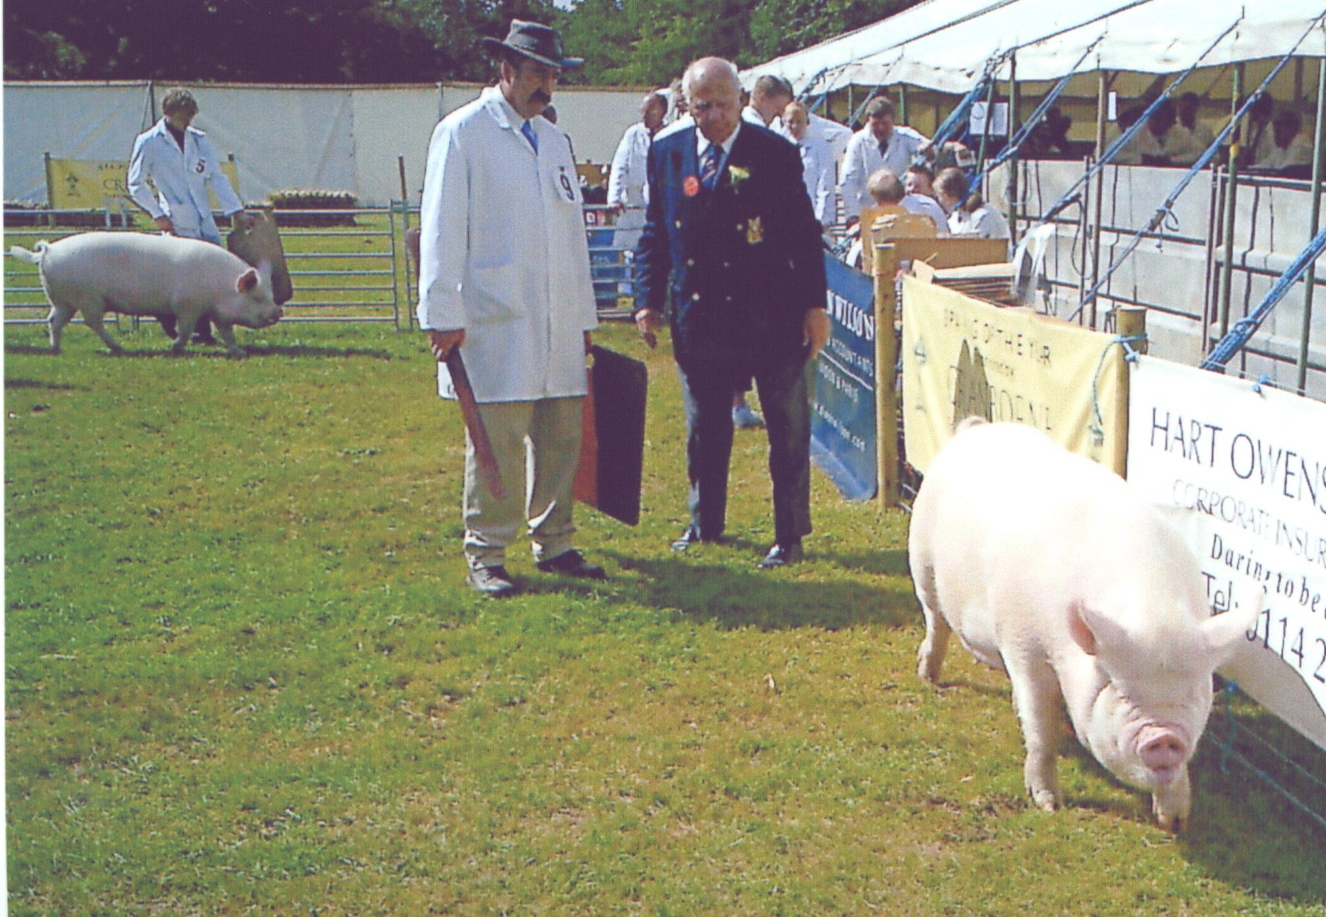
EVES ALMAROSE 6TH
Photo by Emily Marsden





OVER 150 YEARS OF
THE MIDDLEWHITE

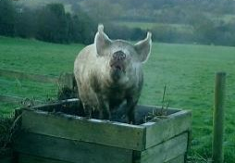
1Above 2 below
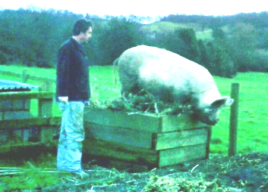
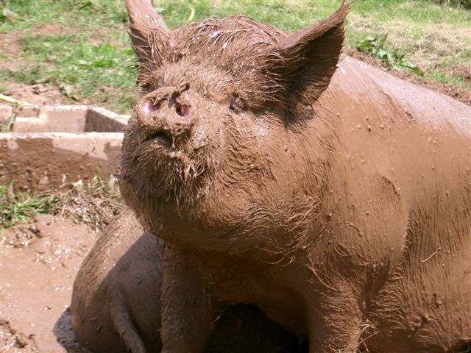
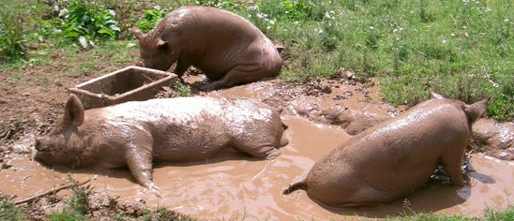
6

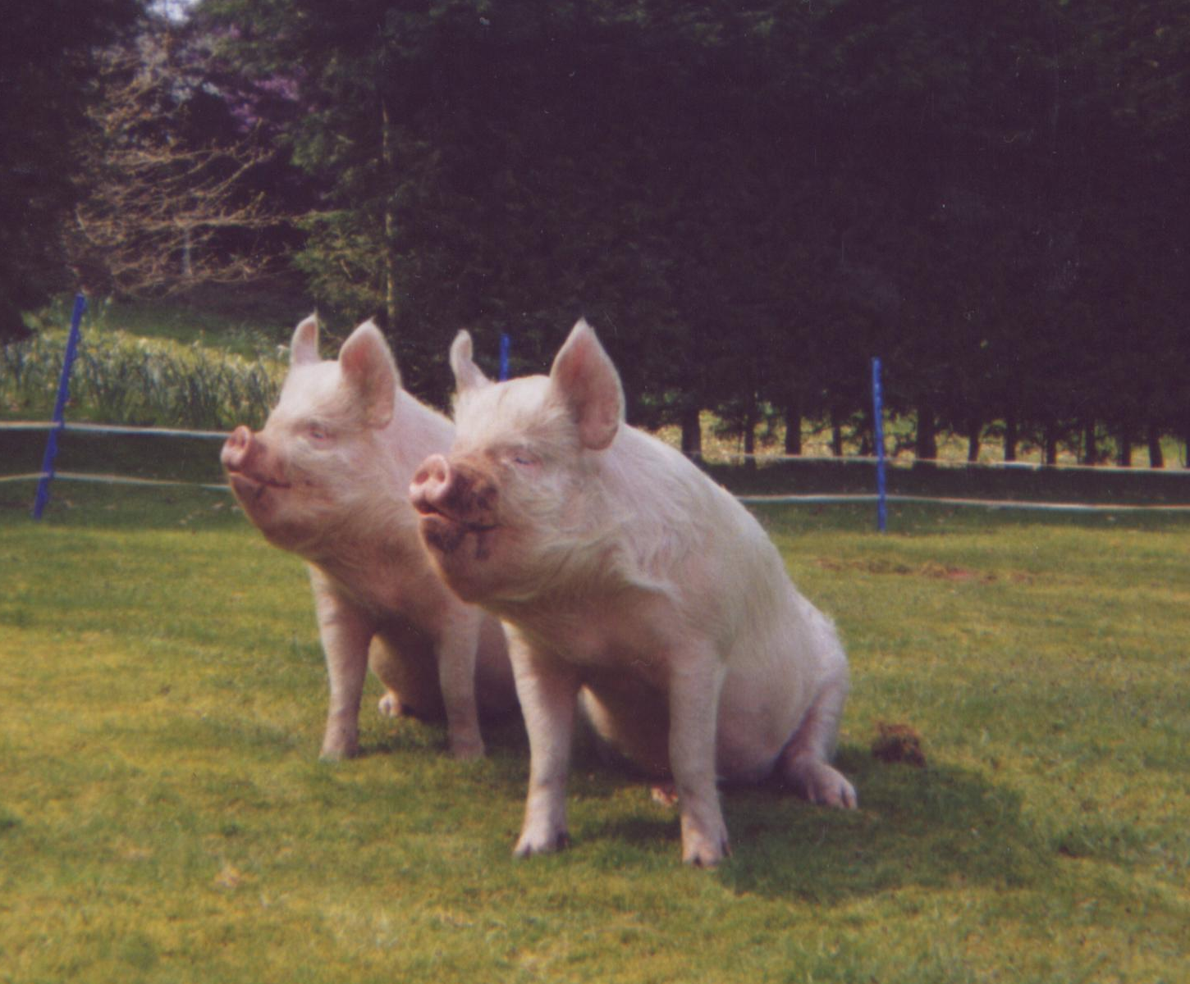
3
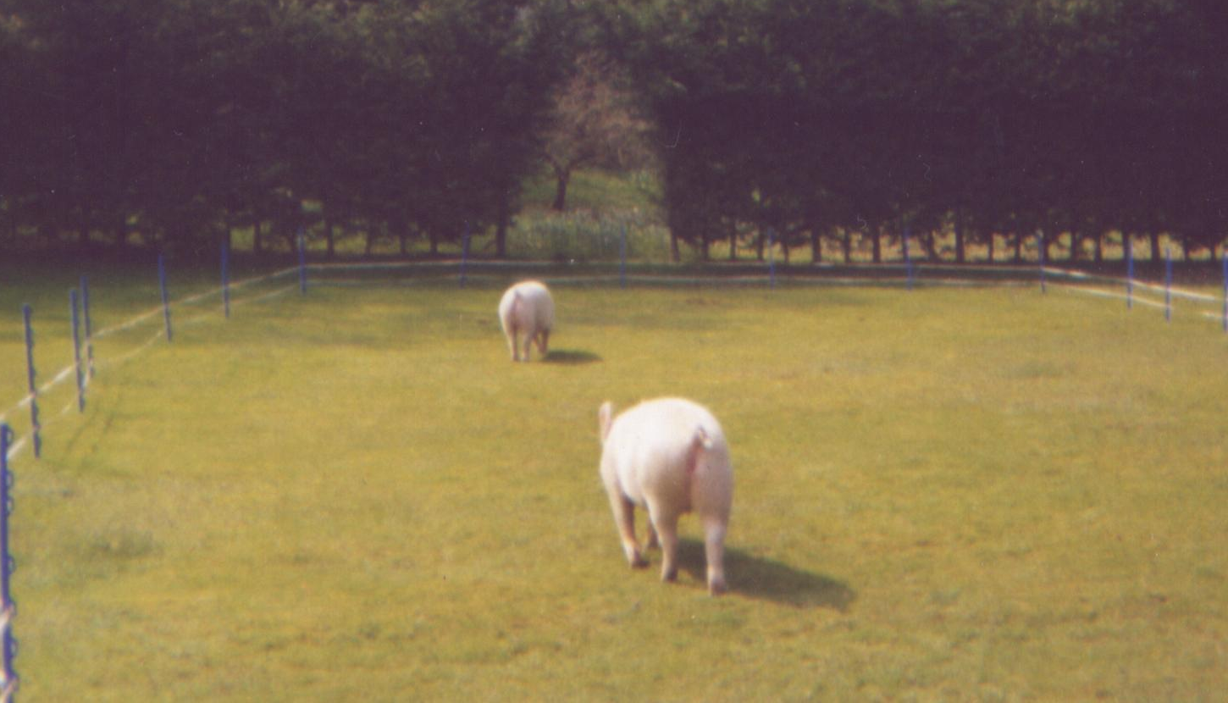
4
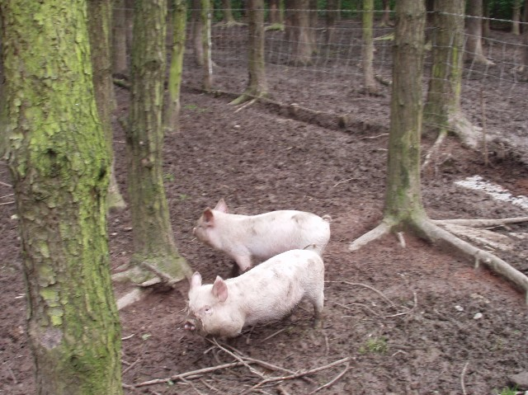
5

Our Patron Antony Worrall Thompson writes

We had a good year in 2005 – I expanded my herd.

More importantly, more and more chefs are getting the message regarding Middle Whites – which is good news!

I enjoyed a flying visit to Hatfield in September, managing to squeeze in a cookery demonstration; with plenty of amusing banter with Hedli Niklaus, who plays Kathy Perks in the Archers. This was in between Saturday Kitchen which is live, before dashing off to catch a flight to Scotland for another engagement. And all that while I was supposed to be on holiday – you know me – I like to keep myself busy.

Sadly we lost a boar this year but we’ve gained another one which is doing well. Rajah (or Sid as he was affectionately known) was the sire of Ferrylane Rajah 2nd that Tracey Bretherton did well showing this year, and all being well with blood tests being passed etc. one of his July progeny boars will be off to Japan in January.

Christmas greetings and best wishes for the New Year to all members from myself, Jay and the family.

Antony

Front Cover Photo:
Duncan Staig judging the July gilt class at Hatfield Show in September 2005, Eves Almarose 6th with Mick Paddock. Photo by Emily Paddock.

Page 2 Photos
1 – I’m king of the heap – the compost heap that is. Photo Emily Paddock.
2 – Get down you dirty rascal! Photo Emily Paddock.
3 & 4 – Brian Merry’s July gilts doing their party piece, followed by a lap of honour. Photos Brian Merry.
5 – The babies lost in the woods? No, these ones will soon root their way out. Photo Emily Paddock.
6 and bottom – No, it’s not a new breed of hippo, just some of Viki Mills’ Middle Whites enjoying a mid summer wallow – and meeting John Herbert’s boar. Photo Tracey Scott.

Chairman’s Letter

Dear Members,

Well it’s been a very strange year for me, sitting and watching instead of doing, but on cold wet days it’s not so bad! The rest of you breeders, feeders, producers and Showmen & Women have had a very busy and successful year with shows, exports, and producing top quality pork.

We have a young Rajah Boar "strutting his stuff" at the Isolation unit having completed his testing and training sessions and passed with flying colours. I'm not sure about his travel arrangements yet or when semen will be available to the RBST, BPA or yourselves but I hope that I'll be able to announce that in the Spring Newsletter. Well done Tony May for stepping into the breach when our search for a suitable Mischief boar was fruitless and a great big ‘’Thank You’’. Without you this consignment of boars would have gone without a representative from the Middle Whites.

3
The other piece of good news is that we have finally made some progress on our web-site !!

Brian Douglas who designed and set up our original website within Stockmaster has agreed to design and set up a new one for our Club, based loosely on the old one but with some new upmarket content. Any ideas or images you would like considered please e-mail them to me as soon as possible. My e-mail is m.v.card@homecall.co.uk We can then link our site to the B.P.A and up-date annual survey results, publish show results etc etc. Watch this space!
We will probably have a new Domain name rather than the original one I purchased, which will be easier to remember but being the only committee member as yet who can drive a computer I am still wearing L-Plates and still have an awful lot to learn.

It just remains for me to wish you all very "Merry Christmas" and a successful and prosperous new year. Mary Card

Secretary’s Notes

It’s Newsletter time again, where does the time go? There isn’t much to go in this issue unfortunately.

We have had several new members join this year, which is encouraging. We extend a warm welcome to all of you, we hope that you will enjoy your association with us and help with the promotion of the Middle White breed.

Reading the Farmers Weekly in September I was surprised to see an article about club member Amanda Windsor’s husband from Fforest Farm, Whitland in Carmarthenshire. He is a retained fire fighter/farmer and she has Middle Whites plus doing dairy and beef cattle. Another household where these two occupations are vaguely linked like ours, as my brother is a vintage fire engine enthusiast, with a 65 year old Dennis pump that he takes to rallies, and my love of pigs, especially the M/W.

I hope that not too many of you were affected by the recent snow, fortunately we didn’t have any here. Horrible stuff, a friend of mine on the Devon Somerset border had 5 inches and couldn’t get out as she is out in the sticks on a nasty hill and even the 4X4 couldn’t get up the lane.

It just leaves me to wish you all a happy Christmas and a prosperous new year, with some good January litters.

JOHN MASON

Following the sad death of John Mason, his friend and companion Joyce Medcalf, has asked me to thank everyone who has written or contacted her for their support.

HATFIELD SHOW RESULTS & PHOTO CAPTION CORRECTIONS

In the Autumn issue we reported that in the Gilts Born after 1st January Class it was actually Eaves Dorothy 3rd that came 5th not Yasmyns Almarose 8th. Apologies to Sarah Marsden and family for the error.
Also apologies are due to Sarah’s daughter Emily for two incorrect photo captions on the front and back covers, these should read taken by Emily Paddock. Thank you very much for supplying the pictures Emily.

4

SUBSCRIPTIONS – DUE 1ST JANUARY 2005

The 1st January brings us to renewal time again, those of you who need to renew will have a form included with this newsletter. The subscription rate is £15.00, there are still a few of you who haven’t altered their standing orders or sent the £5.00 top up that was due on 1st January 2005. There have been notices to all of you in the last three newsletters.

Stop a visit from this old hag by paying up promptly
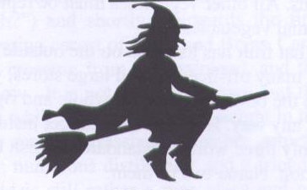
PLEASE do try and cut down my workload and the unnecessary cost to the club of a stamp or phone call and ensure that you have increased your standing order to £15.00, or that your subscription is sent promptly. Thank you very much.

For Sale

4 year old Mischief Boar, Cestrian Mischief 10th currently out on loan with Angus Appleton. Sadly Brian Farrington passed away on 12 December and the boar must go.
Tel Angus Appleton 01248 355046 (Bangor) if you are interested.

July born Rajah Boar from a Woodlands Lady X Ferrylane Rajah 2nd litter.
Tel Tracey Bretherton 01772 685950 or 07884071924 (Lancs.).

October born Silk Gilts X Ferrylane Rajah.
Tel Miranda Squire 01753 652207

Wanted

Middle White Gilts, as old as possible so that they can go to the boar ASAP, also young Middle White Boar, NOT a Revival or Mischief. Tel. 07879 492787 Trevor, based in Hampshire.

NATIONAL PRIME STOCK SHOW STAFFORD 2005

Pigs were present at the Primestock Show at Stafford Showground for the first time for about ten years. On this occasion the pigs were there for display only and not for competition.

Six breeds of pig were at the Show:-
Welsh from Christine Vaughan, Tamworth from Bill Howes, Oxford Sandy and Black from Ron Annetts, British Saddleback from John Wreakes, Gloucester Old Spot from Mick Bradshaw and
Middle White from John Herbert.

The display of pigs created great interest – many people said how nice it was to see pigs at the
Primestock Show again. A particular attraction was the Gloucester Old Spot sow and a good litter of ten pigs from Mick Bradshaw who also had an excellent display of meat and meat products on sale.

5
After the grand parade of cattle had finished we took five pigs into the main ring. These were Middle White, Welsh, Tamworth and two British Saddlebacks. Considering the young age of the pigs, they were very well behaved. Marcus Bates provided a commentary during the parade of pigs.

Many thanks are due to those who brought pigs to the show and also to Tracey and Ian Bretherton, Geoff Parker and Mary and Brian Merry who all came to support us and helped with the pig parade, also Mick Paddock, Sarah Marsden and Emily.

Hopefully, we will have competition classes for pigs next year – so please give this some thought when planning your breeding and showing programmes.

Included in this newsletter is an article from Rachael Wylie giving valuable advice for preparing pigs for fatstock shows. We must thank Rachael for allowing her article to be reprinted, it was printed in a newsletter some years ago.

John Herbert

Some photos taken at the Show are shown below.
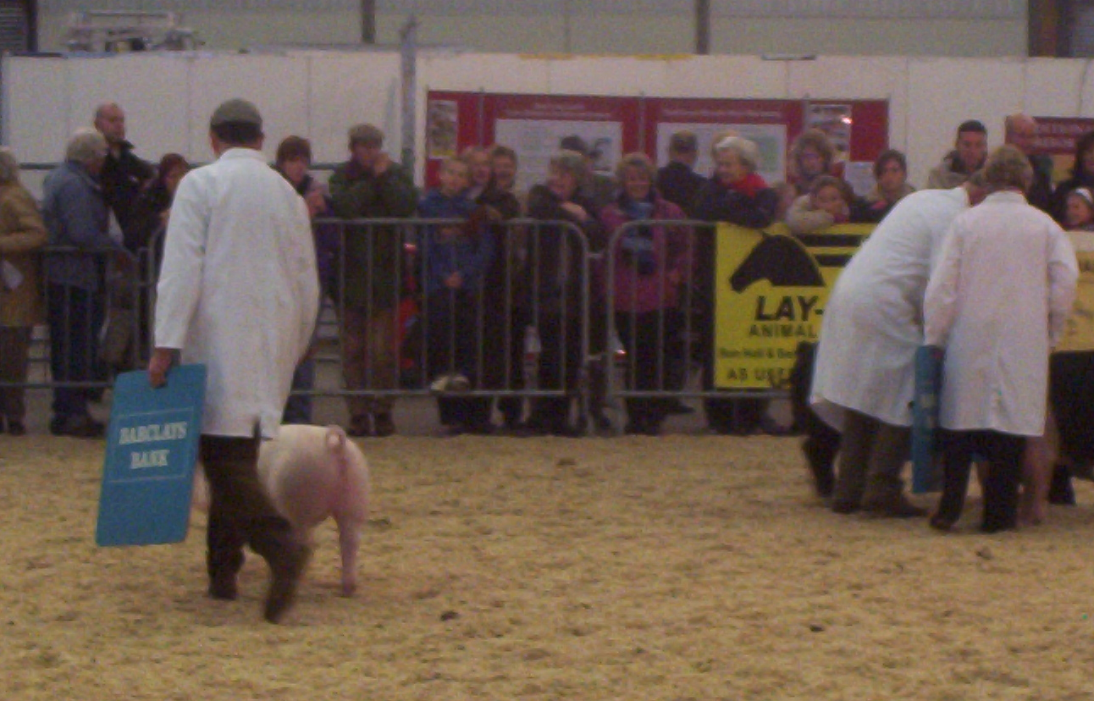
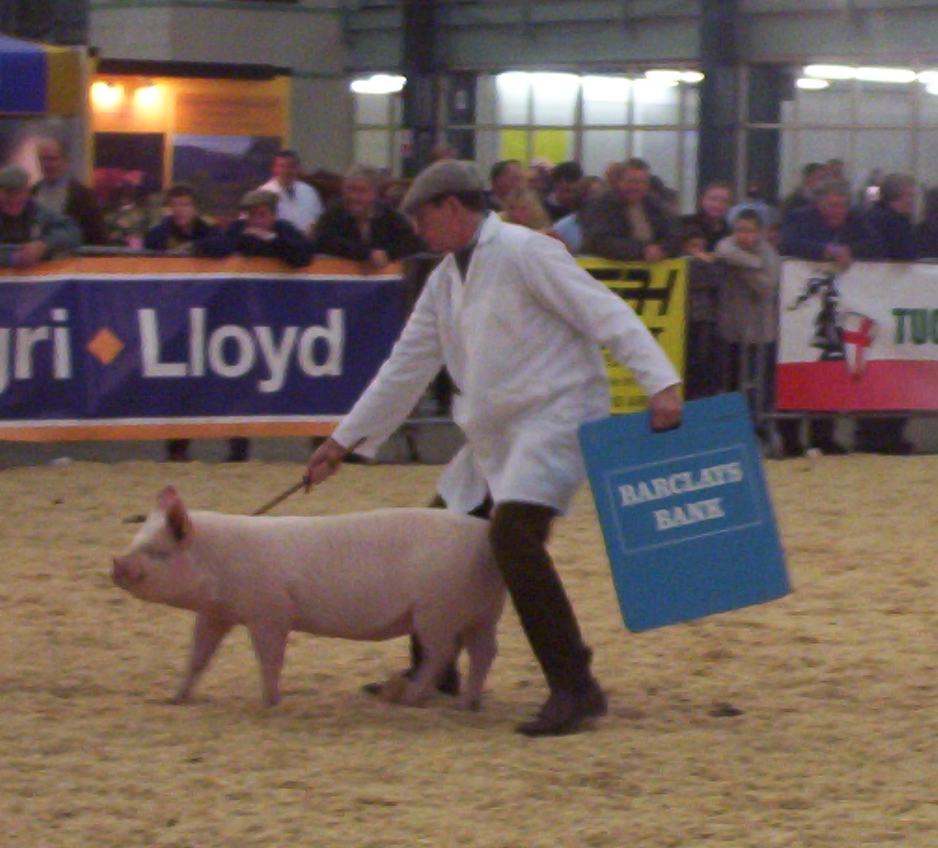

6
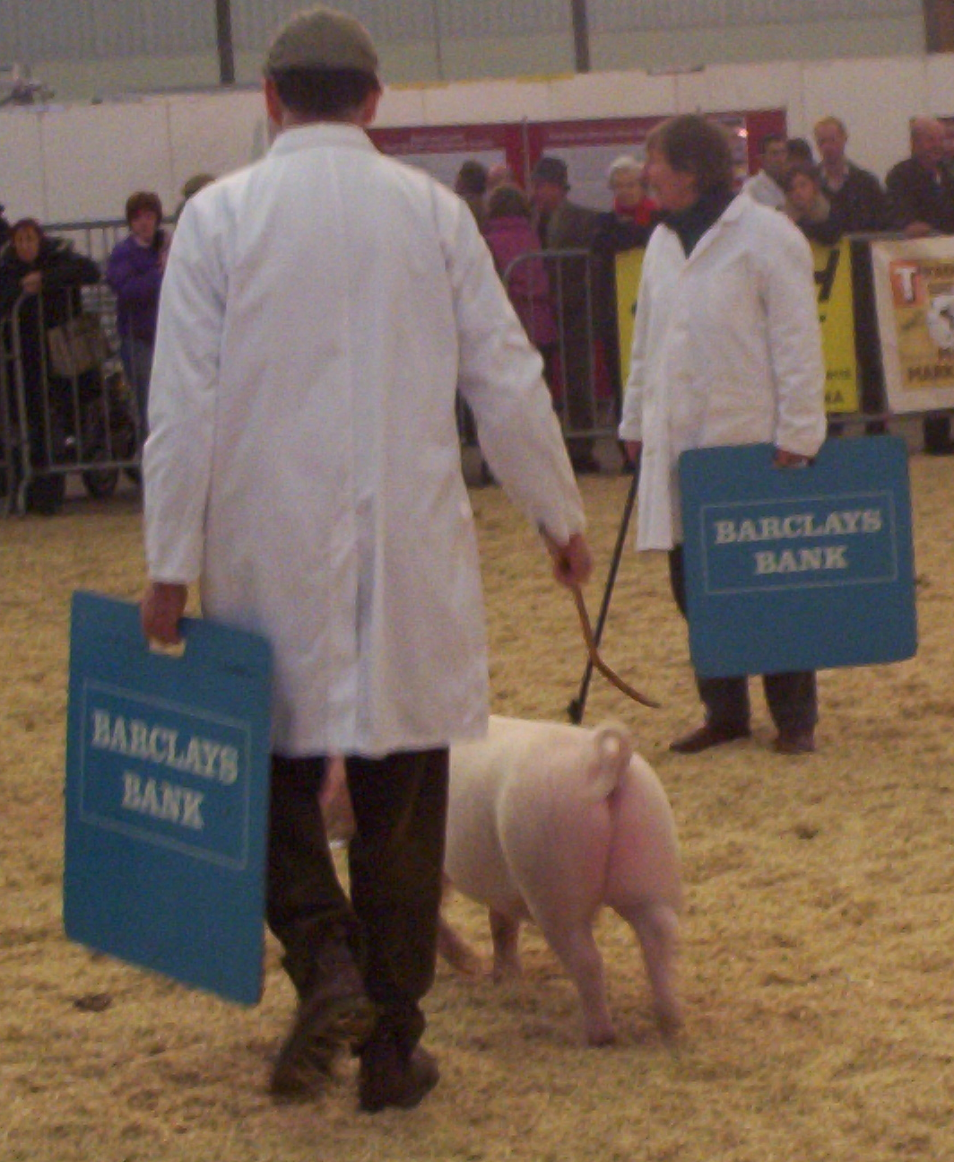

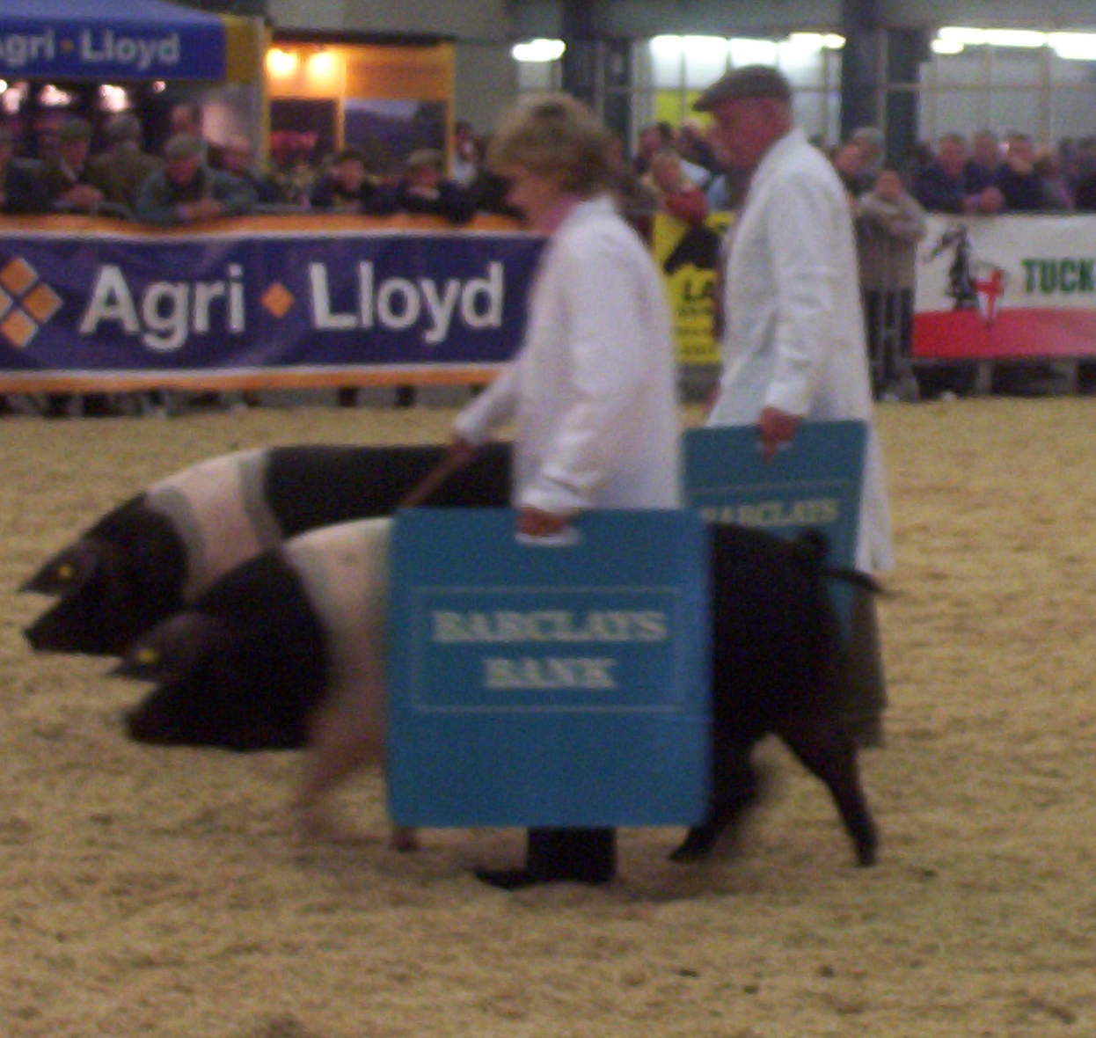

The following article, by Rachael Wylie, was first published in the Autumn 1995 newsletter

PREPARING FATSTOCK PIGS FOR SHOWING

Firstly work out your breeding plan with dates of show.
E.g. early December Show

• Heavy pigs born late May
• Bacon pigs born late June
• Cutter pigs born late July
• Pork pigs born early August

(Obviously for shows held in other months the dates of birth will need to be adjusted accordingly.)

These are just guidelines and not always possible; also check weights in the show schedules as they may differ between shows. Before you go any further this project is going to be hard work and definitely dedication, especially in the last month.

Select your pigs; pairs are always difficult so go for a three and you have a spare if possible and preferably gilts, if not, castrates. Enter Boars only in boar classes, which are not very often in the schedules. If you have an exceptional single pig always enter a pair then you always have got a chance in the single class.

When selecting, have a good top line and back end and good legs with no bumps on. Underlines are not important in these classes, as these classes are for killing and not breeding pigs. Always watch the schedule, if pure bred classes the pigs must be true to breed type. Wean pigs between 6 to 8 weeks old, having got used creep feed. If the pen is suitable take the sow away and leave the pigs in, reducing the risk of shock to the piglets.

I would ring your local feed rep. and tell him what you are doing and ask them for advice as to which food they recommend to have bloom, condition, good growth rate and good firm flesh and what quantity you should feed per pig per day to get them to the right weight. If possible, feed them on wet food, water and meal, or you can leave nuts or pellets to soak overnight or during the day for the night feed.

Remember that animals like a routine, always feed at the same time morning and night or three times day if pushing the animals. If the weather is frosty take the chill off the water. Do not forget to worm the pigs. Clean the pigs out regularly so they do not get stained from lying in wet straw, as the stains show up under the lights.

For the last six weeks before the show you want to weigh them; same day; same time, once a week so you can regulate their weights. The last fortnight, weigh twice a week, and this is when you may have to feed pigs separately, so the pairs weigh and look alike. If too heavy give them less water and food and more exercise; and too light, more food.

Training pigs for the last month at least, give them a titbit out of your hands e.g. an apple so they
come towards you. Then go onto feed scoops with food in. Get the pair of pigs, one per hand, heads not too high or low when showing, to keep the back straight. It takes two people to show, one on the heads and one with the pig boards at the side of the heads to push their bums together. On show day remember you want the pigs hungry so you can show them with feed bowls.

Give the pigs a good wash before arriving at the show, remembering the faces and inside
7
ears. At the show always weigh them on the show scales; do not forget to take some hand scales to weigh the food to get the weights correct, fine the time of the show weighing and work to that. After the weighing and your pair are within a kilo of each other and all pigs are in the weights, you will feel like you have won!.

Brian Merry Writes:-

Mervyn Forster was the first person I saw who could get a Middle White sow to sit, and Geoff Parker carried it on with his Pig of the Year winner Freda. Last year both of my August gilts would sit together at the same time. Four year old Grace Bretherton also taught her January gilts to sit. The M.W.is extremely clever and can pick things up very quickly.

Last year Tracey Bretherton wanted to put some new blood into her Gracebank herd and decided upon the Rajah Boar line, and subsequently purchased a weaner from our Patron, Antony Worrall Thompson, Ferry Lane Rajah 2nd.

Later in the year this boar qualified for the Pig of the Year final at Yorkshire, and was also the supreme champion at the Great Eccleston Show in July. The Rajah line dates back to Ribvalley Rajah over 40 years ago and was bred by our President, the late Jack Howlett, who is sadly missed for all he did for the Middle White and his tales in the newsletter. I don’t know whether Tracey told her little boar this or not, as she is always talking to her pigs, or whether he had read the 2005 Bloodline survey. After Tracey’s success with her Rajah boar a few other people wanted to use him and Tracey being Tracey let him go out.

Jack Howlett was one of the instigators of the Young Pig of the Year, for January born pigs, held for the first time in 2005, with the final being held at Hatfield House. It would be nice to see a lot more Middle Whites in the final in 2006, because you can be sure that Jack will be watching from somewhere with a packet of senior Service in one hand and a big smile on his face if one of Tracey’s Ferry Lane Rajah 2nd’s offspring wins the top award.

Gracebank boars and gilts from Ferry Lane Rajah 2nd, crossed with Silk, Woodlands Lady 8th and Yootha sows can only be purchased from Tracey Bretherton, 01772 685950 or 07784071924, so whether you are an exhibitor or just want one as a pet give Tracey a ring, poa.

Tracey will be keeping two Rajah Boars herself and might call one of them Jack after Jack Howlett, and the other Jasper after Ribvalley Jasper.

If I was a vicar it would be news from the pews, but the next write up I think will be news from the queues of people buying Gracebank blood stock.

Up to now I know of 3 people who will be exhibiting boars and gilts which are descendants of the Ferry Lane Rajah owned by Tracey.

Merry Xmas to you all and I hope that everyone has good litters in the New Year, especially Tracey. See you at the AGM, the start of an exciting year for the Rajah and Middle White breed in general.

Kind regards The roving reporter, Brian Merry.

Back Cover Photos
This white stuff isn’t very tasty, Middle Whites get their first taste of snow. Photos taken by Emily Paddock on 25 December 2004.
8
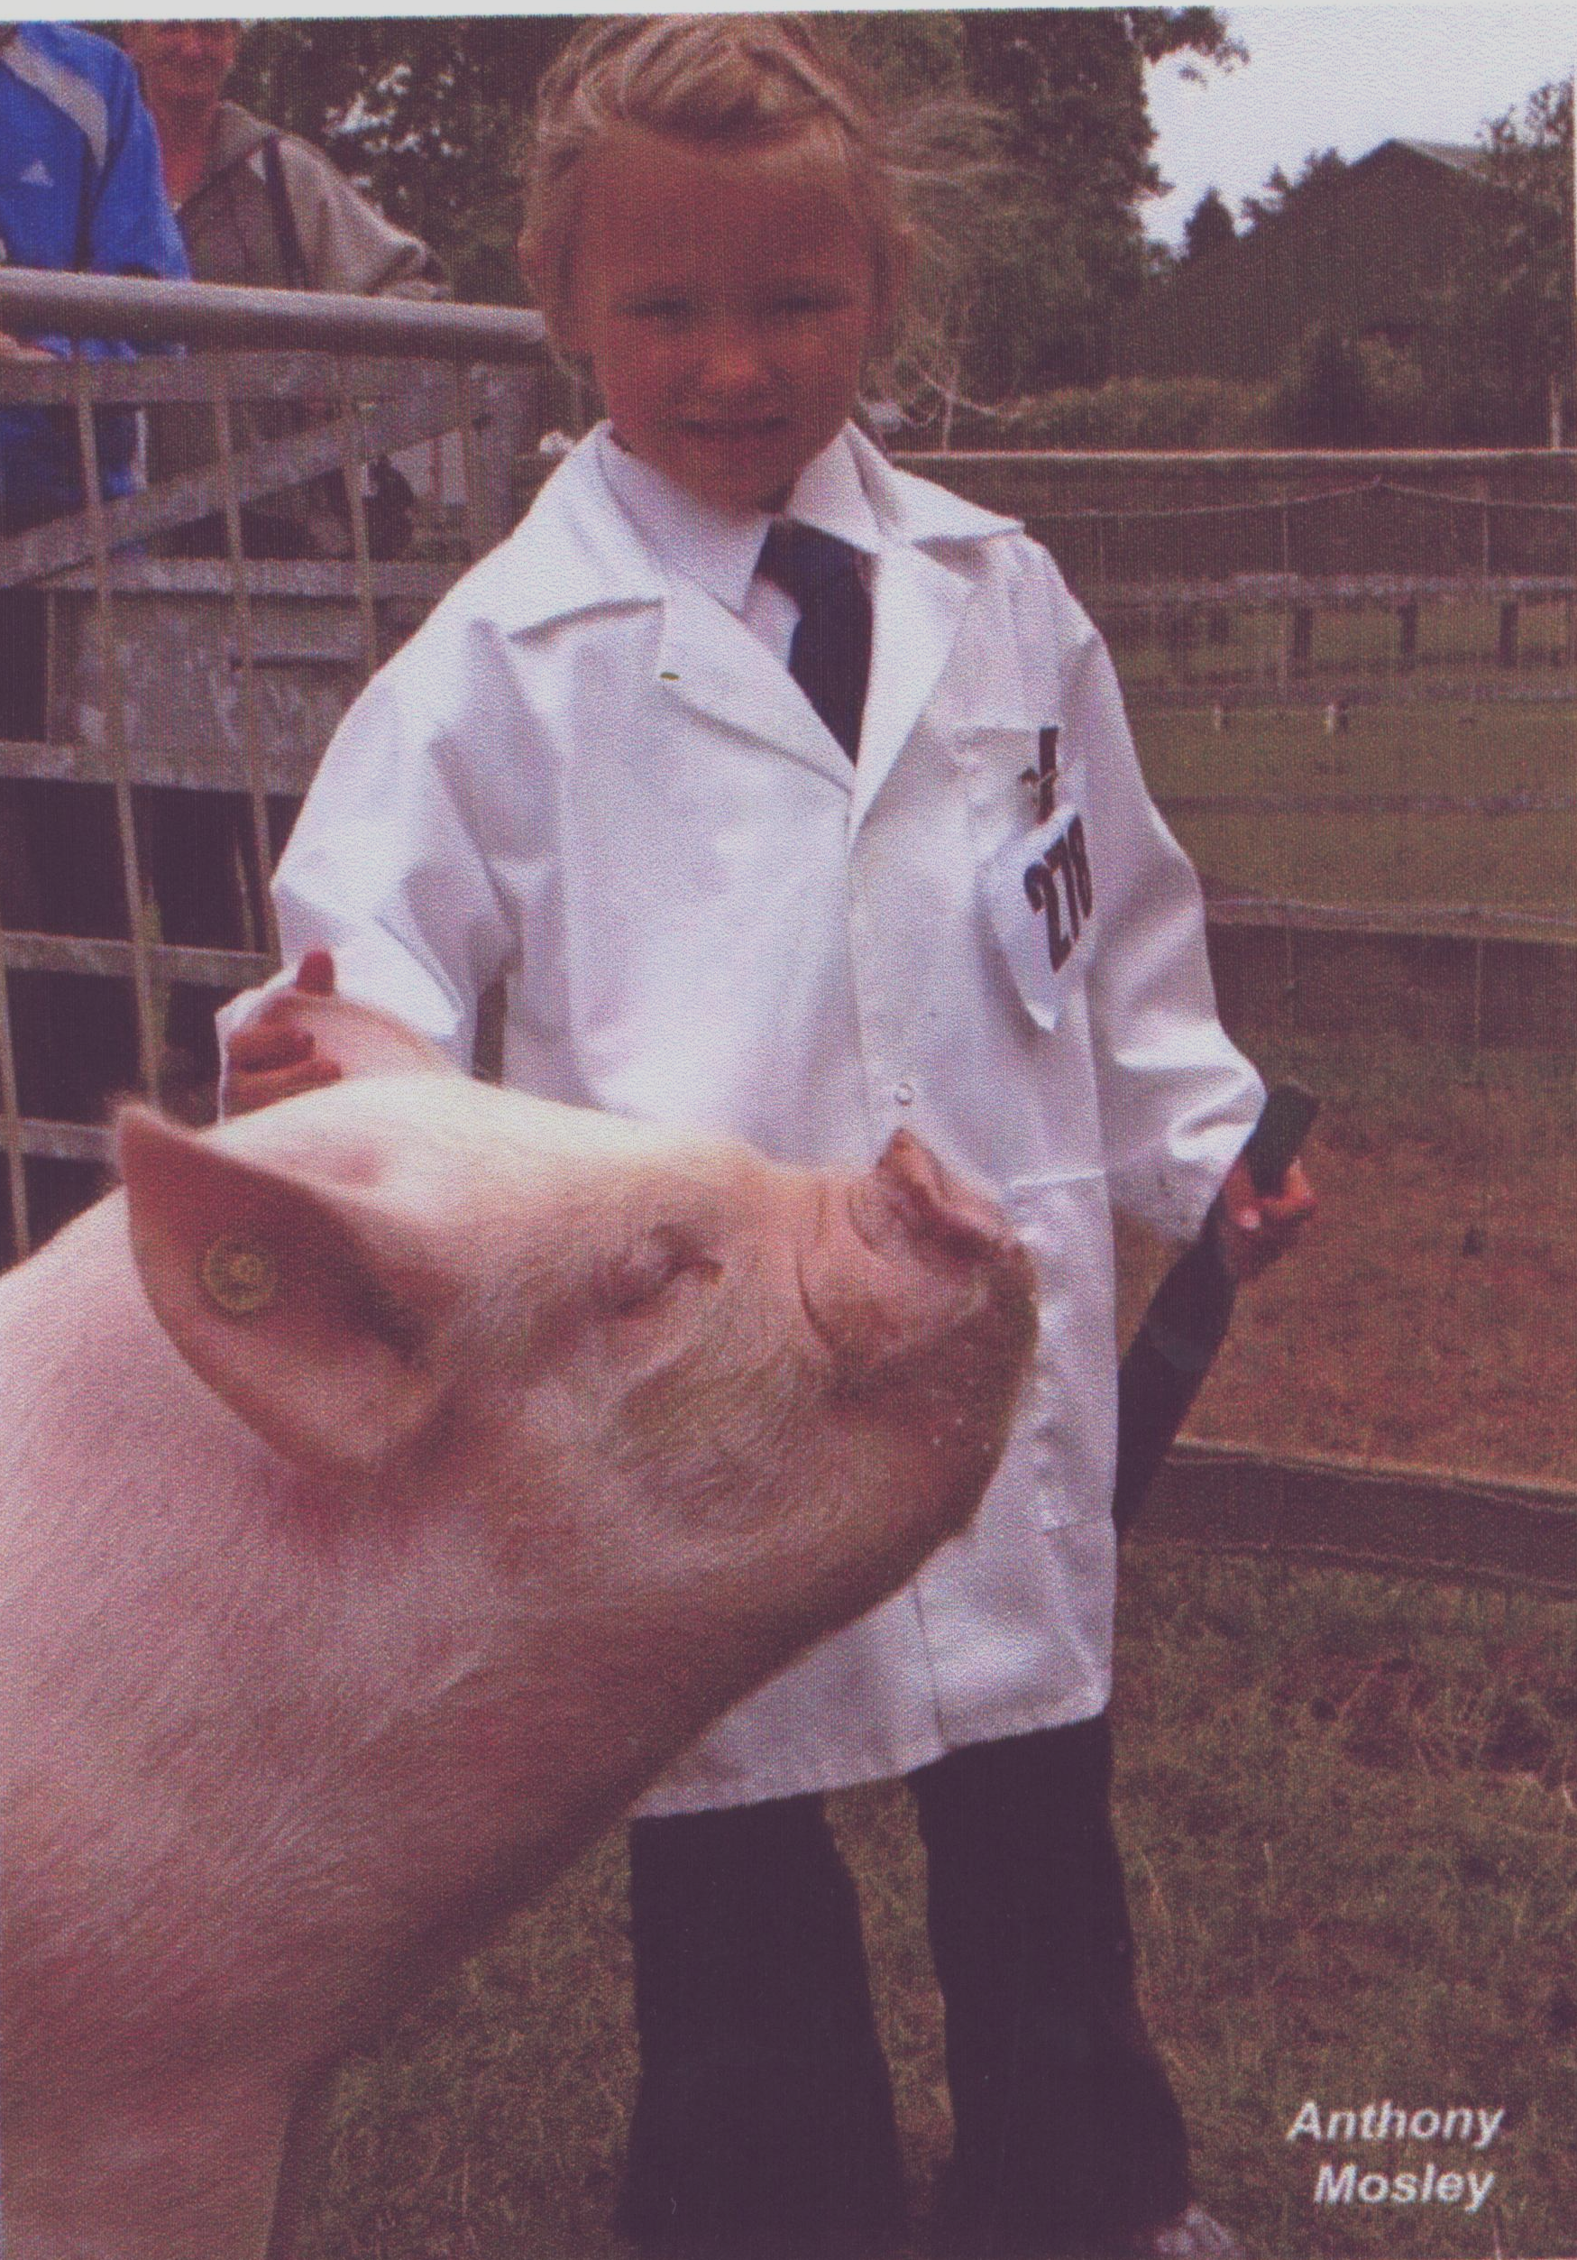
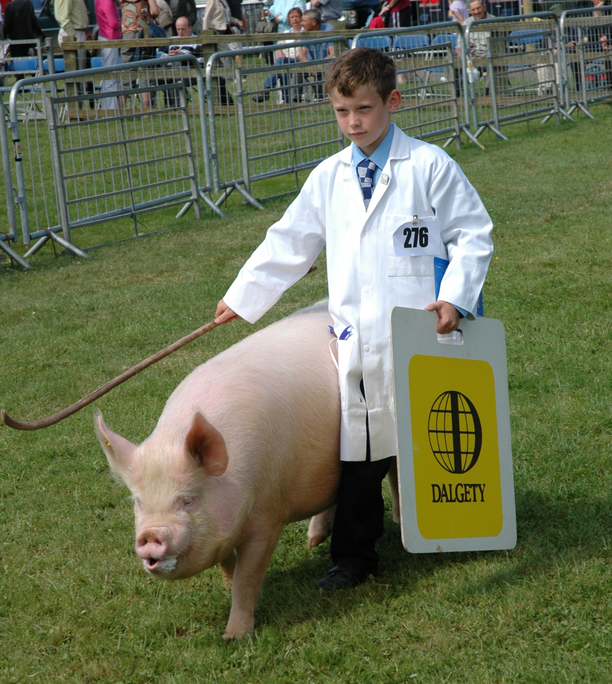

Two of our younger members, both looking very smartly turned out, with well presented pigs.

Top Left: Grace Bretherton – Photo courtesy Anthony Mosley.
Top Right: Lewis Bennett (Chris Pedley’s grandson).
Bottom left: Lewis again – engaged in another of his hobbies.
Below: Why bother to forage for your dinner when you can have fresh grass tipped on top of you – makes a change from a pizza delivery.
Photo by Emily Marsden.

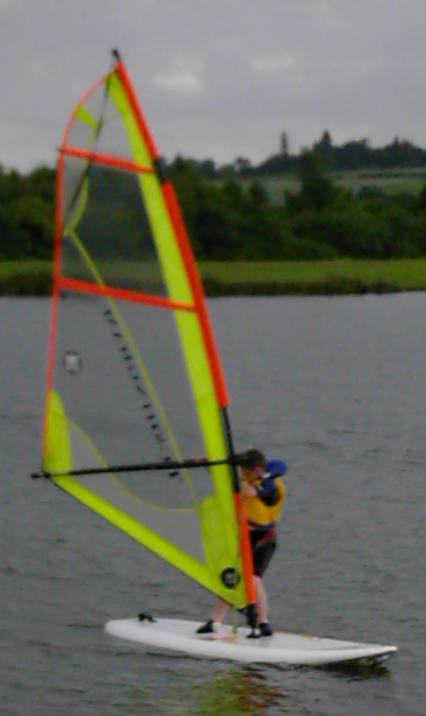

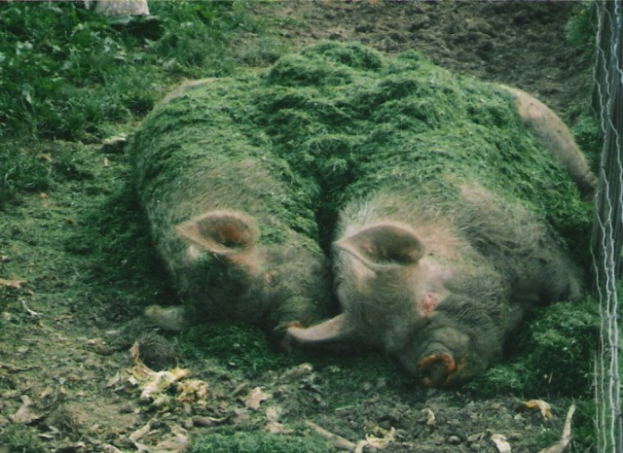

 | 

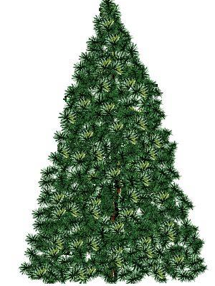 |  | 
 | THE COMMITTEE OF THE MWPBC WISHES YOU ALL A VERY MERRY CHRISTMAS AND A HAPPY NEW YEAR FOR 2005

 | 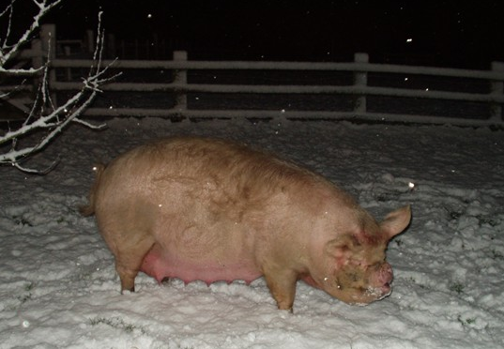 |  | 


